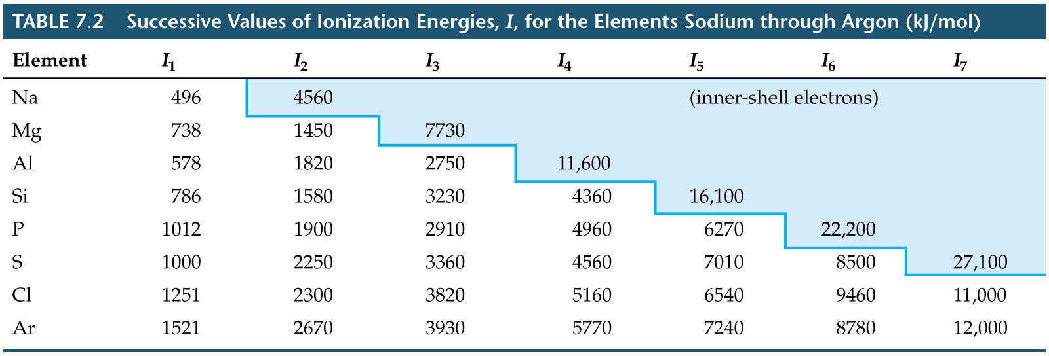
Ionization Energy
Variations in Successive Ionization Energies
There is a sharp increase in ionization energy when a core electron is removed.

