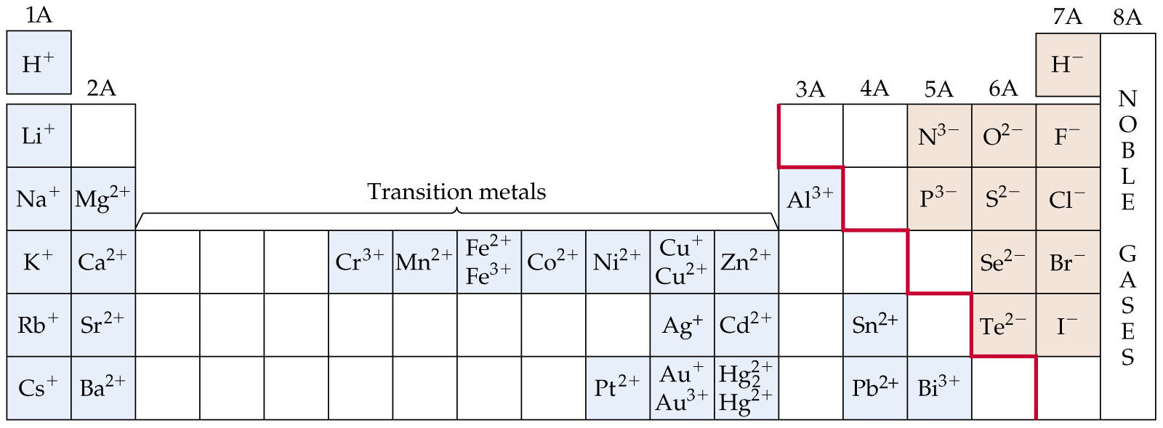
Metals, Nonmetals, and Metalloids

