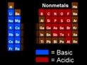
Metals, Nonmetals, and Metalloids
Metals

When metals are oxidized they tend to form
characteristics cations.
All group 1A metals form M⁺ ions.
All group 2A metals form M²⁺ ions.
Most transition metals have variable charges.

