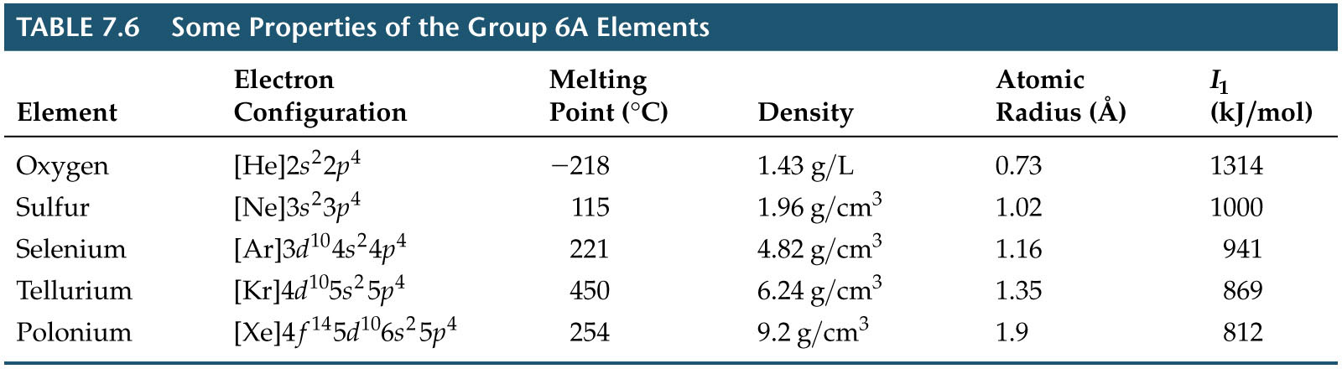
Group 6A: The Oxygen Group

