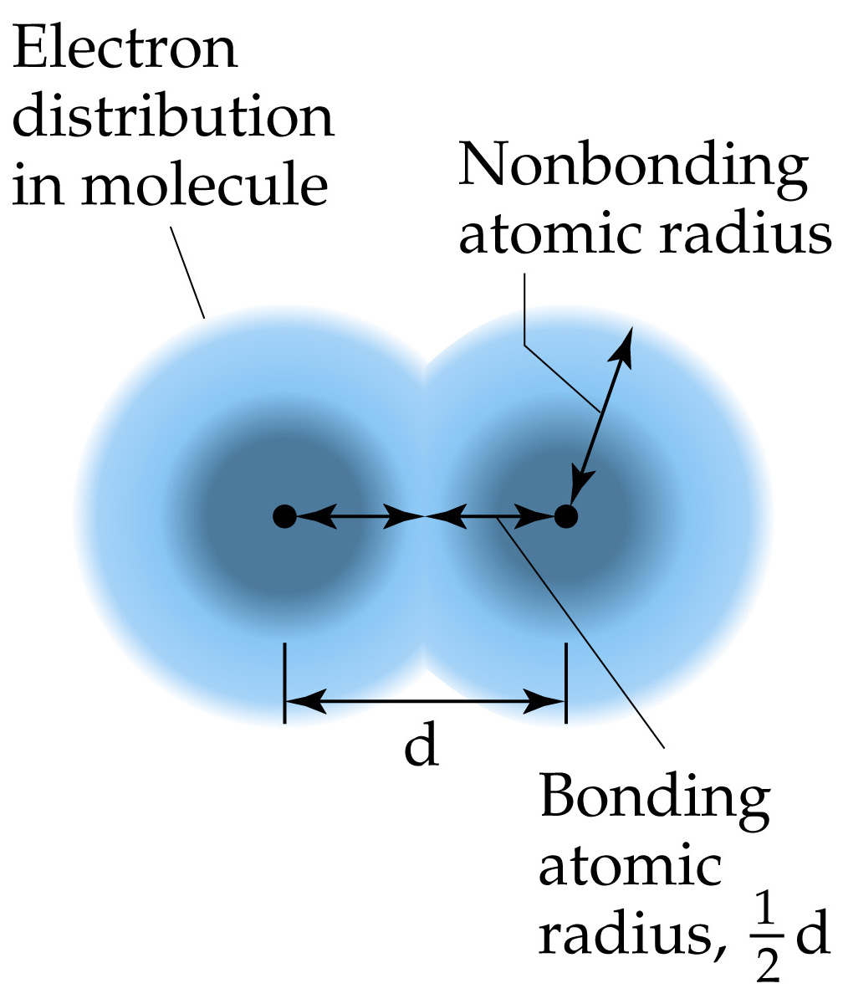

Consider a simple diatomic molecule.
The distance between the two nuclei is called the bond distance.
If the two atoms which make up the molecule are the same, then half the bond distance is called the covalent radius of the atom.
Sizes of Atoms and Ions

