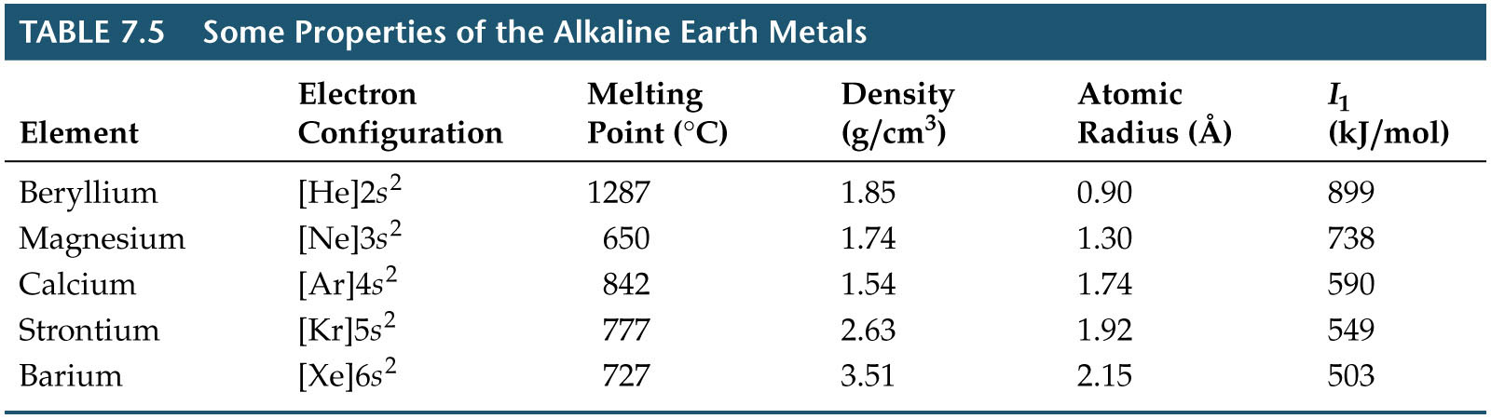
Group 2A: The Alkaline Earth Metals

