Energetics of Ionic Bond Formation

Lattice energy: the energy required to completely separate an ionic solid into its gaseous ions.

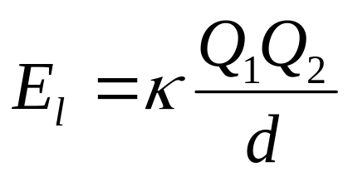Lattice energy depends on the charges on the ions and the sizes of the ions:

k is a constant (8.99 x 10⁹ J·m/C²), Q₁ and Q₂ are the charges on the ions, and d is the distance between ions.

Lattice energy increases as
- The charges on the ions increase
- The distance between the ions decreases.

