Electronegativity
The affinity for electrons. The atoms of the various elements differ in their affinity for electrons. This image distorts the conventional periodic table of the elements so that the greater the electronegativity of an atom, the higher its position in the table.
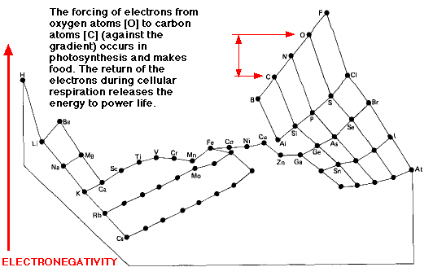
Although fluorine (F) is the most electronegative element, it is the electronegativity of runner-up oxygen (O) that is exploited by life.
The shuttling of electrons between carbon (C) and oxygen (O) atoms powers life. Moving electrons against the gradient (O to C) - as occurs in photosynthesis - requires energy (and stores it).
- the removal of hydrogen (H) atoms from water molecules 2H₂O -> 4e⁻ + 4H⁺ + O₂

- the reduction of carbon dioxide (CO₂) by these hydrogen atoms to form organic molecules.

Moving electrons down the gradient (C to O) - as occurs in cellular respiration - releases energy.

glycolysis, the breakdown of glucose to pyruvic acid
the complete oxidation of pyruvic acid to carbon dioxide and water

