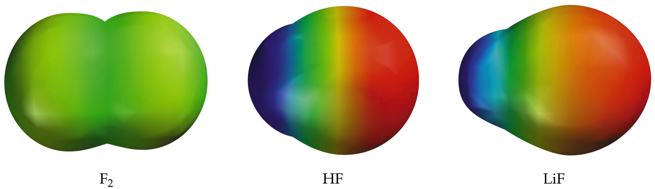
Bond Polarity and Electronegativity
Electronegativity and Bond Polarity
There is no sharp distinction between bonding types.
The positive end (or pole) in a polar bond is represented δ+ and the negative pole δ-.

