- In this reaction one C-H bond (413 kJ)and one Cl-Cl bond (242 kJ) gets broken while one C-Cl bond (328 kJ)and one H-Cl bond (431 kJ) gets formed.
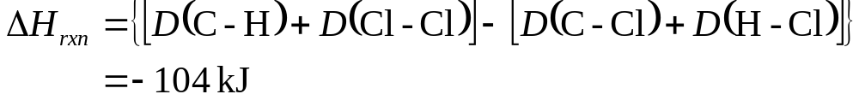

The overall reaction is exothermic which means than the bonds formed are stronger than the bonds broken.
- The above result is consistent with Hess’s law.

