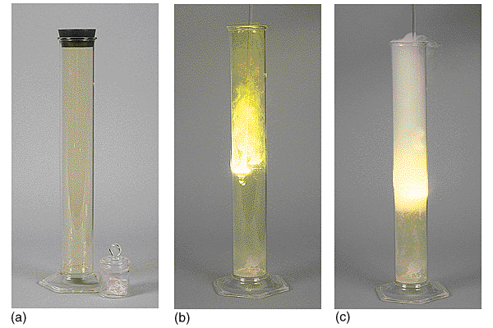

Consider the reaction between sodium and chlorine:
Na(s) + ½Cl₂(g) → NaCl(s)ΔHº_{f} = -410.9 kJ
Ionic Bonding

