NaCl forms a very regular structure in which each Na⁺ ion is surrounded by 6 Cl⁻ ions.
Similarly, each Cl⁻ ion is surrounded by six Na⁺ ions.
There is a regular arrangement of Na⁺ and Cl⁻ in 3D Lattice
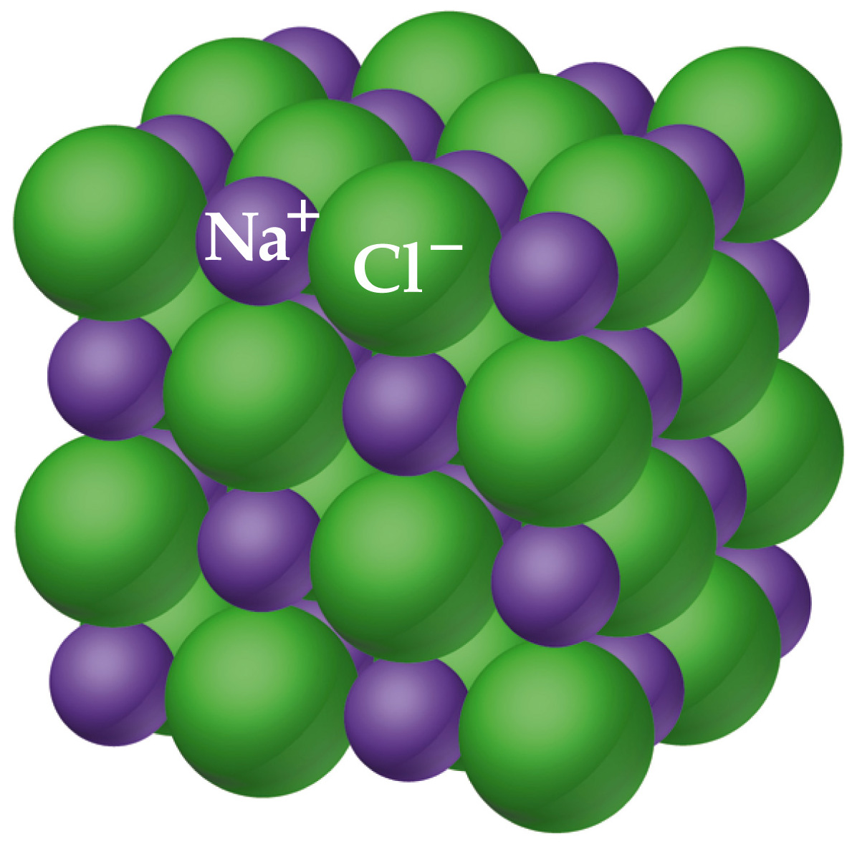

Note that the ions are packed as closely as possible.
Note that it is not easy to find a molecular formula to describe the ionic lattice.

