Conjugate pairs

When hydrogen chloride dissolves in water, almost 100% of it reacts with the water to produce hydroxonium ions and chloride ions. Hydrogen chloride is a strong acid, and we tend to write this as a one-way reaction:

In fact, the reaction between HCl and water is reversible, but only to a very minor extent. In order to generalize, consider an acid HA, and think of the reaction as being reversible.
Thinking about the forward reaction:
- The HA is an acid because it is donating a proton (hydrogen ion) to the water.
- The water is a base because it is accepting a proton from the HA.
- But there is also a back reaction between the hydroxonium ion and the A⁻ ion:
- The H₃O⁺ is an acid because it is donating a proton (hydrogen ion) to the A⁻ ion.
- The A⁻ ion is a base because it is accepting a proton from the H₃O⁺.
The reversible reaction contains two acids and two bases. We think of them in pairs, called conjugate pairs.
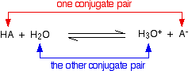

When the acid, HA, loses a proton it forms a base, A⁻. When the base, A⁻, accepts a proton back again, it obviously refoms the acid, HA. These two are a conjugate pair.

Members of a conjugate pair differ from each other by the presence or absence of the transferable hydrogen ion.

- If you are thinking about HA as the acid, then A⁻ is its conjugate base.
- If you are thinking about A⁻ as the base, then HA is its conjugate acid.
- The water and the hydroxonium ion are also a conjugate pair. Thinking of the water as a base, the hydroxonium ion is its conjugate acid because it has the extra hydrogen ion which it can give away again.
- Thinking about the hydroxonium ion as an acid, then water is its conjugate base. The water can accept a hydrogen ion back again to reform the hydroxonium ion.

A second example of conjugate pairs
This is the reaction between ammonia and water that we looked at earlier:
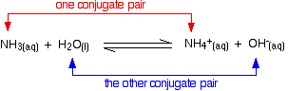

- Think first about the forward reaction. Ammonia is a base because it is accepting hydrogen ions from the water. The ammonium ion is its conjugate acid - it can release that hydrogen ion again to reform the ammonia.
- The water is acting as an acid, and its conjugate base is the hydroxide ion. The hydroxide ion can accept a hydrogen ion to reform the water.
- Looking at it from the other side, the ammonium ion is an acid, and ammonia is its conjugate base. The hydroxide ion is a base and water is its conjugate acid.

Amphoteric substances

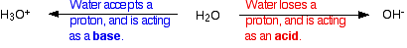
You may possibly have noticed (although probably not!) that in one of the last two examples, water was acting as a base, whereas in the other one it was acting as an acid.
A substance which can act as either an acid or a base is described as being amphoteric.

