CHEMISTRY 102 KEY EXAM 1
NAME: PRINT _______________________________ Sign ______________________________

FREE RESPONSE SECTION 5 points each DO ANY 10 = 50pts
(Choose any 10 problems and CIRCLE else grade will be scaled by number done

Cyclopropane C₃H₆ reacts to form the linear molecule propene also C₃H₆ in the gas phase. The reaction is first order in cyclopropane and has a rate constant of 5.87 x 10⁻⁴ sec⁻¹ at 485 C.

If a 2.7 L reaction vessel initially contains 722 torr of cyclopropane at 485 C, how long will it take for the partial pressure of cyclo-propane to drop to below 101.0 torr ?

= | 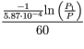  55.8

1) The gas phase decomposition of dimethyl ether at 480 ºC
CH₃OCH₃ CH₄ + H₂ + CO
is first order in CH₃OCH₃ with a rate constant of 4.21x10⁻⁴ s⁻¹. If the initial concentration of CH₃OCH₃ is 471mM, what will the concentration of CH₃OCH₃ be after 129.7 seconds have passed.

 | M
  c= 471e-3*exp(-4.21e-4*129.7) | 0.445971

2) An aqueous solution is 6.00% by mass ethanol, CH₃CH₂OH, and has a density of 0.988 g/mL.
The Molality and Molarity of Ethanol in the solution is

=(6.00g/46)/0.094kg | 1.387 m
=(6/46)=moles = 0.130
100grams of solution/0.988g/ml= |  |  | 101.2 | ml
Which is |  |  | 0.1012 | L
Molarity =0.130moles /0.1012 L= |  |  | 1.28M

3) In a laboratory experiment, students synthesized a new compound and found that when 15.0 grams of the compound were dissolved to make 320.0 mL of a chloroform solution, the osmotic pressure generated was 4.20 atm at 298 K. The compound was also found to be nonvolatile and a non-electrolyte.
What is the molecular weight they determined for this compound?
=15.0*0.0821*298/(4.20*0.320)= | 273.1

4) A 4.00 m solution of KCl (74.55 g/mol)) was prepared using 1.00 kg of water at 25.0ºC. Once the solid had all dissolved, the temperature of the solution was 12.3ºC. Calculate the heat of solution, ΔH_{solution}, of KCl . Assume that the specific heat of the solution is identical to that of water, 4.18 j/(g ºC)
(Be careful about the sign and final units)

298.2 | g KCl + 1000 g water = 1298 g
 | =4.18*(12.3-25)*1298 | -68905.63
 |  | 68.9 | kJ
 | 68.9/4 | 17.2 | kJ/mole KCl

5) If the reaction A + 2D --> C + 2B products is second-order in A and first-order in D, then the Rate Law will have the form

Rate = k [A]²[D]
6The solvent for an organic reaction is prepared by mixing 30.0 ml of acetone (C₃H₆O) with 40.0 ml of ethyl acetate (C₄H₈O₂). This mixture is stored at 28.0 C. The vapor pressure and the densities for the two pure components at 28.0 C are given in the following table. What is the vapor pressure of the stored mixture?
Compound | Vapor pressure  () | Density  ()
Acetone | 230.0 | 0.791
Ethyl acetate | 95.38 | 0.900

Acetone | =(30*0.791)/58.105 | 0.408 | moles
EA | =(40*0.900)/88.08 | 0.409 | moles
nt |  | 0.817
x(acetone)= | 0.500
x(EA)= | 0.500
Pt= | 162.7 | torr

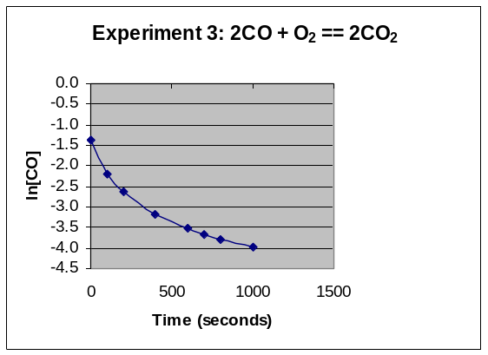

7) For Experiment 3; Explain the Order of the Reaction AND write an expression that defines the change in concentration of [CO] as a function of time. Function should include the numeric values of the rate constant and the initial concentration

1/[CO] = 0.05t + 1/0.25

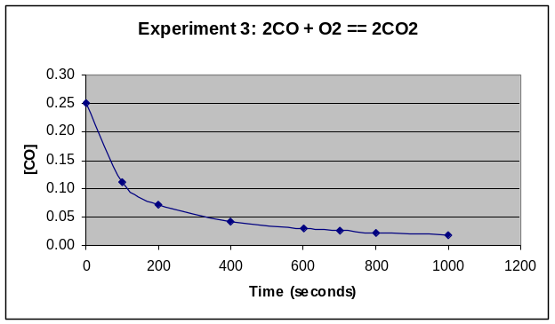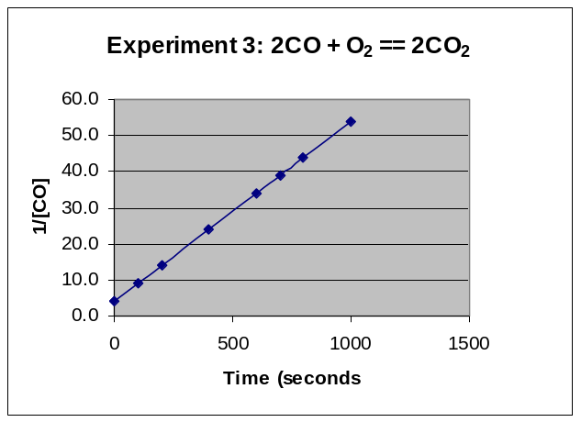

8) Draw a rough PHASE DIAGRAM to illustrate the changes of state of a Pure Solvent as a non-volatile solute is introduced into the solution. How does this alter the boiling point and freezing point. ALSO comment on how Raoult’s Law and the Relationship between Vapor pressure and Boiling point are responsible for this phenomena.

Vapor Pressure above a solution is diminished by solute and proportional to the mole fraction of molecules of the volatile solvent at the surface. This reduction in vapor pressure shifts/reduces the G/L interface line of the phase diagram and resultantly changes the boiling point and indirectly the melting point of the solution.
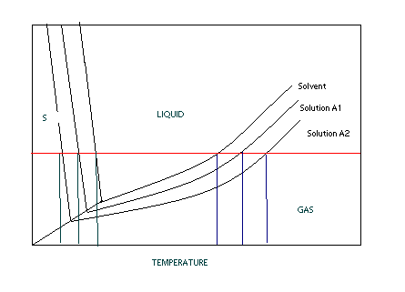

9) The following initial rate data are for the oxidation of arsenate ion by Cerium(IV) ion in aqueous solution:
AsO₃³⁻ + 2 Ce⁴⁺ + H₂O AsO₄³⁻ + 2 Ce³⁺ + 2 H⁺
Experiment | [AsO₃³⁻]_{o}, M | [Ce⁴⁺]_{o}, M | Initial Rate, Ms⁻¹
1 | 4.57e-2 | 0.383 | 1.32E-05
2 | 9.14e-2 | 0.383 | 5.30E-05
3 | 4.57e-2 | 0.766 | 5.30E-05
4 | 9.14e-2 | 0.766 | 2.12E-04
From these data, the rate constant is

Rate = k* [AsO₃³⁻]²[Ce⁴⁺]²
=0.000212/(0.0914^2*0.766^2) | 0.04325

10) The reaction of mercury(II) chloride with oxalate ion
2 HgCl₂ + C₂O₄²⁻ 2 Cl⁻ + Hg₂Cl₂ + 2 CO₂
is first order in HgCl₂ and second order in C₂O₄²⁻. In an experiment to determine the rate law, the rate constant was determined to be 1.22e-2 M⁻²s⁻¹. Using this value for the rate constant, the RATE of the reaction when [HgCl₂] = 0.234 M and [C₂O₄²⁻] = 0.307 M would be
=1.22E-2*0.234*0.307^2 | 0.000269

- Consider the reaction
The average rate of consumption of Br⁻ is 1.3×10⁻⁴ M/s over the first two minutes. What is the average rate of formation of Br₂ during the same time interval?
Br2 = (3/5)* 1.3e-4 | 7.80E-05
12) The activation energy for the gas phase decomposition of dinitrogen pentoxide is 50.5 kJ.
N₂O₅ 2 NO₂ + 1/2 O₂
The rate constant at 300 K is 7.5e-4 /s. What is the Rate Constant at 320 K.

k₂= k₁/exp(E_{act}/R*(1/T₂-1/T₁)) k2 must be GREATER than k1 !
=(50.5/0.008314)*((1/320)-(1/300)) | -1.265435811
=7.5e-4/exp(-1.265) | 2.66E-03

13) The diagram below shows the total vapor pressure at 25C for a mixture of diethyl ether (b.p. 34.6°C) and ethyl alcohol (b.p. 78.3°C), as calculated from the vapor pressure curves of the individual substances?
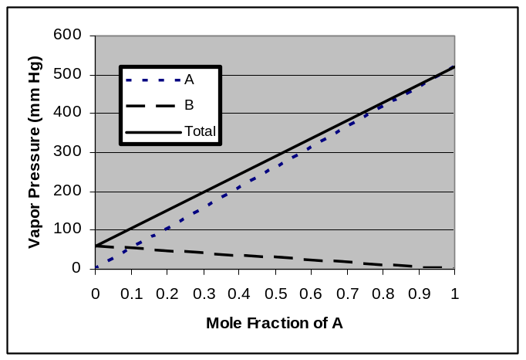
What are the vapor pressures for ethyl alcohol and diethyl ether at 25 C?
Ethyl alcohol (B line ) because higher BP (less volatile) VP= 60 torr
Diethyl ether (A line) because lower BP ( more volatile VP= 520 torr
What is the vapor pressure of ethyl alcohol at 78.3ºC
Vapor Pressure at the Boiling Point is the atmosphere pressure above it 760 torr
Extra Credit (2pointst: Why does the vapor pressure of the B line go down
As mole fraction of A increase mole fraction of B goes down so there is NO B at lower right thus no VP

14) Match the following aqueous solutions with the appropriate letter from the column on the right.

D___ 0.22 m AgNO₃ = 0.44 a) Lowest freezing point
B___ 0.18 m MnBr₂ = 0.54 b) Second lowest freezing point
C _ 0.17 m NiBr₂ = 0.51 c) Third lowest freezing point
A__ 0.57 m Sucrose (nonelectrolyte) = 0.57 d) Highest freezing point

MULTIPLE CHOICE SECTION ( 2x10 Points) DO ALL

1) Which of the following statements is/are false:
a) The rate of a typical reaction doubles with a 10° C rise in temperature.
b) The overall rate of reaction is determined by the rate of the fastest elementary step.
c) The reaction mechanism is a step-by-step pathway by which reaction occurs.
d) The reaction mechanism is typically a series of elementary reaction steps.
e) Reaction orders for a single elementary step are equal to the balancing coefficients for that step.

2) Based upon the Arrhenius equation, if one knows that an increase of 10ºC will double the rate of a reaction, one would thus know that a 10ºC decrease will:
- will also double the rate of the reaction
- will decrease the rate approximately by two
- will decrease the rate exactly by a factor of two
- will increase the rate by a factor of four

3) A reaction profile (not to scale!) for the reaction
O₃ + O 2 O₂ is shown below:
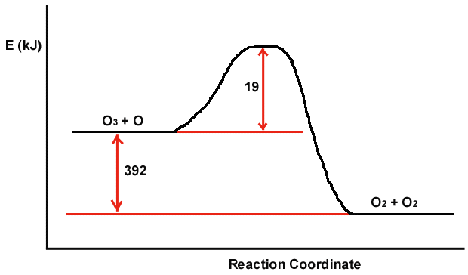
Which of the following are true?
a) The magnitude of E_{act} for the reverse reaction is larger than 19.0 kJ.
b) The energy of the products is lower than the energy of the reactants.
c) The value of H in the presence of a catalyst would be smaller than -392kJ
d) H is positive.
e) The value of E_{act} in the presence of a catalyst would be smaller than 19.0 kJ.

4) Which one of the following solutes has a limiting van't Hoff factor (i) of 4 when dissolved in water?
a) KNO₃ b) Na₃PO₄ c) HC₂H₃O₂ d) CH₃OH e) NaH₂PO₄

5) In which colligative properties does the value decrease as more solute is added?
a) The vapor pressure of the solvent when a nonvolatile solute is added.
b) The vapor pressure of the solvent when a volatile solute is added
c) Boiling point
d) Freezing point
e) Osmotic pressure
f) Solubility of the gas above the solution

6) In the Convertion of Molarity to Molality, in addition to the unit molarity of the solution, one ADDITIONALLY needs:
  - the molecular weight the solute and the density of the solution
  - the molecular weight of the solvent and the density of the solvent
  - the volume and number of moles of solvent
  - the number of grams of solute and specific heat of the solvent
  - the volume and molecular weight of the solvent
  - the mole fraction of the solute

7) Which of the following forms of concentration would be influenced by Temperature?
- Molarity b) Molality
- Mole Fraction d) PPM
e) Weight Percent f) Volume Percent

8) In ANY reaction with a defined E_{act}, an increase in the temperature/energy of the reactants will result the number of molecules with energies greater than E_{act} will
a) increase linearly b) increase exponentially
c) decrease exponentially d) will have no effect.

9) Identify the INCORRECT statement below regarding chemical equilibrium:
a) All chemical reactions are, in principle, reversible.
b) Equilibrium is achieved when the forward reaction rate equals the reverse reaction rate.
c) Equilibrium is achieved when the concentration of species become constant.
d) Equilibrium is achieved when the reaction quotient Q equals the equilibrium constant.
e) Equilibrium is achieved when the reactant and product concentrations become equal.

10) Three beakers are placed in a sealable container. Beaker A is filled with 100 mL of pure water, beaker B is filled with 100 mL of 1 molal potassium nitrate and beaker C is filled with 100 mL of 1 molal sugar. The container is sealed for several days and then reopened to the discovery that the three beakers no longer contain equal volumes. What would you predict to be the relationship of the volumes in beakers A, B, and C? (Write Order with inequality symbols between) AND EXPLAIN WHY!!
B>C>A

Extra Credit: When will this process come to an equilibrium (5pts)

TRUE AND FALSE WITH EXPLANATION 2x15 =30pt +2s

1)The Enthalpy of dissolution of many solids is actually Endothermic (positive) because the sum of solvation/hydration processes is greater than those associated with disruption/breaking of inter and intra-bonds.
False, the sum would need to be less for the overall enthalpy to be positive.

2) If two volatile solvents are mixed together, the resulting TOTAL vapor pressure is always greater than the individual vapor pressures for the PURE solvents. (True or False AND Explain Answer)
VP(total) = X_{A}P_{A}⁰ + X_{B}P_{B}⁰
X_{A} and X_{B} are less than one thus the total pressure is never greater than the most volatile solvent

3) The driving force largely responsible for the dissolution of nonvolatile SOLIDS(such as salts) into Solutions is Enthalpy. (True or False AND Explain Answer)
The Driving force for MOST solids is ENTROPY since these reactions are often ENDOTHERMIC

4) The equilibrium of reaction is reached when the rate constant for the forward reaction is equal to the
Rate constant for the backward reaction.

False, it’s when the Rate of the Forward reaction = Rate of the Back Reaction

5) The Temperature dependence of the solubility of GASES in solvents is largely due to Entropy. (True or False AND Explain Answer)
The Entropy of the gas before and after dissolution are very similar if no negative. Most gases are EXOTHERMIC, release heat when dissolved since the gas molecules are now solvated and lower in energy

6) Using Raoult’s law, doubling the mass of a non-volatile solute introduced into a solvent will half the partial pressure of the solvent (True or False AND Explain Answer)
Raoult’s law works in mole fraction of the SOLVENT! Doubling the mass and mole fraction of the solute does not Half mole fraction of the solvent and thus does not half the vapor pressure

7) The fraction of molecules with energies greater than the Enthalpy ΔH of a reaction are responsible for the Arrhenius Relationship of Rate with temperature? (True or False AND Explain Answer)

The fraction of the molecules with energies greater than the Activation Energy E_{ac}t are responsible.

8) The boiling point of a liquid is that temperature at which the vapor pressure equals the opposing head pressure?

True, this is why the boiling point temperature varies with atmospheric pressure

9) One of the common threads behind colligative properties is that both the solute and solvent play active roles in the chemical process.
True, this is why such properties utilize concentration factors that include both solute and solvent

NaCl is the most soluble = salts form very strong ionic interactions with the solvent water
Ar is the least soluble = very very small interactions/stabilization between inert gas and water

10) The Osmotic Pressure is the result of solute molecules pushing on the semi-permeable membrane in an osmotic cell. (True or False AND Explain Answer)

Solute molecules are not directly responsible for effect. The pressure is due to the water molecules trying to dilute the solute molecules by moving across the membrane

11) The Entropy of a reaction must be positive AND the Enthalpy must be negative for any reaction to take place on it’s own (so-called spontaneous)

False, the Free energy = H-TS must be negative only

12) Knowing the mass of the solute is adequate to access the proportional Osmotic Pressure of two solutions once corrected for the van’t Hoff factor. (True or False AND Explain Answer)

Osmotic pressure is related to the MOLARITY and NOT the MASS. There is only a one to one relationship if one is looking at the SAME chemical!

13) A Catalysis in a reaction is responsible for reducing the Reaction Enthalpy of the Reaction thus allowing molecules to react more readily.
A Catalysis reduces the activation energy of the reaction and NOT the enthalpy

14) The half life for an reaction is always equal to the t _{½} =–0.693/k where k is the rate constant.
False, this is ONLY true for 1st order reactions.

15) The rate law for a reaction is not based upon the stoichiometry of the overall/net reaction, but rather based upon the stoichiometry of the rate-determining elementary step/reaction.

True, this slowest link in the chain is responsible for the difference.

16) The rate of a reaction is reduced when the temperature is reduced. Irrespective of the activation energy of the reaction.

True, this is the principle of the Arrhenius relationship

EXTRA CREDIT (5 points)
Henry’s law tells us that the solubility of a gas increases with the pressure of that gas above it. Assuming that air is simply a 4::1 ratio of N₂ ::O₂ (80%/20% by Volume) at one atmosphere. What would need to be the ratio of N₂ to O₂ in a compressed air tank so as to maintain the SAME ABSORPTION of N₂ in the blood (water) at 5 atmosphere?

[N₂](one atmosphere in blood water = Sg(N₂) * 0.8*(@1 atmosphere) to keep same then
[N₂](one atmosphere in blood water = Sg(N₂) * x*(@5 atmosphere)
5x * Sg = 0.8 Sg ; x= 0.8/5 = 0.16 ➔ 16% N₂ leaving 84% for O2

