CHEMISTRY 102 KEY EXAM 1
NAME: PRINT _______________________________ Sign ______________________________

FREE RESPONSE SECTION

1) The gas phase decomposition of dimethyl ether at 500 ºC
CH₃OCH₃ CH₄ + H₂ + CO
is first order in CH₃OCH₃ with a rate constant of 4.00e-4 s⁻¹. If the initial concentration of CH₃OCH₃ is 7.41e-2 M, what will the concentration of CH₃OCH₃ be after 3129 seconds have passed.
ln a = -4.e-4*3129+ln(7.41e-2)= | -3.85
a = exp(-3.85)= | 0.0213

2) An aqueous solution is 6.00% by mass ethanol, CH₃CH₂OH, and has a density of 0.988 g/mL.
The Molality of Ethanol in the solution is

=(6.00g/46)/0.094kg | 1.39m

3) In a laboratory experiment, students synthesized a new compound and found that when 12.80 grams of the compound were dissolved to make 274.5 mL of a chloroform solution, the osmotic pressure generated was 2.95 atm at 298 K. The compound was also found to be nonvolatile and a non-electrolyte.
What is the molecular weight they determined for this compound?
=12.8*0.0821*298/(2.95*0.2745)= | 386.7

4) The common laboratory solvent benzene is often used to purify substances dissolved in it. The vapor pressure of benzene, C₆H₆ (78.12 g/mol) , is 73.03 mm Hg at 25ºC. In a laboratory experiment, students synthesized a new compound and found that when 16.17 grams of the compound were dissolved in 287.7 grams of benzene, the vapor pressure of the solution was 71.93 mm Hg. The compound was also found to be nonvolatile and a non-electrolyte. What is the molecular weight of this compound?
xa= 71.93/73.03 = 0.9849
0.9849 = (287.7/78.12)/[ (287.12/78.12)+ (16.17/x)]
x=288.4

5) If the reaction 2A + 3D --> C + 2B products is second-order in A and first-order in D, then the Rate Law will have the form

Rate = k [A]²[D]
6) The boiling point of benzene C₆H₆ is 80.10⁰C at 1 atmosphere. In a laboratory experiment, students synthesized a new compound and found that when 11.30 grams of the compound were dissolved in 298.0 grams of benzene, the solution began to boil at 80.52⁰C. The compound was also found to be nonvolatile and a non-electrolyte. What is the molecular weight they determined for this compound?
K_{f} (benzene)= 5.12; K_{b}(benzene)=2.53
0.42= 2.53 *(11.30/MW)/(0.298)
=11.3/(0.298*0.42/2.53) | MW=228.4

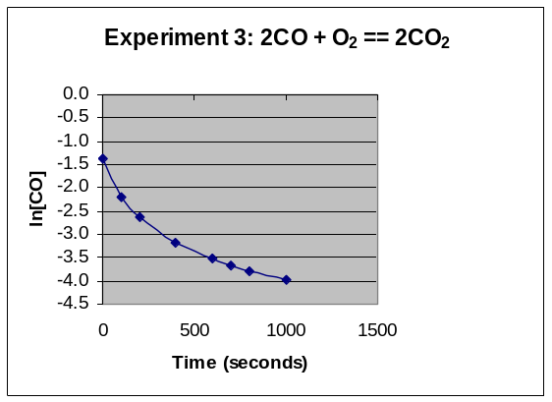

7) For Experiment 3; Explain the Order of the Reaction AND write an expression that defines the change in concentration of [CO] as a function of time.
1/[CO] = 0.05t + 1/0.25

Extra Credit (2pts) what would the graph look like for [O₂]?
[O₂] is zeroth order so [O₂] = [O₂]₀ – k’t
A straight line with negative slope for O₂ vs time
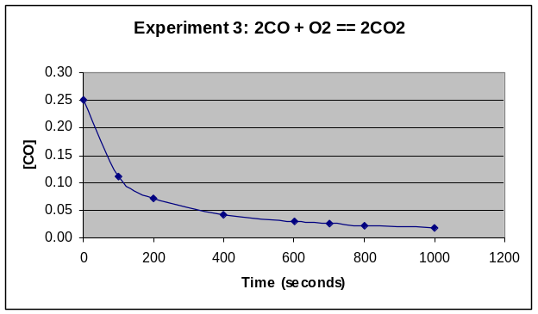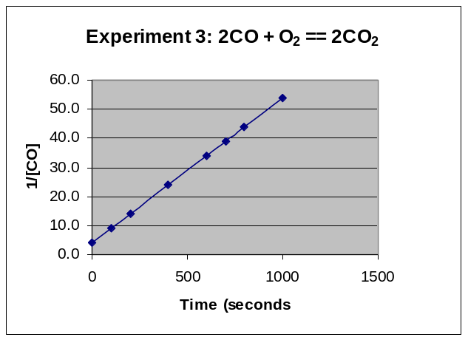

8) Draw a rough PHASE DIAGRAM to illustrate the changes of state of a Pure Solvent; and TWO additional Solutions with differing concentrations of soluble solute; thus showing THREE phase diagrams on same the graph to illustrate the effect of solute concentration on MP and BP of all three systems. Draw three phase diagram and slow how sequential inclusion of more and more solute will lower vapor pressure and thus shift BP higher and MP lower
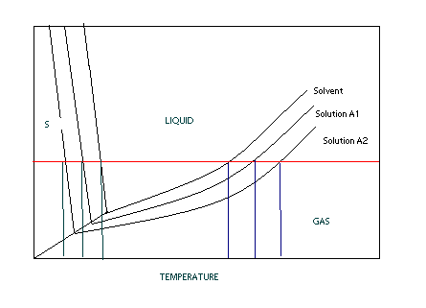
9) The following initial rate data are for the oxidation of arsenate ion by Cerium(IV) ion in aqueous solution:
AsO₃³⁻ + 2 Ce⁴⁺ + H₂O AsO₄³⁻ + 2 Ce³⁺ + 2 H⁺
Experiment | [AsO₃³⁻]_{o}, M | [Ce⁴⁺]_{o}, M | Initial Rate, Ms⁻¹
1 | 4.57e-2 | 0.383 | 3.57e-3
2 | 9.14e-2 | 0.383 | 7.13e-3
3 | 4.57e-2 | 0.766 | 1.43e-2
4 | 9.14e-2 | 0.766 | 2.85e-2
From these data, the rate constant is

Rate = k* [AsO₃³⁻][Ce⁴⁺]²
=0.0285/(0.0914*0.766^2)= | 0.531424

10) The reaction of mercury(II) chloride with oxalate ion
2 HgCl₂ + C₂O₄²⁻ 2 Cl⁻ + Hg₂Cl₂ + 2 CO₂
is first order in HgCl₂ and second order in C₂O₄²⁻. In an experiment to determine the rate law, the rate constant was determined to be 1.22e-2 M⁻²s⁻¹. Using this value for the rate constant, the RATE of the reaction when [HgCl₂] = 0.234 M and [C₂O₄²⁻] = 0.307 M would be
=0.0122E-2*0.234*0.307^2 | 0.000269

11) The gas phase decomposition of nitrogen dioxide at 383 ºC
2 NO₂ 2 NO + O₂
is second order in NO₂. In one experiment, when the initial concentration of NO₂ was 0.425 M, the concentration of NO₂ dropped to 9.39e-2 M after 10.1 seconds had passed. Based on these data, the Rate Constant for the reaction is ?
k[NO₂]²
1/9.39e-2 = k(10.1) + 1/0.425
k= (1/9.39e-2-1/0.425)/10.1= |  |  | 0.821454

12) The activation energy for the gas phase decomposition of dinitrogen pentoxide is 103 kJ.
N₂O₅ 2 NO₂ + 1/2 O₂
The rate constant at 322 K is 7.72e-4 /s. What is the Rate Constant at 344 K.

k₂= k₁/exp(E_{act}/R*(1/T₂-1/T₁)) k2 must be GREATER than k1 !
k2 = 8.96 E-3

13) The diagram below shows the total vapor pressure at 25C for a mixture of diethyl ether (b.p. 34.6°C) and ethyl alcohol (b.p. 78.3°C), as calculated from the vapor pressure curves of the individual substances?
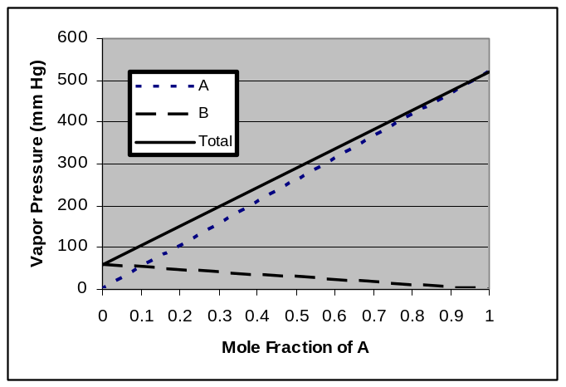
What are the vapor pressures for ethyl alcohol and diethyl ether at 25 C?
Ethyl alcohol (B line ) because higher BP (less volatile) VP= 60 torr
Diethyl ether (A line) because lower BP ( more volatile VP= 520 torr
What is the vapor pressure of ethyl alcohol at 78.3ºC
Vapor Pressure at the Boiling Point is the atmosphere pressure above it 760 torr
Extra Credit (2pointst: Why does the vapor pressure of the B line go down
As mole fraction of A increase mole fraction of B goes down so there is NO B at lower right thus no VP

14) Match the following aqueous solutions with the appropriate letter from the column on the right.

D___0.22 m AgNO₃ = 0.44 a) Lowest freezing point
B___0.18 m MnBr₂ = 0.54 b) Second lowest freezing point
C _0.17 m NiBr₂ = 0.51 c) Third lowest freezing point
A__0.57 m Sucrose (nonelectrolyte) = 0.57 d) Highest freezing point

MULTIPLE CHOICE SECTION ( 2 Points Each) DO ALL
1) Three beakers are placed in a sealable container. Beaker A is filled with 100 mL of pure water, beaker B is filled with 100 mL of 1 molal potassium nitrate and beaker C is filled with 100 mL of 1 molal sugar. The container is sealed for several days and then reopened to the discovery that the three beakers no longer contain equal volumes. What would you predict to be the relationship of the volumes in beakers A, B, and C? (Write Order with inequality symbols between)
B>C>A

2) Based upon the Arrhenius equation, if one knows that an increase of 10ºC will double the rate of a reaction, one would thus know that a 10ºC decrease will:
- will also double the rate of the reaction
- will decrease the rate approximately by two
- will decrease the rate exactly by a factor of two
- will increase the rate by a factor of four

3) A reaction profile (not to scale!) for the reaction
O₃ + O 2 O₂ is shown below:
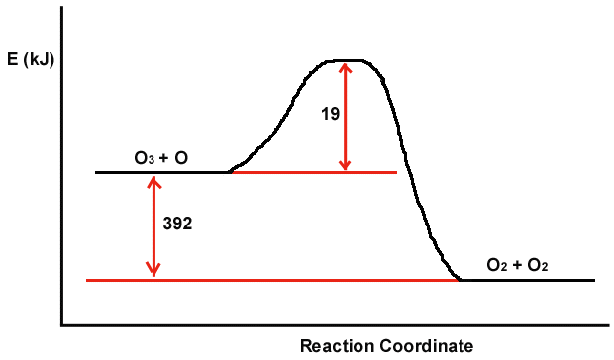
Which of the following are true?
a) The magnitude of E_{act} for the reverse reaction is larger than 19.0 kJ.
b) The energy of the products is lower than the energy of the reactants.
c) The value of H in the presence of a catalyst would be smaller than -392kJ
d) H is positive.
e) The value of E_{act} in the presence of a catalyst would be smaller than 19.0 kJ.

4) Which one of the following solutes has a limiting van't Hoff factor (i) of 4 when dissolved in water?
a) KNO₃ b) Na₃PO₄ c) HC₂H₃O₂ d) CH₃OH e) NaH₂PO₄

5) In which colligative properties does the value decrease as more solute is added?
a) The vapor pressure of the solvent when a nonvolatile solute is added.
b) The vapor pressure of the solvent when a volatile solute is added
c) Boiling point
d) Freezing point
e) Osmotic pressure
f) Solubility of the gas above the solution

6) In the Convertion of Molarity to Molality, in addition to the unit molarity of the solution, one ADDITIONALLY needs:
  - the molecular weight the solute and the density of the solution
  - the molecular weight of the solvent and the density of the solvent
  - the volume and number of moles of solvent
  - the number of grams of solute and specific heat of the solvent
  - the volume and molecular weight of the solvent
  - the mole fraction of the solute

7) Which of the following forms of concentration would be influenced by Temperature?
- Molarity b) Molality
- Mole Fraction d) PPM
e) Weight Percent f) Volume Percent

8) In ANY reaction with a defined E_{act}, an increase in the temperature/energy of the reactants will result the number of molecules with energies greater than E_{act} will
a) increase linearly b) increase exponentially
c) decrease exponentially d) will have no effect.

TRUE AND FALSE WITH EXPLANATION Choose ONLY FIVE
1) If two volatile solvents are mixed together, the resulting TOTAL vapor pressure is always greater than the individual vapor pressures for the PURE solvents. (True or False AND Explain Answer)
VP(total) = X_{A}P_{A}⁰ + X_{B}P_{B}⁰
X_{A} and X_{B} are less than one thus the total pressure is never greater than the most volatile solvent

2) The driving force largely responsible for the dissolution of nonvolatile SOLIDS(such as salts) into Solutions is Enthalpy. (True or False AND Explain Answer)
The Driving force for MOST solids is ENTROPY since these reactions are often ENDOTHERMIC

3) The Temperature dependence of the solubility of GASES in solvents is largely due to Entropy. (True or False AND Explain Answer)
The Entropy of the gas before and after dissolution are very similar if no negative. Most gases are EXOTHERMIC, release heat when dissolved since the gas molecules are now solvated and lower in energy

4) Using Raoult’s law, doubling the mass of a non-volatile solute introduced into a solvent will half the partial pressure of the solvent (True or False AND Explain Answer)
Raoult’s law works in mole fraction of the SOLVENT! Doubling the mass and mole fraction of the solute does not Half mole fraction of the solvent and thus does not half the vapor pressure

5) Which of the following substances would be the most AND least soluble in water?
N₂ Ar CH₄ NaCl PH₃ (Note which and explain WHY)

NaCl is the most soluble = salts form very strong ionic interactions with the solvent water
Ar is the least soluble = very very small interactions/stabilization between inert gas and water

6) The Osmotic Pressure is the result of solute molecules pushing on the semi-permeable membrane in an osmotic cell. (True or False AND Explain Answer)

Solute molecules are not directly responsible for effect. The pressure is due to the water molecules trying to dilute the solute molecules by moving across the membrane

7) The Osmotic Pressure is proportional to the mass of solute added to the solution once corrected for the van’t Hoff factor. (True or False AND Explain Answer)

Osmotic pressure is related to the MOLARITY and NOT the MASS. There is only a one to one relationship if one is looking at the SAME chemical!

EXTRA CREDIT (5 points)
Henry’s law tells us that the solubility of a gas increases with the pressure of that gas above it. Assuming that air is simply a 4::1 ratio of N₂ ::O₂ (80%/20% by Volume) at one atmosphere. What would need to be the ratio of N₂ to O₂ in a compressed air tank so as to maintain the SAME ABSORPTION of N₂ in the blood (water) at 5 atmosphere?

[N₂](one atmosphere in blood water = Sg(N₂) * 0.8*(@1 atmosphere) to keep same then
[N₂](one atmosphere in blood water = Sg(N₂) * x*(@5 atmosphere)
5x * Sg = 0.8 Sg ; x= 0.8/5 = 0.16 ➔ 16% N₂ leaving 84% for O2

