KEY EXAM 1 (Summer 2008)

FREE RESPONSE SECTION 5 points each DO ANY 13 = 65pts

1) Fill in missing words
Endothermic/Exothermic;Free Energy/Entropy/Enthalpy;increase/decrease;release/absorb

- The two main driving forces in nature are __Entropy_ and __Enthalpy__

- The driving force largely responsible for the dissolution of nonvolatile SOLIDS(such as salts) into Solutions is ENTROPY__ since these reactions are often Endothermic.

- The Temperature dependence associated with the solubility of GASES in solvents is largely due to Enthalpy_
- Since the Entropy_ of the gas before and after dissolution are very similar if no negative.
- The dissolving of most gases are Exothermic, thus release heat when dissolved since the gas molecules are now solvated and lower in energy.

2) What is the molar mass of a solid nonelectrolyte if 1.40g in 386 ml of solution has an osmotic pressure of 696 torr at 18 C

MW= gRT/PV
=1.4*0.0821*(273+18)/((696/760)*0.386) | 94.62

If the solid were actually a salt, would the MW be larger or smaller? MW= I*gRT/PV Larger since I would be a number greater than 1

3) If the reaction A + 2D --> C + 2B products is second order overall and first-order in A, then the Rate Law will have the form

Rate = k [A][D]
4) The solvent for an organic reaction is prepared by mixing 15.0 ml of acetone (C₃H₆O) with 45.0 ml of Ethyl Acetate (C₄H₈O₂). This mixture is stored at 23.0 C. The vapor pressure and the densities for the two pure components at 23.0 C are given in the following table. What is the vapor pressure of the stored mixture?
Compound | Vapor pressure  () | Density  ()
Acetone | 230.0 | 0.791
Ethyl acetate | 95.38 | 0.900

Acetone | =(15*0.791)/58.1 | 0.204216867 | moles
EA | =(45*0.9)/88.1 | 0.459704881 | moles
nt |  | 0.663921748
x(acetone)= | 0.308
x(EA)= | 0.692
Pt= | 136.79 | torr

5) An aqueous solution is 8.00% by mass ethanol, CH₃CH₂OH, and has a density of 0.978 g/mL.
The Molality and Molarity of Ethanol in the solution is

=(8.00g/46)/0.092kg 1.89 m

100grams of solution/0.978g/ml= 102.25 ml
0.102249 L
Molarity =(8/46)/0.102249 1.701 M

6) Henry’s law tells us that the solubility of a gas increases with the pressure of that gas above it. Assuming that air is simply a 4::1 ratio of N₂ ::O₂ (80%/20% by Volume) at one atmosphere. What would need to be the ratio of N₂ to O₂ in a compressed air tank so as to maintain the SAME ABSORPTION of N₂ in the blood (water) at 5 atmosphere?

[N₂](one atmosphere in blood water = Sg(N₂) * 0.8*(@1 atmosphere) to keep same then
[N₂](one atmosphere in blood water = Sg(N₂) * x*(@5 atmosphere)
5x * Sg = 0.8 Sg ; x= 0.8/5 = 0.16 ➔ 16% N₂ leaving 84% for O2

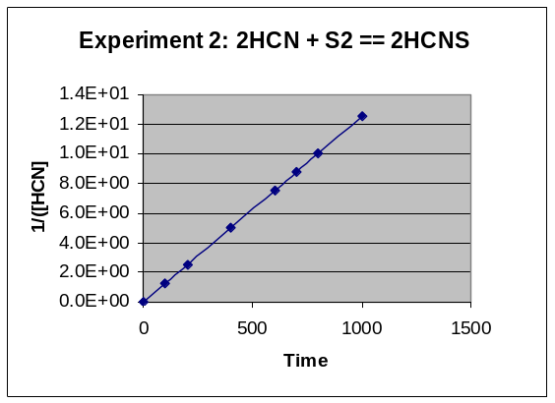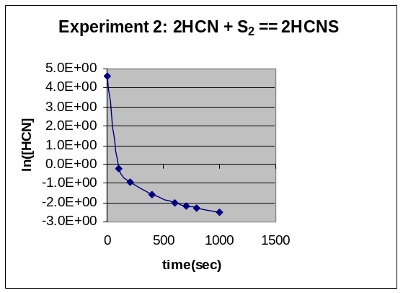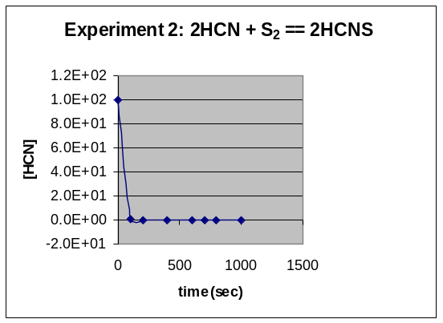
7) For Experiment 3; Explain the Order of the Reaction AND write an EQUATION/Function that defines the change in concentration of [HCN] as a function of time. Function should include the numeric values of the rate constant and the initial concentration

2nd Order
K=1.3E-02
A0=1.0E+02

1/[HCN] = 0.013t + 1/100

8) Three aqueous solutions containing sequentially multiple concentrations (say doubled) of a solute(molar mass=MW) are introduced. Write a general equation that would DEFINE each of their vapor pressures at a fixed temperature. Show how these would differ in their phase diagrams and explain how and why their boiling points would vary. Remember to comment on how Raoult’s Law and the Relationship between Vapor pressure and Boiling point are responsible for this phenomena.

Vapor Pressure above a solution is diminished by solute and proportional to the mole fraction of molecules of the volatile solvent at the surface. Each of the three would have diminished vapor pressure. x_{a}^{/(x}_{a}^{+x}_{H2O}^{) :: 2x}_{a}^{/(2x}_{a}^{+x}_{H2O}^{) :: 3x}_{a}^{/(3x}_{a}^{+x}_{H2O}^{) where ( x}_{a}^{= ( n}_{a}/MW ) ) This reduction in vapor pressure shifts/reduces the G/L interface line of the phase diagram and resultantly changes the boiling point and indirectly the melting point of the solution.
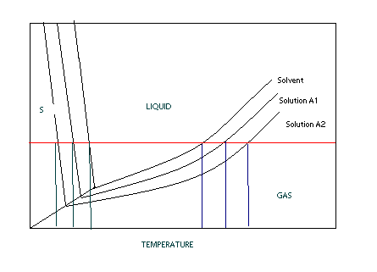

9) The following initial rate data are for the oxidation of Antimonate ion by Lanthinum(IV) ion in aqueous solution:
SbO₃³⁻ + 2 La⁴⁺ + H₂O SbO₄³⁻ + 2 La³⁺ + 2 H⁺
Experiment | [SbO₃³⁻]_{o}, M | [La⁴⁺]_{o}, M | Initial Rate, Ms⁻¹
1 | 0.0457 | 0.383 | 4.26E-05
2 | 0.0914 | 0.383 | 1.70E-04
3 | 0.0457 | 0.1915 | 2.13E-05
4 | 0.0914 | 0.766 | 3.41E-04
From these data, the rate constant is

Rate = k* [SbO₃³⁻]²[La⁴⁺]
=4.26e-5 /(0.0457^2*0.383) | 0.05325

10) The reaction of mercury(II) chloride with oxalate ion
2 HgCl₂ + C₂O₄²⁻ 2 Cl⁻ + Hg₂Cl₂ + 2 CO₂
is first order in HgCl₂ and second order in C₂O₄²⁻. In an experiment to determine the rate law, the rate constant was determined to be 1.22e-2 M⁻²s⁻¹. Using this value for the rate constant, the RATE of the reaction when [HgCl₂] = 0.370 M and [C₂O₄²⁻] = 1.307 M would be
=0.0122*0.37*1.307^2 | 0.007711

11) Consider the reaction
The average rate of consumption of Br⁻ is 3.1×10⁻² M/s over the first 6.3 minutes. What is the average rate of formation of Br₂ during the same time interval?
Br₂ = (3/5)* 3.1e-2 | 0.0186

12) The activation energy for the gas phase decomposition of Dinitrogen Pentoxide is 40.5 kJ.
2N₂O₅ 4 NO₂ + O₂
The rate constant at 25 ºC is 7.71e-4 /s. What is the Rate Constant at 53 ºC

k₂= k₁/exp(E_{act}/R*(1/T₂-1/T₁)) k2 must be GREATER than k1 !

=(40.5/0.008314)*((1/325)-(1/298)) | -1.358029306
=0.000771/EXP(-1.358) | 3.00E-03

13) The diagram below shows the total vapor pressure at 22C for a mixture of diethyl ether (b.p. 34.6°C) and propyl alcohol (b.p. 97.3°C), as calculated from the vapor pressure curves of the individual substances?
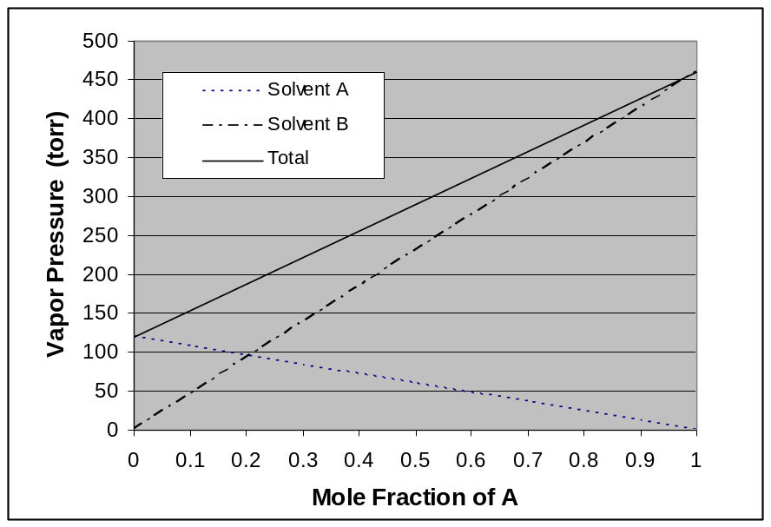
What are the vapor pressures for propyl alcohol and diethyl ether at 22 C?
Propyl alcohol (B line ) because higher BP (less volatile) VP= 125 torr
Diethyl ether (A line) because lower BP ( more volatile VP= 460 torr
What is the vapor pressure of propyl alcohol at 97.3ºC
Vapor Pressure at the Boiling Point is the atmosphere pressure above it 760 torr
Why does the vapor pressure of the B line go down
As mole fraction of A increase mole fraction of B goes down so there is NO B at lower right thus no VP
(Graph Legend was mislabeled. A and B should be interchanged, be generous with grading and give partial credit.)

MULTIPLE CHOICE SECTION ( 2x10 Points) =20pts

1) Which of the following statements is/are false:
a) The overall rate of reaction is determined by the rate of the fastest elementary step.
b) The reaction mechanism is a step-by-step pathway by which reaction occurs.
c The reaction mechanism is typically a series of elementary reaction steps.
d) The rate of a typical reaction doubles with a 10° C drop in temperature.
e) Reaction orders for a single elementary step are equal to the balancing coefficients for that step.
2) A reaction profile (not to scale!) for the reaction
O₃ + O 2 O₂ is shown below:
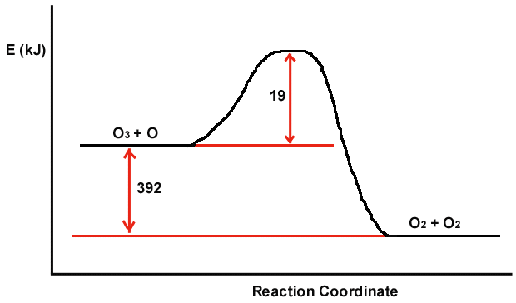
Which of the following are true?
a) The magnitude of E_{act} for the reverse reaction is smaller than 19.0 kJ.
b) The energy of the reactants is higher than the energy of the products.
c) The value of H in the presence of a catalyst would be smaller than 19.0kJ
d) H is positive.
e) The rate of the backward reaction is independent of the temperature of the reaction

3) Which is/are false regarding the properties of colloids?
a) Colloids are independent of gravitational forces
b) The energies translated by molecular collisions with neighboring solvent molecules is much greater than gravitational forces
c) Colloids will only settle if left undisturbed
d) Colloids are typically particles with dimensions between 1 millimeter and 1 micrometer
e) Einstein’s theory of relativity can be used to explain their properties.

4) Which one of the following solutes has a limiting van't Hoff factor (i) of five when dissolved in water?
a) KNO₃ b) Na₃PO₄ c) HC₂H₃O₂ d) CH₃OH e) Ca₃(PO₄)₂

5) In which colligative properties does the value DECREASE as more solute is added?
a) The boiling of the solution when a volatile solute is added
b) The vapor pressure of the solvent when a nonvolatile solute is added.
c) Boiling point
d) Freezing point
e) Osmotic pressure
f) Solubility of the gas solute into solution

6) In the Convertion of Molarity to Mole Fraction, in addition to the unit molarity of the solution, one ADDITIONALLY needs:
  - the molecular weight the solute and the density of the solution
  - the molecular weight of the solvent and the density of the solvent
  - the volume and number of moles of solvent
  - the number of grams of solute and specific heat of the solvent
  - the volume and molecular weight of the solvent
  - the molecular weight the solute as well as solvent and the density of the solution

7) Which of the following forms of concentration would be influenced by Temperature?
- Molarity b) Molality
- Volume Percent d) PPM
e) Weight Percent f) Mole Fraction

8) In ANY reaction with a defined E_{act}, an INCREASE in the temperature/energy of the reactants will result the number of molecules with energies greater than E_{act} will
a) increase linearly b) increase exponentially
c) decrease exponentially d) will have no effect.

9) Identify the INCORRECT statement below regarding chemical equilibrium:
a) All chemical reactions are, in principle, reversible.
b) Equilibrium is achieved when the forward reaction rate equals the reverse reaction rate.
c) Equilibrium is achieved when the concentration of species become constant.
d) Equilibrium is achieved when the reaction stops.
e) Equilibrium is achieved when the reactant and product concentrations become equal.

10) Three beakers are placed in a sealable container. Beaker A is filled with 100 mL of pure water, beaker B is filled with 100 mL of 1.5 molal potassium nitrate and beaker C is filled with 100 mL of 4 molal sugar. The container is sealed for several days and then reopened to the discovery that the three beakers no longer contain equal volumes. What would you predict to be the relationship of the volumes in beakers A, B, and C? (Write Order with inequality symbols between) AND EXPLAIN WHY!!
C>B>A

TRUE AND FALSE WITH EXPLANATION IF FALSE 2x15 =30pt

1) The fraction of molecules with energies greater than the Activation Energy E_{act} of a reaction are responsible for the Arrhenius Relationship of Rate with temperature?
TRUE

2) The addition of a Catalysis to a reaction results in reducing the initial reactant concentrations thus allowing the most energetic molecules to react more readily.
False, A Catalysis reduces the activation energy of the reaction and NOT the enthalpy

3) The boiling point of a ANY liquid is that temperature at which the vapor pressure equals the opposing head pressure?
True, this is why the boiling point temperature varies with atmospheric pressure

4) The driving force largely responsible for the dissolution of nonvolatile SOLIDS(such as salts) into Solutions is Enthalpy.
False, The Driving force for MOST solids is ENTROPY since these reactions are often ENDOTHERMIC

5) The half life for a Second Order reaction is always equal to the t _{½} =0.693/k where k is the rate constant.
False, this is ONLY true for 1st order reactions.

6) The rate of a reaction independent of temperature and only dependent on activation energy of the reaction.
False, the Arrenhius relationship tells us that both T and Ea influence the rate

7) The fact that the solubility of GASES in solvents decreases with increasing Temperature is largely due to Entropy. False, The Entropy of the gas before and after dissolution are very similar if not negative. Most gases are EXOTHERMIC, release heat when dissolved since the gas molecules are now solvated and lower in energy

8) The rate law for a reaction is not based upon the stoichiometry of the overall/net reaction, but rather based upon the stoichiometry of the rate-determining elementary step/reaction or fastest step in the reaction
False it is based on the RDS but that is the SLOWEST step.

9) The Osmotic Pressure is the result of solute molecules pushing on the semi-permeable membrane in an osmotic cell.
False, Solute molecules are not directly responsible for effect. The pressure is due to the water molecules trying to dilute the solute molecules by moving across the membrane

10) The equilibrium of reaction is reached when the Rate for the forward reaction is equal to the Rate constant for the backward reaction.
False, it’s when the Rate of the Forward reaction = Rate of the Back Reaction

11) If two volatile solvents are mixed together, the resulting partial vapor pressure of EACH of the solvents is greater than the individual vapor pressures for the PURE solvents. (True or False AND Explain Answer)
False: VP(each) = X_{each}P_{A}⁰
Because each solvent is diluted, the partial pressure is always less than that of the PURE volatile solvent

12) The Entropy of a reaction must be positive AND the Enthalpy must be negative for any reaction to take place on it’s own (so-called spontaneous)
False, the Free energy = H-TS must be negative only

13) Using Raoult’s law, doubling the mole fraction of a non-volatile solute introduced into a solvent will half the partial pressure of the solvent
False, vapor pressure of solvent is proportional to mole fraction of solvent NOT solute. Doubling solvent does not necessarily half solute!

14) Knowing the mass of the solute is adequate to access the proportional Osmotic Pressure of two solutions once corrected for the van’t Hoff factor.
False, Osmotic pressure is related to the MOLARITY and NOT the MASS. There is only a one to one relationship if one is looking at the SAME chemical!

15) One of the common threads behind colligative properties is that both the solute and vapor play active roles in the chemical process.
False, factors that include both solute and solvent not vapor

