KEY for EXAM 1 (Many of the Questions)

Four beakers are placed in a sealable container, and
Beaker A is filled with 100 mL of pure water
Beaker B is filled with 100 ml of 1 molal potassium chloride
Beaker C is filled with 100 mL of 1 molal calcium nitrate
Beaker D is filled with 100 mL of 1 molal albumine/sucrose(non-electrolyte)
The container is sealed for several days and then reopened to the discovery that the four beakers no longer contain equal volumes. What would you predict to be the relationship of the volumes in beakers A, B, C and D? Write Order with inequality symbols between: C>B>D>A

Match up the following solutes based upon their influence on Freezing Point Depression of Water
0.22 m AgNO₃ | a) Lowest freezing point | 0.44 | e
0.20 m Ammonium Sulfate (NH₄)₂SO₄ | b) Second lowest freezing point | 0.60 | a
0.16 m NiBr₂ | c) Third lowest freezing point | 0.48 | d
0.17 m H₂SO₄ | d) Fourth lowest freezing point | 0.51 | b
0.50 m Ethanol (nonelectrolyte) | e) Highest freezing point | 0.50 | c

Match up the following solutes based upon their influence on Freezing Point Depression of Water
0.12 m AgNO₃ | a) Lowest freezing point | 0.24 | e
0.19 m MnBr₂ | b) Second lowest freezing point | 0.57 | b
0.16 m NiBr₂ | c) Third lowest freezing point | 0.48 | d
0.17 m H₂SO₄ | d) Fourth lowest freezing point | 0.51 | c
0.58 m Albumin (nonelectrolyte) | e) Highest freezing point | 0.58 | a

Circle Appropriate Choice:
Dissolution of |  | Primary Driving Force |  | Solubility Increase with  Temperature If
Non-Volatile Solids  in Liquid Solvent |  | Enthalpy or Entropy |  | Endothermic or Exothermic
Gases in Liquid Solvent |  | Enthalpy or Entropy |  | Endothermic or Exothermic

Circle Appropriate Choice:
Dissolution of |  | Primary Driving Force |  | Solubility Decrease with  Temperature If
Non-Volatile Solids  in Liquid Solvent |  | Enthalpy or Entropy |  | Endothermic or Exothermic
Gases in Liquid Solvent |  | Enthalpy or Entropy |  | Endothermic or Exothermic

Circle Appropriate Choice:
Dissolution of |  | Primary Driving Force |  | Typically these reactions are:
Non-Volatile Solids  in Liquid Solvent |  | Enthalpy or Entropy |  | Endothermic or Exothermic
Gases in Liquid Solvent |  | Enthalpy or Entropy |  | Endothermic or Exothermic

The following initial rate data are for the oxidation of platinate ion by cerric ion in solution
PtO₃³⁻ + 2 Cr³⁺ + 2OH⁻ ➔ PtO₄³⁻ + 2 Cr²⁺ + H₂O

Experiment | [Cr⁺³]_{o}, M |  | [PtO₃³⁻]_{o}, M | Initial Rate, Ms⁻¹
1 | 1.0724 |  | 0.0914 | 1.55E-04
2 | 0.5362 |  | 0.0457 | 4.83E-06
3 | 0.5362 |  | 0.0914 | 1.93E-05
4 | 0.2681 |  | 0.0457 | 6.04E-07
k[PtO₃³⁻]² | [Cr⁺³]³
Rate Constant(k)= |  | 1.50E-02

The following initial rate data are for the oxidation of plumate ion by cerric ion in solution
PbO₃³⁻ + 2 Cr³⁺ + 2OH⁻ ➔ PbO₄³⁻ + 2 Cr²⁺ + H₂O

Experiment | [PbO₃³⁻]_{o}, M |  | [Cr⁺³]_{o}, M |  | Initial Rate, Ms⁻¹
1 | 0.0457 |  | 0.5362 |  | 4.83E-06
2 | 0.0914 |  | 0.5362 |  | 1.93E-05
3 | 0.0457 |  | 0.2681 |  | 6.04E-07
4 | 0.0914 |  | 1.0724 |  | 1.55E-04
k[PbO₃³⁻]² |  | [Cr⁺³]³
Rate Constant(k)= |  | 1.50E-02

a) Find the Rate Order for the reaction AND Rate Law for this reaction: 2H₂O₂ ➔ O₂ + 2H₂O
Using this, what is the TIME DEPENDENT Concentration of Hydrogen Peroxide?

m =20-5/(600) =15/600 = 0.025 =k
1/A0 =5.0 A0 = 0.2

1/[H₂O₂]= 0.025t+1/0.2

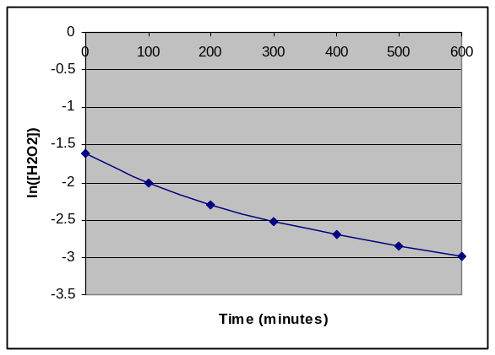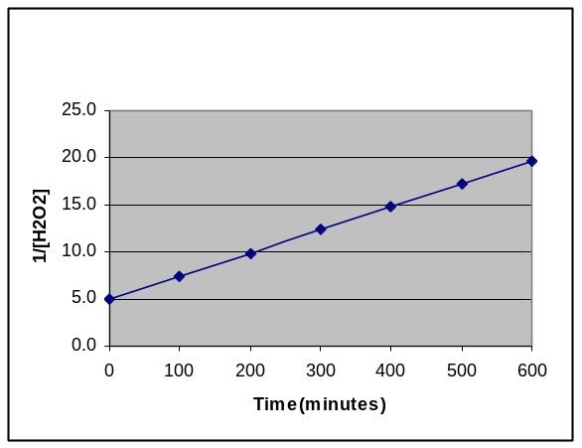
Vapor Pressure of a Solution of Benzene & Toluene at 25C

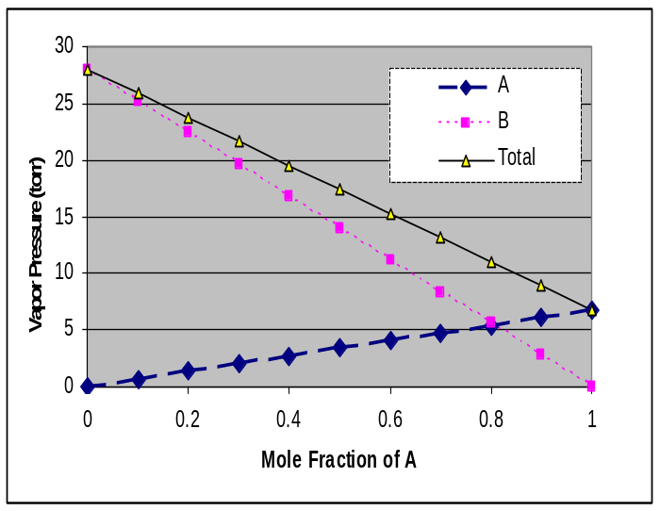

Using the below information(5pts total):
Benzene(MW= 78.11 ) BP 110.6 ºC
Toluene (MW= 92.14 ) BP 173.3 ºC

What are the vapor pressures for Benzene at 25ºC (4pts)
28 torr

What are the vapor pressures for Toluene at 25ºC (4pts)
7 torr

Which has the WEAKER intermolecular force? (2pts)
Benzene
Which has the STRONGER intermolecular force? (2pts)
Toluene

If equal masses of the two liquids are combined into a solution, what would be the Total Vapor Pressure? (4pts)

50grams of each
0.542 | n _{toluene} |  | x_{toluene}= | 0.458
0.640 | n _{benzene} |  |  | 0.541
1.182 | n _{total}
P_{t}= 7*0.459+28*0.541
P_{t}= | 18.37 | torr

The diagram below shows the total vapor pressure at 25C for a mixture of diethyl ether (b.p. 34.6°C) and ethyl alcohol (b.p. 78.3°C), as calculated from the vapor pressure curves of the individual substances?
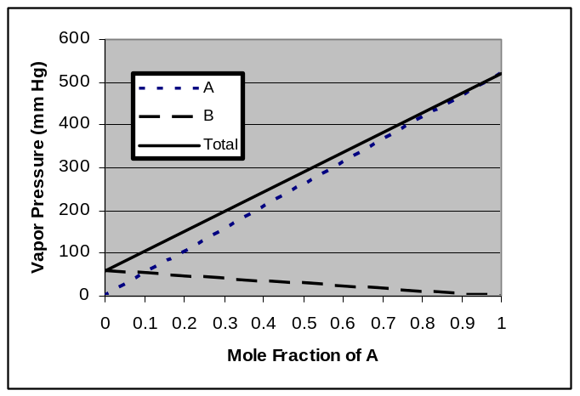
What are the vapor pressures for ethyl alcohol and diethyl ether at 25 C?
Ethyl alcohol (B line ) because higher BP (less volatile) VP= 60 torr
Diethyl ether (A line) because lower BP ( more volatile VP= 520 torr
What is the vapor pressure of ethyl alcohol at 78.3ºC
Vapor Pressure at the Boiling Point is the atmosphere pressure above it 760 torr
Why does the vapor pressure of the B line go down
As mole fraction of A increase mole fraction of B goes down so there is NO B at lower right thus no VP

Henry’s law tells us that the solubility of a gas increases with the pressure of that gas above it. Assuming that air is simply a 4::1 ratio of N₂ ::O₂ (80%/20% by Volume) at one atmosphere. What would need to be the partial pressure of N₂ in a compressed air tank so as to maintain the SAME ABSORPTION of N₂ in the blood (water) at 10 atmosphere?

Absorption dependent only on partial pressure of relevant gas thus P= 0.8/10 = 0.08 atm

Henry’s law tells us that the solubility of a gas increases with the pressure of that gas above it. Assuming that air is simply a 4::1 ratio of N₂ ::O₂ (80%/20% by Volume) at one atmosphere. What would need to be the partial pressure of N₂ in a compressed air tank so as to maintain the SAME ABSORPTION of N₂ in the blood (water) at 8 atmosphere?

Absorption dependent only on partial pressure of relevant gas thus P= 0.8/8 = 0.1atm
What is the molar mass of a non-electrolyte if 1.5grams in 350 ml of solution results in an osmotic pressure of 961 torr at 25 C

MW= gRT/(PV)
=1.5*0.0821*(25+273)/((961/760)*0.35)= 82.92

What is the molar mass of a non-electrolyte if 1.5grams in 350 ml of solution results in an osmotic pressure of 196 torr at 25 C

MW= gRT/(PV)
=1.5*0.0821*(25+273)/((196/760)*0.35)
406.57
5 grams of sodium chloride are added to 90 grams of water. What is the percent weight of salt? The density of solid salt is 1.25 g/cc and the final density of the above solution is found to be 1.0359g/ml. What is the volume of the solution before and after mixing the components? What is the molality and molarity of the solution?
5 grams of Salt(58.44) |  | 1.25 g/cc | 4 | ml | 94.0 ml total before mixing
95 grams of solution |  | 1.0359 | 91.71 | ml | After mixing
90 grams of water
Molality = | 0.0856 | moles/ | 0.09 | kg/water= | 0.951 | m
Molarity= | 0.0856 | moles/ | 0.0917 | L | 0.933 | M

10 grams of sodium chloride are added to 180 grams of water. What is the percent weight of salt? The density of solid salt is 1.25 g/cc and the final density of the above solution is found to be 1.0359g/ml. What is the volume of the solution before and after mixing the components? What is the molality and molarity of the solution?
10 grams of Salt(58.44) |  | 1.25 g/cc | 8 | ml | 94.0 ml total before mixing
190 grams of solution |  | 1.0359 | 183.4 | ml | After mixing
180 grams of water
Molality = | 2*0.0856 | moles/ | 2*0.09 | kg/water= | 0.951 | m
Molarity= | 2*0.0856 | moles/ | 2*0.0917 | L | 0.933 | M

The activation energy for the gas phase decomposition of dinitrogen pentoxide is 70.5 kJ.
N₂O₅ 2 NO₂ + 1/2 O₂
The rate constant at 320 K is 1.5e-2 sec⁻¹. What is the Rate Constant at 400 K.

k₂= k₁/exp(E_{act}/R*(1/T₂-1/T₁)) = 3.00 sec⁻¹

The activation energy for the gas phase decomposition of dinitrogen pentoxide is 50.5 kJ.
N₂O₅ 2 NO₂ + 1/2 O₂
The rate constant at 400 K is 1.5e-2 sec⁻¹. What is the Rate Constant at 320 K.

k₂= k₁/exp(E_{act}/R*(1/T₂-1/T₁)) = 3.37E-04 sec⁻¹

Given the following information for a first order reaction, what is the Activation Energy for this reaction? What can be said about the Enthalpy for this reaction?
k₁ (T=300K) ₌ | 2.12E-04 sec⁻¹
k₂ (T=400K) ₌ | 1.23E-02 sec⁻¹

E_{act} = R*ln(k₁/k₂)/ (1/T₂-1/T₁) = 40.5 kJ

Given the following information for a first order reaction, what is the Activation Energy for this reaction? What can be said about the Enthalpy for this reaction?
k₁ (T=300K) ₌ | 3.00e-3 sec⁻¹
k₂ (T=320K) ₌ | 1.20E-2 sec⁻¹

E_{act} = R*ln(k₁/k₂)/ (1/T₂-1/T₁) = 55.3 kJ

The solvent for an organic reaction is prepared by mixing 30.0 ml of acetone (C₃H₆O) with 40.0 ml of ethyl acetate (C₄H₈O₂). This mixture is stored at 28.0 C. The vapor pressure and the densities for the two pure components at 28.0 C are given in the following table. What is the vapor pressure of the stored mixture?
Compound | Vapor pressure  () | Density  ()
Acetone | 230.0 | 0.791
Ethyl acetate | 95.38 | 0.900

Acetone | =(30*0.791)/58.1 | 0.408 | moles
Ethyl Acetate | =(40*0.900)/88.1 | 0.409 | moles
n_{t} |  | 0.817
x(acetone)= | 0.500
x(EA)= | 0.500
Pt= | 162.7 | torr

The gas phase decomposition of dimethyl ether at 480 ºC
CH₃OCH₃ CH₄ + H₂ + CO
is first order in CH₃OCH₃ with a rate constant of 2.41x10⁻⁴ s⁻¹. If the initial concentration of CH₃OCH₃ is 741mM, what will the concentration of CH₃OCH₃ be after 921.7 seconds have passed.

= 0.741*EXP(-0.000241*921.7) | 0.593

The gas phase decomposition of dimethyl ether at 840 ºC
CH₃OCH₃ CH₄ + H₂ + CO
is first order in CH₃OCH₃ with a rate constant of 2.41x10⁻⁴ s⁻¹. If the initial concentration of CH₃OCH₃ is 741mM, what will the concentration of CH₃OCH₃ be after 129.7 seconds have passed.

= 0.741*EXP(-0.000241*129.7) | 0.718

The reaction of mercury(II) chloride with oxalate ion
2 HgCl₂ + C₂O₄²⁻ 2 Cl⁻ + Hg₂Cl₂ + 2 CO₂
is first order in HgCl₂ and second order in C₂O₄²⁻. In an experiment to determine the rate law, the rate constant was determined to be 1.22e-2 M⁻²s⁻¹. Using this value for the rate constant, the RATE of the reaction when [HgCl₂] = 0.234 M and [C₂O₄²⁻] = 0.307 M would be
=0.0122E-2*0.234*0.307^2 | 0.000269

Consider the reaction
The average rate of consumption of Br⁻ is 1.3×10⁻⁴ M/s over the first two minutes. What is the average rate of formation of Br₂ during the same time interval?
Br2 = (3/5)* 1.3e-4 | 7.80E-05

If the reaction A + 2E --> C + 2B products is first-order in A and first-order in E, then the Rate Law will have the form
Rate = k [A][E]

What does that tell us about the Rate Determining step?

Biomolecular and Possibly A+E ➔ ???

The half-life of radioactive ⁴⁵Ca is 162.7 days. How long would it take for 95% of 7microgram/cc of ⁴⁵Ca(NO₃)₂ to decay away?
 |  | 162.7days
t=ln2/k
k= ln2/t |  | 0.00426
t₉₅=-ln(0.05/k)= |  | 703.18 | days
1st order independent of Concentration

The half-life of radioactive ⁴⁵Ca is 162.7 days. How long would it take for 99% of 1microgram/cc of ⁴⁵CaCl₂ to decay away?
 |  | 162.7days
t=ln2/k
k= ln2/t |  | 0.00426
t₉₅=-ln(0.01)/k)= |  | 1081.0 | days
1st order independent of Concentration

In the Second Order Reaction the Initial concentration of reactant is 0.5M and decreases to 0.125 M in 125 microseconds. What is the rate constant for this reaction?

=1/0.125-1/0.5 | 6.0
k=6.0/0.000125= | 48000

In the Second Order Reaction the Initial concentration of reactant is 5.0M and decreases to 0.125 M in 250 microseconds. What is the rate constant for this reaction?

=1/0.125-1/5 | 7.8
k=7.8/0.000250= | 31200

What would need to be the PERCENT WEIGHT of Sodium Chloride( molar mass=58.44) in water to reduce the Freezing Point of water by 10oC ( ΔT=10K) ? (The Kf for water is 1.86)
10= 2* 1.86*(g/58.44)/1kg
g= 10*58.44/(2*1.86)= |  | 157.0968 |  | g
0.135768
13.57%

In ANY reaction with a defined E_{act}, an increase in the temperature/energy of the reactants will result the number of molecules with energies greater than E_{act} will
a) increase linearly b) increase exponentially
c) decrease exponentially d) will have no effect.

In which colligative properties does the value decrease as more solute is added?
- Freezing point
- The partial pressure of the solvent when a volatile solute is added.
- Osmotic pressure of the solution
- The vapor pressure of the solvent when a volatile solute is added
- Boiling point
- The vapor pressure of the solvent when a nonvolatile solute is added.

In the Convertion of Molarity to Molality, in addition to the unit molarity of the solution, one ADDITIONALLY needs:
  - the molecular weight of the solvent and the density of the solvent
  - the volume and number of moles of solvent
  - the number of grams of solute and specific heat of the solvent
  - the volume and molecular weight of the solvent
  - the mole fraction of the solute
  - the density of the solution and the molecular weight the solute.

Which of the following forms of concentration would NOT be influenced by Temperature?
- Molarity b) Molality
- Mole Fraction d) PPM
e) Weight Percent f) Volume Percent

Which of the following forms of concentration would be influenced by Temperature?
- Parts Per Million b) Molality
- Mole Fraction d) Molarity
e) Weight Percent f) Volume Percent

Which of the following statements is/are false:
a) The rate of a typical reaction doubles with a 10° C rise in temperature.
b) The overall rate of reaction is determined by the rate of the fastest elementary step.
c) The reaction mechanism is a step-by-step pathway by which reaction occurs.
d) The reaction mechanism is typically a series of elementary reaction steps.
e) Reaction orders for a single elementary step are equal to the balancing coefficients for that step.

Based upon the Arrhenius equation, if one knows that an increase of 10ºC will double the rate of a reaction, one would thus know that a 10ºC decrease will:
- will also double the rate of the reaction
- will decrease the rate approximately by two
- will decrease the rate exactly by a factor of two
d) will increase the rate by a factor of four

Which of the following statements is incorrect?
- The rates of two reactions can be equal at one temperature but differ at another.
- The rate does not depend on the magnitude of the Enthalpy.
- More molecules in a reaction will have energies above E_{act} as the temperature is decreased
- Activation energies of simple reactions can be negative.
- The lower the activation energy, the faster the rate if equal numbers of collisions are involved.

The driving force largely responsible for the dissolution of nonvolatile SOLIDS(such as salts) into Solutions is Enthalpy
FALSE: The Driving force for MOST solids is ENTROPY since these reactions are often ENDOTHERMIC

Which of the following statements is correct?
- More molecules in a reaction will have energies above E_{act} as the temperature is decreased
- Activation energies of simple reactions can be negative.
- The rates of two reactions can be equal at one temperature but differ at another.
- The rate does not depend on the magnitude of the Enthalpy.
- The lower the activation energy, the faster the rate if equal numbers of collisions are involved.

What is the osmotic pressure in atm produced by a 1.20 M glucose (C₆H₁₂O₆) solution at 25°C?

- 2.46 atm
- 20.4 atm
- 29.3 atm
- 0.163 atm
- 26.9 atm

1) In a reaction mechanism with many steps, that step with the highest Activation barrier is the rate determining step.
TRUE

The rate law for a reaction is not based upon the stoichiometry of the overall/net reaction, but rather based upon the stoichiometry of the fasted elementary step/reaction.
False, the slowest link in the chain/step is responsible for the difference.

The rate of a reaction is increased when the temperature is increased; irrespective of the activation energy of the reaction.
True, this is the principle of the Arrhenius relationship

Knowing the mass of the solute is adequate to access the Osmotic Pressure of any solutions once corrected for the van’t Hoff factor.
Osmotic pressure is related to the MOLARITY and NOT the MASS. There is only a one to one relationship if one is looking at the SAME chemical!

A Catalysis in a reaction is responsible for reducing the overall Enthalpy of the Reaction thus allowing molecules to react more readily.
False, A Catalysis reduces the activation energy of the reaction and NOT the enthalpy

One of the common threads behind colligative properties is that both the solute and solvent play active roles in the chemical process.
True, this is why such properties utilize concentration factors that include both solute and solvent

The Enthalpy of dissolution of many solids is actually Endothermic (positive) because the sum of solvation/hydration processes is greater than those associated with disruption/breaking of inter and intra-bonds.
False, the sum would need to be less for the overall enthalpy to be positive.

If two volatile solvents are mixed together, the resulting TOTAL vapor pressure is always greater than the individual vapor pressures for the PURE solvents. (True or False AND Explain Answer)
VP(total) = X_{A}P_{A}⁰ + X_{B}P_{B}⁰
X_{A} and X_{B} are less than one thus the total pressure is never greater than the most volatile solvent

The half life for all reactions is independent on the initial concentration by definition.
False, this is ONLY true for 1st order reactions.

The rate law for a reaction is not based upon the stoichiometry of the overall/net reaction, but rather based upon the stoichiometry of the fasted elementary step/reaction.
False, the slowest link in the chain/step is responsible for the difference.

The rate of a reaction is increasedwhen the temperature is increased; irrespective of the activation energy of the reaction.
True, this is the principle of the Arrhenius relationship

Using Raoult’s law, doubling the mass of a non-volatile solute introduced into a solvent will double the partial pressure of the solvent
Raoult’s law works in mole fraction of the SOLVENT! Doubling the mass and mole fraction of the solute does not Double or Half mole fraction of the solvent and thus does not half the vapor pressure

The fraction of molecules with energies greater than the Activation Energy of a reaction are responsible for the Arrhenius Relationship of Rate with temperature?
True The fraction of the molecules with energies greater than the Activation Energy E_{ac} are responsible.

One of the common threads behind colligative properties is that both the solute and solvent play active roles in the chemical process.
True, this is why such properties utilize concentration factors that include both solute and solvent

The Enthalpy of dissolution of many solids is actually Endothermic (positive) because the sum of solvation/hydration processes is greater than those associated with disruption/breaking of inter and intra-bonds.
False, the sum would need to be less for the overall enthalpy to be positive.

The Osmotic Pressure is the result of solute molecules pushing on the semi-permeable membrane in an osmotic cell
False, Solute molecules are not directly responsible for effect. The pressure is due to the water molecules trying to dilute the solute molecules by moving across the membrane

The Entropy of a reaction must be positive AND the Enthalpy must be negative for any reaction to take place on it’s own (so-called spontaneous)
False, the Free energy = H-TS must be negative only

