KEY for EXAM 3 CHEMISTRY 102 (April 4, 2007)

in
PART A FREE RESPONSE (5 points each)
1) Draw a reasonable titration curve for the reaction of 100 ml 0.02M Isophthalic acid (pK_{a}= 3.46) with 0.01M Barium hydroxide (assume totally soluble). Contrast this with the titration curve for a 0.2M Hydrochloric acid.

Note the three(3) important pH’s that help define the shape of this graph

pH= ½ (pKa-log(HA)) = 2.95
2.58

pH= pK_{a} –log( [HA]/[A])=pK_{a} 4.2
3.46

pH(salt)= 7+ ½ (pKa+log[A-] 8.1
8.2

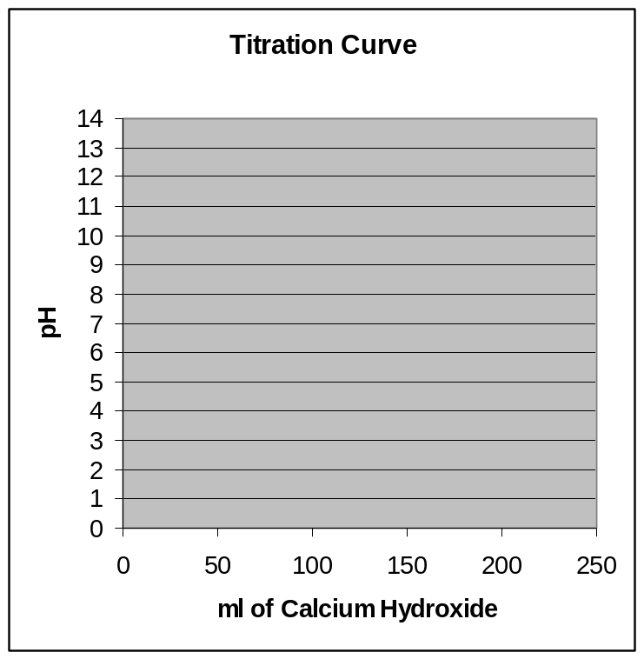

2) The Henderson Hasselbalch Equation: pH = pK_{a}+ log[A⁻ ]/[HA ]
When is this equation EXACT? AND when can it NOT be used?
EXACT when the concentrations of HA and A are known not approximated by original/starting concentrations
Can NOT be used when [HA] or [A] are near zero

3) If the pH of a solution of NaF is adjusted for pH. Using the fact that pK_{a}(HF) = 3.17; when is half of the total fluoride in the form of F⁻ and when is 75% of the total fluoride in the form of F⁻?
pH= pKa + log (0.5/0.5) = pKa = 3.17
pH = pKa + log(0.75/0.25) = 3.65

4) What is the Solubility in moles/L AND g/L of Ag₂CO₃ (K_{sp}=8.1x10⁻¹²; Molar Mass=275.74)
[Ag]²[CO₃]= (2x)²(x) = 4x3 = 8.1e-12
x= 1.27e-4 M or 1.27e-4*275.74 = 3.5e-2 g/L

5) Draw a reasonable titration curve for the reaction of 50 ml 0.01M Phosphoric Acid
with 0.01M sodium hydroxide (assume totally soluble). pK_{a}(1)= 2.15; pK_{a}(2)= 7.20; pK_{a}(3)= 12.35

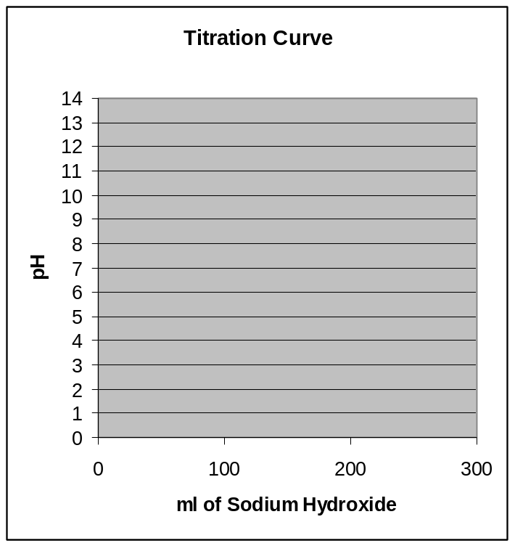
At a pH near 7 what are the most important/most relevant ions?

There are three buffer/flat areas in the titration profile. Since the acid and base are equal in molarity. It will take:
50ml to reach the first at pH=2.15 where [H₃PO₄]=[H₂PO₄]

100ml to reach the second at pH=7.20 where [H₂PO₄]=[HPO₄]

150ml to reach the third at pH=12.35 where [HPO₄]=[PO₄]

6-7) A saturated solution of Al(OH)₃ K_{sp}= 4.6 x 10⁻²¹ is prepared.
a)What would be the pH of this solution?
[Al ]{OH]³ = x (3x)³ =27x⁴= 4.6e-21
 | 27x⁴= 4.6e-21
x= | 3.61E-06
[OH]=3x= | 1.08E-05
pOH | 4.97
pH= | 9.03
b) If HCl were now added to this solution, what would happen to the solution? (TREND)
Shift to RIGHT (Remove OH)
c) If a solution of AlCl₃ where added to the solution what would happen to the solution (TREND)
Shift to LEFT (Common Ion Effect/ Add to Right pushes reaction to left)
d) If a solution of NH₃ which complexes with the Al ion were added; what would happen to the solution (TREND)
Shift to RIGHT (NH3 removes Al )

8) Describe how a pH Indicator works as it relates to acid/base dissociation. Give at least one example
HA + H₂O == A⁻ + H₃O⁺
IND + H₂O === IND ⁻ + H₃O⁺
Acid form and base form are different colors and shift near pK_{a}
9) What ARE the HYDROLYSIS REACTIONS for the SALT of a WEAK ACID and WEAK BASE? AND When a salt basic?
A- + H₂O == HA + OH- K_{h}(acid)
BH⁺ + H₂O === B + H3O+ K_{h}’(base)
Salt of weak acid/weak base is acidic when K_{h}’(base)> K_{h}(acid) which means K_{acid}>K_{base}
Salt of weak acid/weak base is basic when K_{h}’(base)< K_{h}(acid) which means K_{acid}<K_{base}

PART B ( Equivalence Point) (20 points)
a) What volume of a 0.219 M hydrochloric acid solution is required to titrate to equivalence 26.0 mL of a 0.125 M potassium hydroxide solution ? And what is the resulting pH
MV=MV
(0.219)*x = 0.125*0.026 x= 0.0148L ➔ 14.8ml
Strong Acid/Strong Base ==> No excess and Ions are Neutral pH=7
b) What volume of a 0.219 M sulfuric acid solution is required to titrate to equivalence 26.0 mL of a 0.125 M barium hydroxide solution ? And what is the resulting pH
MV=MV
2*(0.219)*x = 2* 0.125*0.026 x= 0.0148L ➔ 14.8ml
Strong Acid/Strong Base ==> No excess and Ions are Neutral pH=7
c) What volume of a 0.219 M nitric acid solution is required to titrate to equivalence 26.0 mL of a 0.125 M ammonium hydroxide (pK_{b}= 4.75) solution ? And what is the resulting pH
MV=MV
(0.219)*x = 0.125*0.026 x= 0.0148L ➔ 14.8ml
Strong Acid/WEAK base ==> No excess Acid/Base and BUT contains Salt of Weak Base (Acidic)
Molarity of NH₄⁺ = moles of NH₄/(Total Volume) = (0.026*0.125)/(0.0148+0.026) = 0.0797 M
pH= 7- ½ *(4.75+log(0.0797)) = 5.17
d) What volume of a 0.219 M nitrous acid (pKa=3.35) solution is required to titrate to equivalence 26.0 mL of a 0.125 M ammonia (pK_{b}= 4.75) solution ? And what is the resulting approximate pH
MV=MV
(0.219)*x = 0.125*0.026 x= 0.0148L ➔ 14.8ml
WEAK acid/WEAK base ==> No excess Acid/Base and BUT contains Salt of Weak Base/Weak Acid(??)
pK_{h}(NH₄⁺) = 14- 4.75 = 9.25 (STRONGER and thus WINS/dominates slightly thus solution is ACIDIC
pK_{h}(NO₂⁻) = 14 – 3.35 = 10.65
pH will be similar to above but slightly higher due to OH produced by hydrolysis of NO₂⁻

PART C Choose TEN(10) ONLY of 12 problems (5pts each) \
1) Each of the insoluble salts below are put into 0.10 M hydrochloric acid solution. Do you expect their solubility to be more, less, or about the same as in a pure water solution ?
Silver bromide AuBr SAME (HBr is a strong acid
Cupric hydroxide Cu(OH)₂ MORE Base reacts with acid
Aniline C₆H₇N: MORE Base reacts with acid
Potassium sulfite K₂SO₃ MORE Salt of weak acid is BASE which reacts with acid

2) When 25.0 mL of a 0.756 mM potassium hydroxide solution is combined with 22.0 mL of a 0.817 mM magnesium sulfate solution , what is the Reaction Quotient and does a precipitate form ?
Total Volume = 0.047L
Moles of OH = 0.025x0.756e-3 ➔ 3.82e-4M
Moles of Mg = 0.22x 0.817e-3 ➔ 6.02e-4M thus Q= (6.02e-4)*( 3.82e-4)² = 6.18e-11 > K_{sp}=5.1e-12
Will Precipate since Q>K_{sp}
3) The maximum amount of manganese(II) carbonate (K_{sp} = 1.8 x 10⁻¹¹) that will dissolve in a 0.182 M manganese(II) acetate solution (in molarity).
MnCO_{3(s)} == Mn⁺² + CO₃⁼ = 0.182 * x = K_{sp} = 1.8e-11 x= 9.9e-11

4) Classify each of the following substances:
4NH₃  3KOH  1H₂SO₄  5BaCl₂  2H₃PO₄ |  | 1) | strong acid
 |  | 2) | weak acid
 |  | 3) | strong base
 |  | 4) | weak base
 |  | 5) | salt: soluble
 |  | 6) | salt: not soluble
5) What is the pH of an aqueous solution of 0.547 M pyridine (a weak base with the formula C₅H₅N) pK_{b}= 8.79
BASE: pOH= ½(Kb-log(0.547) = 4.54 ➔ pH= 9.46

6) What is the pH of a 0.207 M aqueous solution of ammonium nitrate, NH₄NO₃ ? pK_{b}(NH₃)=4.75
SALT of WEAK BASE: pH= 7-1/2(pK_{b}+log(0.207)) = 4.97

7) Match the following Definitions of ACIDS:
 | Substance | ....... | Definition
E | Lewis base |  | A. Provides H⁺ in water
D | Bronsted-Lowry base |  | B. Provides OH ⁻ in water
A | Arrhenius acid |  | C. Proton donor
 |  |  | D. Proton acceptor
 |  |  | E. Electron pair donor
 |  |  | F. Electron pair acceptor

8) Calculate the concentration of HS⁻ in an aqueous solution of 0.052 M hydrosulfuric acid, H₂S (aq). K_{a1} = 1.00 x 10⁻⁷ ; K_{a2} = 1.00 x 10⁻¹⁹
H₂S + H₂O == HS⁻ + H₃O⁺
(0.052-x) x x
x²/0.052 = 1.0e-7 ➔ x= 7.21e-7M

9) Which of the following aqueous solutions are good buffer systems ?
0.24 M hydroiodic acid + 0.22 M potassium iodide | NO(strong acid)
0.31 M ammonia + 0.34 M amonium hydroxide | NO(both ammonia)
0.04 M potassium fluoride + 0.47 M hydrofluoric acid | NO(could be BUT KF too small
0.31 M ammonia + 0.34 M amonium chloride | YES
0.36 M potassium bromide + 0.26 M barium bromide | NO(both salts)
0.18 M hydrocyanic acid + 0.19 M sodium cyanide | YES

10) What is the pH of a solution contains 0.282 M ammonium iodide and 0.489 M ammonia. (pK_{b}(NH₃)= 4.75)
pH of BASE BUFFER: pOH= pKb - log ([B]/[BH+]) = 4.75 - log(0.489/0.282) = 4.51 ➔ pH= 9.49

11) An aqueous solution contains 0.31 M ammonium sulfate.
One Liter of this solution could be converted into a buffer by the addition of:…
(Assume that the volume remains constant as each substance is added.)
0.31 mol H₂SO₄ | No Reactions(Both Acids)
0.075 mol Ba(OH)2 | YES ( SB will convert 0.15M NH₄+ to NH₃
0.30 mol Ba SO₄ | No Buffer/salt
0.30 mol NH3 | YES (weak base/conjugate acid)
0.15 mol HNO3 | No Reactions(Both Acids)
12) A buffer solution contains 0.481 M nitrous acid and 0.314 M sodium nitrite. K_{a} = 4.50 x 10⁻⁴
If 0.0309 moles of sodium hydroxide are added to 150 ml of this buffer, what is the pH of the resulting solution? (Assume that the volume change does not change upon adding sodium hydroxide)
 | Initial |  |  | Final
HA(Nitrous Acid)= | 0.481 | M |  | =0.481-0.206 | 0.275
A-( Nitrite) | 0.314 | M |  | =0.481+0.206 | 0.687
NaOH=0.0309/0.15 |  | 0.206 | M
pH= pKa - log (0.275/0.520) |  | 3.35-log(0.275/0.520) = 3.62

PART D: Choose ONE of the two below: (10 points)
A buffer solution contains 0.392 M KHCO₃ and 0.232 M Na₂CO₃. Determine the pH change when 0.093 mol NaOH is added to 1.00 L of the buffer. ΔpH = pH _{after addition} − pH _{before addition}
Carbonic acid | H₂CO₃ | 4.2x10⁻⁷ | 4.8x10⁻¹¹
BUFFER for a WEAK ACID (2nd dissociation)
Initial: 0.392 M KHCO₃ [HA]and 0.232 M Na₂CO₃ [A-]
 | pH = pKa- log [HA]/A] = 10.32- log(0.392/0.232) |  |  |  | 10.09
Then you will lose 0.093 moles of HA and gain 0.093 moles of A
 | pH = pKa- log [HA]/A] = 10.32- log(0.392-0.093/0.232+0.093) |  |  |  | 10.36
 | Delta = 10.36-10.09 |  |  |  | 0.25

Equal volumes of 0.156 M aqueous solutions of acetylsalicylic acid (aspirin)[ HC₉H₇O₄]and sodium benzoate [NaC₆H₅COO] are mixed. What is the acetylsalicylate ion concentration once equilibrium is established?
HC₉H₇O₄ + H₂O |  | C₉H₇O₄⁻ + H₃O⁺ | K_{a} = 3.00e-4
C₆H₅COO⁻ + H₃O⁺ |  | C₆H₅COOH + H₂O | K_{c} = 1 / 6.30e-5

HC₉H₇O₄ + C₆H₅COO⁻ ⁼⁼⁼⁼ C₉H₇O₄⁻ ⁺ C₆H₅COOH K = K₁x K₂ = 4.760.
(0.156-x) (0.156-x) x x

x²/(0.156-x)² = 4.76 ➔ x= 0.107M = [C₉H₇O₄⁻]

