KEY FOR EXAM 3 CHEMISTRY 102 (April 5, 2007)

PART A FREE RESPONSE (5 points each)
1) Draw a reasonable titration curve for the reaction of 100 ml 0.02M Formic Acid (pK_{a}= 3.75) with 0.01M Calcium hydroxide (assume totally soluble). Contrast this with the titration curve for a 0.2M Hydrochloric acid.

Note the THREE(3) important pH’s that help define the shape of this graph
=0.5*(pKa-log(HA)) |  |  | pH= | 2.72
=pKa-LOG(HA/A)=pKa |  |  |  | 3.75
=7+0.5*(pKa+log(A-)) |  |  |  | 7.875

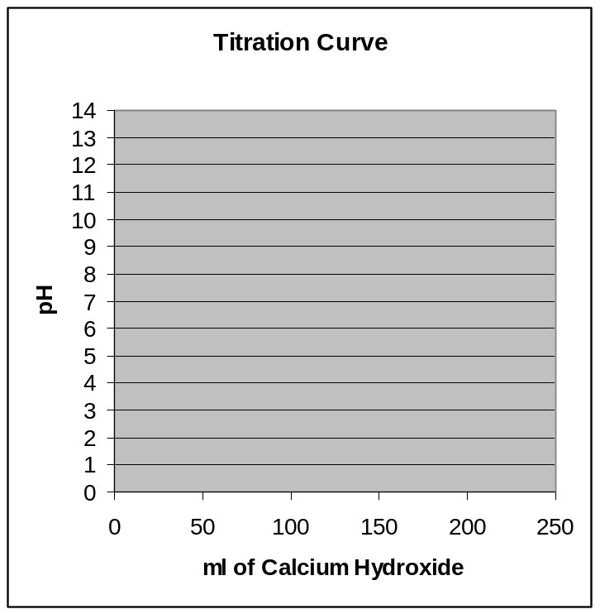

2) Draw a reasonable titration curve for the reaction of 50ml 0.01M Phosphoric Acid with 0.01M sodium hydroxide (assume totally soluble).
pKa(1)= 2.15; pKa(2)= 7.20; pKa(3)= 12.35

At a pH near 7 what are the most important/most relevant ions?

There are three buffer/flat areas in the titration profile. Since the acid and base are equal in molarity. It will take:
50ml to reach the first at pH=2.15 where [H₃PO₄]=[H₂PO₄]

100ml to reach the second at pH=7.20 where [H₂PO₄]=[HPO₄]

150ml to reach the third at pH=12.35 where [HPO₄]=[PO₄]

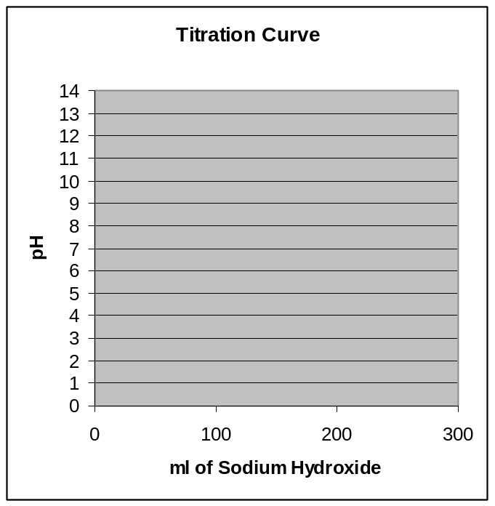

3) The Henderson Hasselbalch Equation: pH = pK_{a}+ log[A⁻ ]/[HA ]
Show the DERIVATION of this equation. AND When is this equation EXACT?
K_{a}= [H₃O⁺][A⁻ ]/[HA] ==== > Solve for H₃O⁺ = K_{a}*([HA]/[A-])
The Take negative log of both sides
-log(H₃O⁺ )= -log( K_{a}) -log([HA]/[A-])
pH= pKa -log([HA]/[A-])
Equation is EXACT when the true EQUILIBRIUM concentration of [HA] and [A-] are known; NOT approximated by the initial concentrations

4) If the pH of a solution of NaF is adjusted for pH. Using the fact that pK_{a}(HF) = 3.17; when is half of the total fluoride in the form of F⁻ and when is 75% of the total fluoride in the form of HF?
pH= pKa + log (0.5/0.5) = pKa = 3.17
pH = pKa + log(0.25/0.75) = 2.69

5) What is the Solubility in moles/L AND g/L of Ag₂CO₃ (K_{sp}=8.1e-6; Molar Mass=275.74)
K_{sp}(Ag₂CO₃ ) = [Ag +]²[CO₃⁼ ]
C-x (2x) x K_{sp}= 4x³ = 8.1e-6 x= 12.7mM * 275.74 ➔ 3.49g/L

6-7) A saturated solution of Cd(OH)₂ K_{sp}= 2.5 x 10⁻¹⁴ is prepared.
What would be the pH of this solution?
K_{sp}(Ag₂CO₃ ) = [Cd ₊+][OH⁻ ]²
C-x (x) 2x thus Ksp = (2x)²*x= 4x³ =8.1e-6 thus x = 1.844e-5
[OH-] = 2x = 3.688e-5 == pOH= 4.43 ➔ pH=9.57
If Acetic Acid were now added to this solution, what would happen to the solution? (TREND IN REACTION)
Acid will remove OH and pull/shift the reaction to the RIGHT
If a solution of CdCl₂ where added to the solution what would happen to the solution (TREND IN REACTION)
Cd is a common ion and will push/shift the reaction back to the LEFT
If a solution of NH₃ which complexes with the Cd ion were added; (TREND IN REACTION)
NH₃ will complex and remove Cd which will pull/sift the reaction to the RIGHT

8) Describe how a pH Indicator works as it relates to acid/base dissociation. Give at least one(1) example
Ind +H₂O == Ind- + H₃O⁺
^{Acid + H}₂^{O === Anion + H}₃^{O+}
The ACID and CONJUGATE BASES(Anions) of the Indicators are different colors. Thus they change color when they move across their pKa form acid side to base side. LITMUS is a good example: Blue Base/Red Acid
9) What ARE the HYDROLYSIS REACTIONS for the SALT of a WEAK ACID and WEAK BASE? AND When is such a salt acidic?
A- + H₂O == HA + OH- K_{h}(acid)
BH⁺ + H₂O === B + H3O+ K_{h}’(base)
Salt of weak acid/weak base is acidic when K_{h}’(base)> K_{h}(acid) which means K_{acid}>K_{base}

PART B ( Define Equivalence Point) (20 points)
a) What volume of a 0.125 M nitric acid solution is required to titrate to equivalence 26.0 mL of a 0.219 M potassium hydroxide solution ? And what is the resulting pH
MV=MV
0.125*x = 0.219*0.026
x= | 0.0456 | L | 45.6 ml
Strong Acid/Strong Base ==> No excess and Ions are Neutral pH=7
b) What volume of a 0.125 M nitric acid solution is required to titrate to equivalence 26.0 mL of a 0.219 M ammonium hydroxide (pK_{b}= 4.75) solution ? And what is the resulting pH
MV=MV
0.125*x = 0.219*0.026
x= | 0.0456 | L | 45.6 ml
Strong Acid/WEAK base ==> No excess Acid/Base and BUT contains Salt of Weak Base (Acidic)
Molarity of NH₄⁺ = moles of NH₄/(Total Volume) = (0.026*0.219)/(0.0456+0.026) = 0.0795M
pH= 7- ½ *(4.75+log(0.0795)) = 5.17
c) What volume of a 0.125 M nitrous acid (pK_{a}=3.35) solution is required to titrate to equivalence 26.0 mL of a 0.219 M ammonia (pK_{b}= 4.75) solution ? And what is the resulting approximate pH
MV=MV
0.125*x = 0.219*0.026
x= | 0.0456 | L | 45.6 ml
WEAK acid/WEAK base ==> No excess Acid/Base and BUT contains Salt of Weak Base/Weak Acid(??)
pK_{h}(NH₄⁺) = 14- 4.75 = 9.25 (STRONGER and thus WINS/dominates slightly thus solution is ACIDIC
pK_{h}(NO₂⁻) = 14 – 3.35 = 10.65
d) What volume of a 0.125 M sulfuric acid solution is required to titrate to equivalence 26.0 mL of a 0.219 M barium hydroxide solution ? And what is the resulting pH
MV=MV
2*0.125*x = 2*0.219*0.026
x= | 0.0456 | L | 45.6 ml
Strong Acid/Strong Base ==> No excess and Ions are Neutral pH=7

PART C Choose TEN(10) ONLY of 12 problems (5pts each)
1) What is the equilibrium concentration of cyanide ion in a saturated zinc cyanide (K_{sp} =8.0e-12) solution (in molarity)
K_{sp} = Zn(CN)₂ = x*(2x)² =4x³= 8.0 x 10⁻¹² thus x = 1.26e-4M BUT [CN⁻] = 2x = 2.52e-4M
2) Classify each of the following substances:
4NH₃  3KOH  2H₃PO₄  5HgCl₂  2H₂SO₃ |  | 1) | strong acid
 |  | 2) | weak acid
 |  | 3) | strong base
 |  | 4) | weak base
 |  | 5) | salt: soluble
 |  | 6) | salt: not soluble
3) What is the hydroxide ion concentration [OH⁻] AND pH of an aqueous solution of 0.400 M caffeine (a weak base with the formula C₈H₁₀N₄O₂) (K_{sp} = 3.5e-8) pK_{a}= 7.46
DISSOLUTION OF BASE B+H₂O ==BH +OH₋
C-x x x
x2/0.4= 3.5e-8 |  | x=[OH-] |  | 1.18E-04 | pOH= | 3.93 | pH= | 10.07
OR
pOH= 0.5*(pKb-log(B)) |  |  |  | 3.93 |  |  | pH= | 10.07

4) The substance acetylsalicylic acid (aspirin) (HC₉H₇O₄) is a weak acid (pK_{a} = 3.52).
What is the pH of a 0.286 M aqueous solution of potassium acetylsalicylate, KC₉H₇O₄?
Salt of a Weak Acid: pH= 7+ ½(pK_{a} +log[A-]) = 7+ 0.5*(3.52+log(0.286))= 8.4
5) Each of the insoluble salts below are put into 0.25 M hydrochloric acid solution. Do you expect their solubility to be more, less, or about the same as in a pure water solution ?
Silver Iodide AgI SAME (Neither Ion Hydrolyzes or Reacts with Acid
Nickel hydroxide Ni(OH)₂ MORE (Base Reacts with Acid)
Aniline hydrochloride C₆H₇NHCl MORE (Base Reacts with Acid)
Barium sulfite BaSO₃ MORE (Salt of WEAK ACID/Strong BASE)➔ Weak Acid is Basic ➔Reacts with Acid

6) When 18.0 mL of a 4.38e-4 M calcium acetate solution is combined with 18.0 mL of a 9.28e-4 M potassium fluoride solution does a precipitate form (K_{sp} (CaF₂) = 3.9e-11)?
Total Volume = 0.018+0.018=0.036L
[Ca⁺⁺] = 0.018*4.38e-4/0.036= 2.19E-04M; [[F⁻]= 0.018*9.28e-4/0.036= 4.64E-04M
K_{sp} (CaF₂)= 2.19E-04 * (4.64E-04)² =4.71E-11 > 3.9e-11 thus a small amount will precipitate.

7) Match the following Definitions:
F | Lewis acid |  | A. Provides H⁺ in water
D | Bronsted-Lowry base |  | B. Provides OH ⁻ in water
B | Arrhenius base |  | C. Proton donor
 |  |  | D. Proton acceptor
 |  |  | E. Electron pair donor
 |  |  | F. Electron pair acceptor

8) What is the pH of an aqueous solution of 0.0697 M hydrosulfuric acid, H₂S (aq) [pK_{a1} = 7;pK_{a2} = 19]
pH of a weak Acid (each proton comes off separately)
pH= ½ (pKa-log[HA]) = 0.5*(7-log(0.0697)) = 4.08
9) Which of the following aqueous solutions are good buffer systems ?
0.24 M hydroiodic acid + 0.22 M potassium bromide | NO:S.Acid
0.31 M ammonia + 0.34 M amonium chloride | YES(WeakBase/ConjAcid)
0.44 M potassium fluoride + 0.47 M hydrofluoric acid | YES(WeakAcid/ConjBase)
0.36 M potassium bromide + 0.26 M amonium bromide | NO(Salt S.A/SB)
0.18 M hydrocyanic acid + 0.19 M sodium bromide | NO(Salt S.A/SB)
10) What is the pH of a solution contains 0.489 M ammonium bromide and 0.282 M ammonia. (pK_{b}(NH₃)= 4.75)
BUFFER : NH₃+ H₂O == NH₄⁺ + OH⁻
[OH-] = K_{b}[NH₃]/[NH₄⁺] = (10^-4.75)* (0.282/0.489) = 1.03E-05 pOH=4.99 pH=9.01
Or
pOH= pK_{b}-log([NH₃]/[NH₄⁺]) = 4.75- (-0.239) = 4.99 ➔ pH=9.01
11) An aqueous solution contains 0.22 M potassium nitrite.
One Liter of this solution could be converted into a buffer by the addition of:…
(Assume that the volume remains constant as each substance is added.)
NEED NITRITE and NITROUS ACID of APPOXIMATELY EQUAL CONC.

0.21 mol HNO₂ | YES ( 0.21[HNO₂]+ 0.22[NO₂⁻] )
0.21 mol KBr | NO
0.22 mol HI | SHIFT TOO FAR TO HNO3
0.11 mol HI | CONVERT ½ of NO₂ to HNO₂
0.11 mol KOH | NO

12) A 21.8 mL sample of 0.374 M dimethylamine, (CH₃)₂NH, is titrated with 0.285 M nitric acid.
After adding 12.3 mL of nitric acid, what is the resulting pH? pK_{b}=5.1
B+ H₂O == BH +OH-
 | Initial |  | moles |  | M
B | 0.0081532 | ➔ | 0.004648 | B | 0.136296
HNO₃ | 0.0035055 | ➔ | 0.003506 | BH | 0.102801

 | OH= Kb* ([B]/[BH]) |  |  |  | Or
 | 1.0531E-05 |  |  |  |  | pOH= 5.1-log(0.00465/0.00351)
pOH | 4.98 |  |  |  |  | 4.98
pH= | 9.02 |  |  |  |  | 9.02

PART D: Choose ONE of the two below: (10 points)
A buffer solution contains 0.392 M KHCO₃ and 0.232 M Na₂CO₃. Determine the pH change when 93.0 millimoles of NaOH is added to 1.00 L of the buffer. [Carbonic acid pK_{a}(1)=6.38 pK_{a}(2)=10.32]
ΔpH = pH _{after addition} − pH _{before addition}
BUFFER for a WEAK ACID (2nd dissociation)
Initial: 0.392 M KHCO₃ [HA]and 0.232 M Na₂CO₃ [A-]
 | pH = pKa- log [HA]/A] = 10.32- log(0.392/0.232) |  |  |  | 10.09
Then you will lose 0.093 moles of HA and gain 0.093 moles of A
 | pH = pKa- log [HA]/A] = 10.32- log(0.392-0.093/0.232+0.093) |  |  |  | 10.36
 | Delta = 10.36-10.09 |  |  |  | 0.25

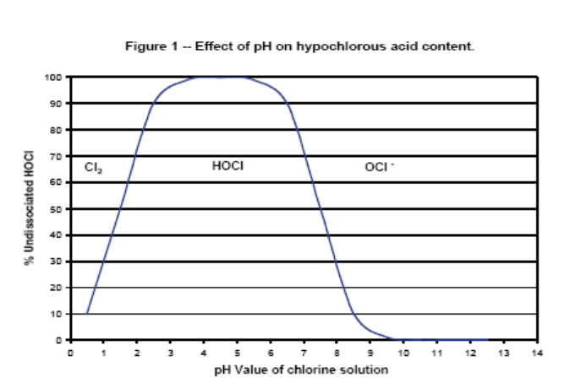

Adjacent is a commercial curve for the use of bleach as a disinfectant. The acid form is most effective in damaging cell walls(antimicrobial).
The recommended pH range for an effective and safe sanitizing solution is 6.5 to 7.5. Solutions with pH values lower than 6.0 are more corrosive; this will shorten the life of treated equipment. Solutions with pH values lower than 5.0 will begin to generate potentially harmful levels of chlorine gas, and solutions with pH values greater than 8.0 quickly lose their effectiveness as sanitizers.

Discuss IN DETAIL what chemical reactions are most-likely taking place based upon the above GRAPH and use it to interpret the pH recommendation noted above

HOCl + H₂O == H₃O⁺ OCl - pKa = 7.5 (?) Add Acid shift to LEFT Add Base Shift to Right

2HOCl + 2H₃O⁺ == Cl₂ + 4H₂O ➔ [Cl₂]/([HOCl]² [H₃O⁺]) = K_{eq} 1/((1)²*10-^{1.5}) = 10 ^{1.5} = 31.6

