TRUE OR FALSE and WHY!!

1) At 25°C and one atmosphere pressure, 4/5ths of the pressure of the atmosphere is due to N₂ and 1/5th is due to O₂. At 10 atmospheres, the partial pressure of O₂ would be approximately 8 atmospheres.
FALSE: (2 atmospheres)

2) Boiling is an exothermic process
FALSE Condensation is an exothermic Process

3) For non-polar molecules, the larger the molecule, the greater the induced dispersive intermolecular force between molecules and thus the lower the boiling point.
FALSE, the higher the boiling point.

4) As the attractive forces between molecules increases, the kinetic energy (Temperature) required to melt the materials increases.
TRUE.

5) In exothermic reactions, more bonds are always broken than are formed.
FALSE, related to the strengths of bonds not number.

6) In organic chemistry often oxidation result from the either hydrogen atoms be lost or oxygen atoms to be gained.
TRUE

7) When the pressure over a liquid is decreased, the boiling point of the liquid will remain the same
FALSE, the boiling point will always decrease

8) Industrially, Ammonia reacts with Carbon dioxide to generate urea, CO(NH₂)₂ for use as a fertilizer (Water is also a by-product):

NH₃(g) + CO₂(g)  CO(NH₂)₂(s) + H₂O(l) (not balanced)

- How many liters of CO₂ at STP would be needed to react with 751 L of NH₃?
- How many grams of urea would be generated?

 |  |  | n=PV/RT
751 | L of NH3 |  | 33.51 | moles
380.5 | L of CO2 |  | 16.98 | moles of CO2 and urea
MW(urea) | 60 |  | 1018.592 | grms of urea

9) What is the normal boiling point and the triple point of this substance?
Below what Pressure will the substance have no liquid state?
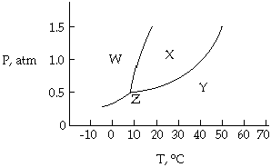
About 40C BP and a triple point at (0.5atm;10C) Below about 0.5 atm

10) Order the following molecules by their Boiling points (LOWEST(1) to HIGHEST(5))by defining most important type of intermolecular force?

 | Type of Intermolecular Force | Order 1 thru 5
C₅H₁₀ | Dispersive | 1
H₂O | Polar | 3
NaCl | Ionic | 5
CH₃COOH | Polar | 4
C₁₄H₃₀ | Dispersive | 2

11) Draw the hybridized orbital structure AND electrons for the following hypothetical molecule AND also note the ANGLES within the molecule.

CH₃-N=N-CH=C=O
sp3 – sp2 –sp2- sp2 – sp-sp2
(109.5)-(120)-(120)-(120)-(180)-(120)
12) The ideal gas equation predicts at constant temperature that a plot of the pressure times the volume of a gas versus the pressure of this gas should be a horizontal straight line as a function of n. When these quantities are graphed for both CO₂ and N₂ however, we find that PV dips below the theoretical straight line (FAR BELOW FOR CO₂ ) at first. What might could explain this behavior and WHY CO2 might CO₂actually go farther below the theoretical value than nitrogen gas ! YOU MUST BE SPECIFIC TO GET CREDIT!!
HINT: (P + n²a/V²)(V - nb) = nRT for Semi-Empirical Model for Real Gas
The value of “a” for CO₂ [3.640] is nearly 4 times that for N₂ [0.975]
The attractive force of the molecules as “a” in the Real Gas equation will decrease the effective pressure and CO₂ has a larger dispersive force than N₂
This allows CO₂ to be compressed fairly easily without dramatically increasing the pressur.
13) The Cyanate ion, NCO⁻, has the least electronegative atom, C, in the center.
HOWEVER, The very unstable Fulminate ion, CNO⁻, has the same formula, but the N atom is in the center.
  - Draw the three possible resonance structures of CNO⁻.
  - On the basis of formal charges, decide on the most stable resonance structure.
  - Mercury fulminate is so unstable it is used in blasting caps. Can you offer an explanation for this instability?
(HINT: Are the formal charges in any structure reasonable?)

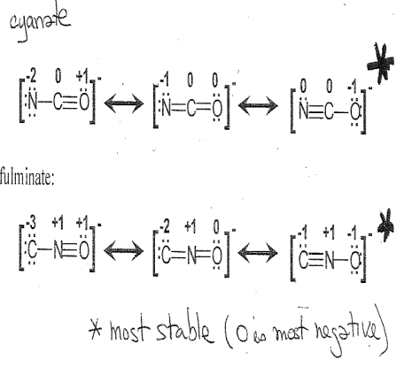
Structure C has formal charge -1 on oxygen atom
Structure B has formal charge -1 on nitrogen atom
Structure A has formal charge -2 on nitrogen atom and+1 on oxygen atom.
The charge of the fulminate ion is -1.
Negative charge on highly electronegative atom is more stable than negative charge on less electronegative atom.
Positive charge on less electronegative atom is more stable than positive charge on more electronegative atom is less stable.
we know that Oxygen is more electronegative than Nitrogen.
Therefore the structures B and C are less stable than A.
So, A is the preferred structure for the fulminate ion.

13) A metal reacts with acid to form hydrogen gas as shown by the following equation.
M(s) + 2 H⁺(aq) ➝ M²⁺(aq) + H₂(g)
What is the ATOMIC WEIGHT and IDENTIFY this metal if 3.49 grams of the metal generates enough hydrogen collected over water to fill a bottle with a volume of 2.20 L at 25°C and 1.00 atmosphere pressure under conditions where the vapor pressure of the solution is 23.8 torr?

736.2 | torr subtract 23.8 Water from 760 total
0.968684 | atm
n=PV/RT
=0.9687*2.2/(0.0821*298)
0.087107 | moles
#g/#moles=MW
=3.49/0.087107
40.06567 | =MW
Possibly CO₂

15) Using Hess’s Law and the below average bond enthalpies, show how the Oxidation of Methanol to Formic Acid and Water can be derived from the NET equation AND from Sequential Oxidation (sum of steps) SHOW ALL EQUATIONS AND STEPS AND ENTHALPIES!!
Methanol |  |  | 2 CH₃OH |  |  | -2 |  | + O₂ |  | 0=>-2 | ==> |  | 2 H₂C=O |  |  | 0 |  | + 2 H₂O
Formaldehyde |  |  | 2 H₂C=O |  |  | 0 |  | + O₂ |  | 0=>-2 | ==> |  | 2 HCOOH |  |  | +2
 | CH3OH |  |  |  | O2 |  |  |  | CH2O |  |  |  |  | H2O
 | 3CH | 413 |  |  |  |  |  |  | 2CH |  |  | 413 |  | 2OH | 463
 | C-O | 358 |  |  |  |  |  |  | C=O |  |  | 614
 | OH | 463
 |  | 2060 |  |  | 495 |  |  |  |  |  |  | 1440 |  |  | 926
ΔH₁ | 2CH3OH+O2==2H2CO+2H2O |  |  |  |  |  | 117 |  | But really negative
 | HCOOH
 | CH | 413
 | C=O | 614
 | C-O | 358
 | OH | 463
 |  | 1848
ΔH₂ | 2H2CO+O2==2HCOOH |  |  |  |  |  | 321 |  | But really negative
NET REACTION
ΔH_{net} | 2CH3OH+2O2==2HCOOH+2H2O |  |  |  |  |  | 438 |  | But really negative
 |  |  |  |  |  |  | which is the same as 321+117 (ΔH1+ΔH2)

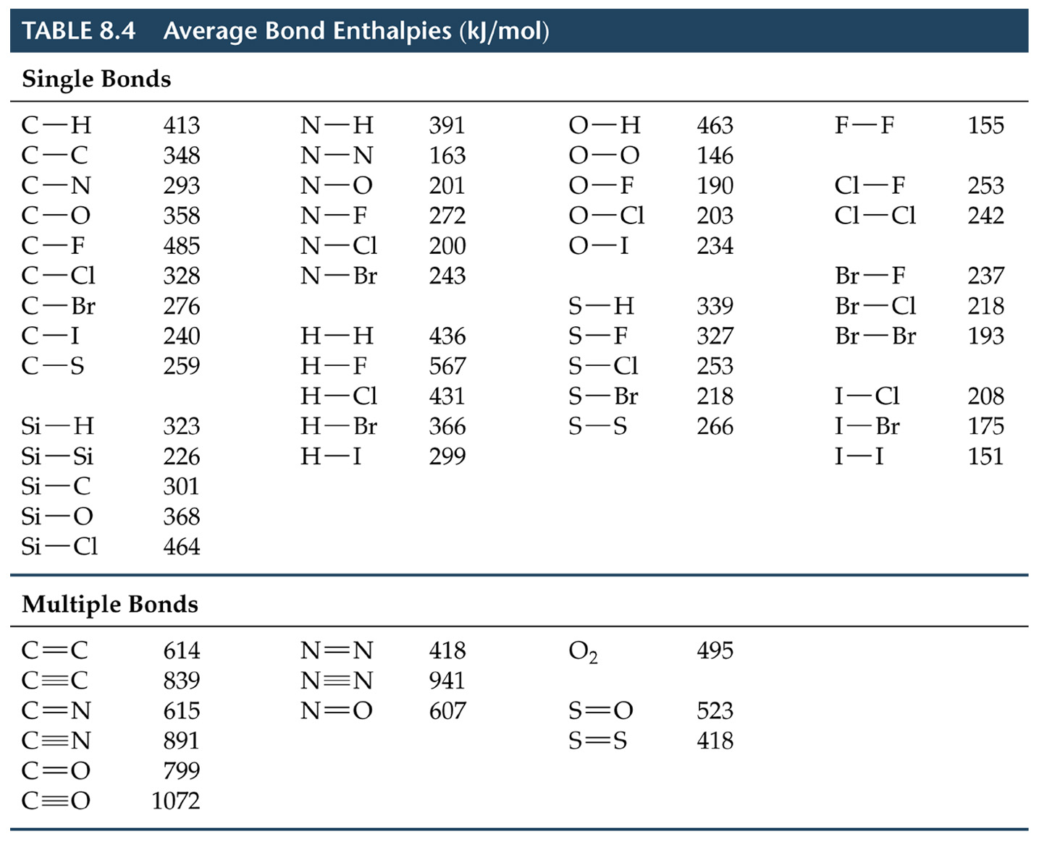

- Identify the strongest intermolecular force present in pure samples of the following substances:
SO₂ H₂O CH₂Cl₂
dipole-dipole forces hydrogen bonds dipole-dipole forces
SCO PCl₃ SO₃
dipole-dipole forces dipole-dipole forces London dispersion forces
- Identify the strongest intermolecular force operating in the condensed phases of the following substances. Fully explain how you determined this.
a. Cl₂ London dispersion forces  The Cl-Cl bond is nonpolar so the molecule is nonpolar. Non polar molecules have only London dispersion forces operating in the substance. | b. CO Dipole-dipole forces  The C-O bond is polar so the molecule is polar. Polar molecules have dipole-dipole forces. They also have London dispersion forces, but dipole-dipole forces are stronger.
c. SO₂ Dipole-dipole forces  SO₂ is a bent, polar molecule. The strongest intermolecular force in a polar molecule is the dipole-dipole force | d. CH₂Cl₂ Dipole-dipole forces  The strongest intermolecular force in a polar molecule that cannot form hydrogen bonds is the dipole-dipole force
e. HF Hydrogen bonding forces  Molecules that have hydrogen attached to an O, N, or F can form hydrogen bonds. These are the strongest of the intermolecular forces. | g. CH₃-O-CH₃ Dipole-dipole forces  The hydrogen atoms are not bonded to the oxygen, so this molecule cannot form hydrogen bonds. It is polar, so it will have dipole-dipole forces.
- Based on the intermolecular forces present, predict the relative boiling points of each of the substances below. Arrange each series of substances in order of increasing boiling point. State your reasons for the order you use (identify the forces and explain how they affect the boiling point).
a. dimethyl ether (CH₃OCH₃), ethanol (CH₃CH₂OH), and propane (CH₃CH₂CH₃)
lowest bp: propane (CH₃CH₂CH₃) < dimethyl ether (CH₃OCH₃)< ethanol (CH₃CH₂OH) highest bp
Dimethyl ether cannot form hydrogen bonds (no O-H bond), but is polar and has dipole-dipole forces. Ethanol can form hydrogen bonds. propane is nonpolar, so it has only London dispersion forces. The boiling point increases as the strength of the intermolecular forces increase:
London dispersion < dipole-dipole forces < hydrogen bonds
[All have similar molar masses: 46.07g/mol, 46.07g/mol and 44.09g/mol respectively.]
b. Br₂, Cl₂, I₂
lowest bp: Cl₂ < Br₂ < I₂ highest bp
All are nonpolar molecules so only London dispersion forces are present. London dispersion forces get stronger as molar mass increases.
- For each pair of substance identify the substance that is likely to have the higher vapor pressure. Explain your reasoning.
a. CO₂ or SO₂
CO₂ will have the higher vapor pressure. Vapor pressure tends to decrease as the strength of the intermolecular forces increase. Carbon dioxide is non-polar (dispersion forces only). Sulfur dioxide is polar (dipole-dipole forces are present).
b. CH₃OH or CH₃-O-CH₃
CH₃OCH₃ will have the higher vapor pressure. Vapor pressure tends to decrease as the strength of the intermolecular forces increase. CH₃OH can hydrogen bond. CH₃OCH₃ is polar (bent shape around the oxygen), so dipole-dipole forces are the strongest forces in this compound.

20) Using the below Molecular Orbital Diagram illustrate how the electronic structure of O₂ and N₂ DIFFER from those expected solely from the LEWIS DOT structure. How does bond order and type of intermolecular bond compare? Also, try to draw the HYBRIDIZED STRUCTURE OF O₂ what’s also wrong with it?
