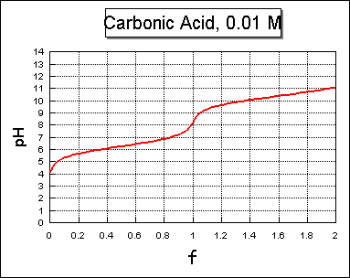
This last example is of a dibasic acid, carbonic acid, H₂CO₃. This is the acid which forms when carbon dioxide gas, CO₂, dissolves in and reacts with water, H₂O. As strong base is added, it reacts with the H₂CO₃ to form water and HCO₃⁻, which is called bicarbonate ion. The pK of carbonic acid is 6.3 (making it a weaker acid than acetic acid). So a pH of 6.3 represents the middle of the first "buffer range" of this acid.
If we continue to add strong base after all of the carbonic acid has been converted to bicarbonate ion, (at f = 1), the HCO₃⁻ reacts with the hydroxide to form water and carbonate ion, CO₃⁼. So bicarbonate ion is both a weak base and a weak acid. As an acid, it has a pK of 10.3, so this is the middle of the second buffer range. The pH of a pure carbonate solution, such as could be made by dissolving powdered sodium carbonate in water, would depend on the concentration: the higher the concentration, the higher the pH (just as a higher concentration of pure carbonic acid would result in a lower pH.) A pure bicarbonate solution has a pH of about 8.3, and is less affected by the concentration.

H₂CO₃ + H₂O === HCO₃⁻+ H₃O⁺ pKa = 6.3

pH = 6.3 – log { [H₂CO₃ ] / [HCO₃⁻]

pH = 6.3 – log { moles_{(Acid)]} / {moles_{(HCO3 )} - moles_{(Acid)}}

HCO₃⁻ + H₂O ==== CO₃ ⁼ + H₃O⁺ pKa =10.3

pH = 10.3 – log { [HCO₃ ⁻] / [CO₃⁼]

pH = 10.3 – log [ {moles_{(HCO3 )} - moles_{(Base)}}/ moles_{(Base)}} ]

