Ethylenediamminetetraacetic acid, more commonly known as EDTA belongs to a class of synthetic compounds known as polyaminocarboxylic acids. Acting as a ligand that shows multiple coordination sites, EDTA forms very strong 1:1 stoichiometric complexes with all +2 and higher charged metal ions in aqueous solution
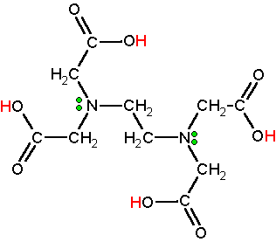
EDTA contains six sites that can be protonated. Since EDTA itself is quite insoluble in water, the disodium salt is normally used to make EDTA solutions. To form the strongest complexes, EDTA solutions are usually buffered in a region that ensures that protonation reactions do not compete with the complexation reaction. The important species in solution are generally H₂Y²⁻ and HY³⁻. Figure 15-4 in your text shows the ideal pH buffer ranges for the EDTA titration of various metal ions.
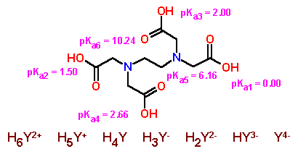
pKa₁ pKa₂ pKa₃ pKa₄ pKa₅ pKa₆
The analytical reaction in this experiment can be written as:
Ca²⁺ + HY³⁻ CaY⁴⁻ + H⁺
note that the reaction has a 1:1 stoichiometry. Since EDTA forms very strong complexes with most metal ions with a charge greater than +2, procedures designed to "mask" or complex impurity ions are often used. In this experiment, however, relatively pure calcium carbonate unknowns are used so that masking reagents are not needed.
The pH is maintained by a high buffer to remove the activity of the other FIVE (5) sites. At a pH of 10, which site survives? (pK_{a6})
The overall procedure to be used involves the standardization of an EDTA solution by titration with a known amount of calcium followed by using the calibrated solution to determine an unknown amount of calcium.

Eriochrome Black (HOC₁₀H₆N=NC₁₀H₄(OH)(NO₂)SO₃Na) forms complexes with a large number of metals, including calcium, but not with sodium, ammonium, nor potassium.

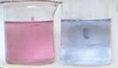
Eriochrome Black T is blue,
but turns red in the presence of metals.

When the dye is not complexed with a metal, and when it is in a solution around pH 10, it has a blue-grey color.

Most of these metal complexes including Calcium are a strong wine red color.

CaCO₃(Molar mass =100.087 g/mol)

Reacts with strong acids, releasing carbon dioxide:
CaCO₃ + 2HCl → CaCl₂ + CO₂ + H₂O

calcium carbonate | CaCO₃ | 3.8 x 10⁻⁹

[Ca⁺⁺ ][CO₃⁼] = 3.8e-9
[Ca⁺⁺ ] = [CO₃⁼] = 6.16441E-05 M
Thus
[Ca⁺⁺ ] = 6.16441E-05 M * 40.078= 2.47E-03 g/L OR 2.47E-06 g/ml

