Background : Liesegang Rings

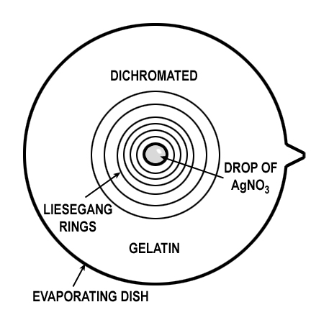
A couple of sites that might be useful. Theory is very complex and still being actively investigated!

Theory behind diffusion controlled kinetics (suggests plotting Distance Squared vs. Time)

Research Paper and References

SAMPLE DATA
Time | β=0.5 | β=0.4 | β=0.6
0 | 0 | 0 | 0 | 1 |  | 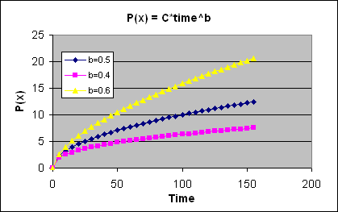
5 | 2.236068 | 1.903654 | 2.626528
10 | 3.162278 | 2.511886 | 3.981072
15 | 3.872983 | 2.954177 | 5.077556
20 | 4.472136 | 3.314454 | 6.034176
25 | 5 | 3.623898 | 6.898648
30 | 5.477226 | 3.89806 | 7.696136
35 | 5.91608 | 4.14598 | 8.441912
40 | 6.324555 | 4.373448 | 9.146101
45 | 6.708204 | 4.584426 | 9.815841
50 | 7.071068 | 4.781762 | 10.4564
55 | 7.416198 | 4.967582 | 11.07178
60 | 7.745967 | 5.143521 | 11.66516
65 | 8.062258 | 5.310866 | 12.23906
70 | 8.3666 | 5.470654 | 12.79555
75 | 8.660254 | 5.623731 | 13.33634
80 | 8.944272 | 5.7708 | 13.8629
85 | 9.219544 | 5.912451 | 14.37644 |  |  | 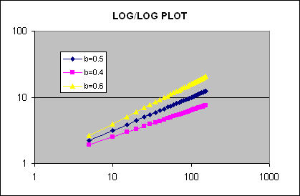
90 | 9.486833 | 6.049187 | 14.87803
95 | 9.746794 | 6.181437 | 15.36859
100 | 10 | 6.309573 | 15.84893
105 | 10.24695 | 6.433921 | 16.31975
110 | 10.48809 | 6.554764 | 16.78169
115 | 10.72381 | 6.672355 | 17.23529
120 | 10.95445 | 6.786916 | 17.68108
125 | 11.18034 | 6.898648 | 18.11949
130 | 11.40175 | 7.00773 | 18.55094
135 | 11.61895 | 7.114322 | 18.97581
140 | 11.83216 | 7.218571 | 19.39442
145 | 12.04159 | 7.320609 | 19.8071
150 | 12.24745 | 7.420557 | 20.21412
155 | 12.4499 | 7.518526 | 20.61574

