Effusion and Diffusion

Diffusion: gradual mixing of molecules of one gas with molecules of another gas by virtue
of their kinetic properties
Effusion: process of a gas under pressure escaping from a container via a small opening.

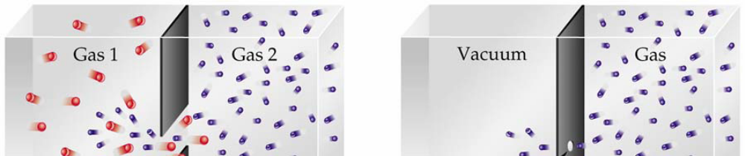
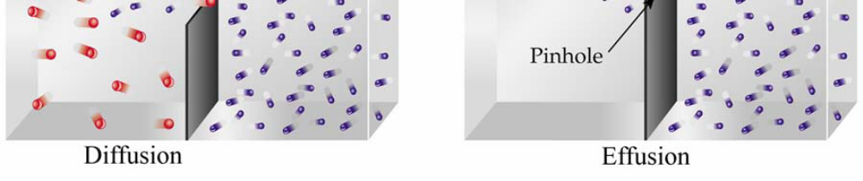

Circle the pair of gases in each set below that diffuse faster.

- Ne & F₂ or Ar & Cl₂ b. Kr & Ar or O₂ & Cl₂

Nitrous oxide, N₂O, also known as laughing gas, is a colorless gas and has been used as a weak anesthetic. Hydrogen cyanide, HCN, is a poisonous, colorless gas that can cause a quick death. If both of these gases were accidentally released at the same time in the front of a theater full of moviegoers, would the people die laughing

