Chemical Equilibrium
• Define Equilibrium:

In a closed system the rate of the forward reaction equals the rate of the reverse reaction.
Rate _{f} = Rate _{b}

• What does a system at equilibrium look like?

Nothing happening.... no color change, no temperature changes, no pressure changes, no pH changes (acid/base thing), no changes in concentrations.... If you didn't know any better you might think the reaction has STOPPED.

Not At Equilibrium  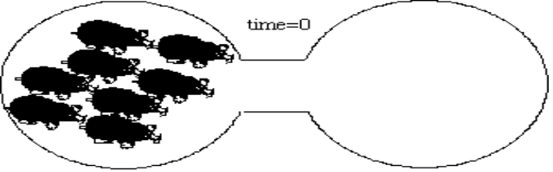  At Equilibrium | The concentration of products do not need to equal the concentration of reactants.  Only the forward and reverse reaction rates need to be equal.

• Why do systems go to equilibrium?

Most reactions are reversible. Reactants Reactants

In a closed container, as long as the temperature remains constant, an equilibrium will be established between liquid water and water vapor.

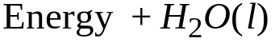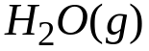

Reactant: less energy Product: more disordered

Driving Forces
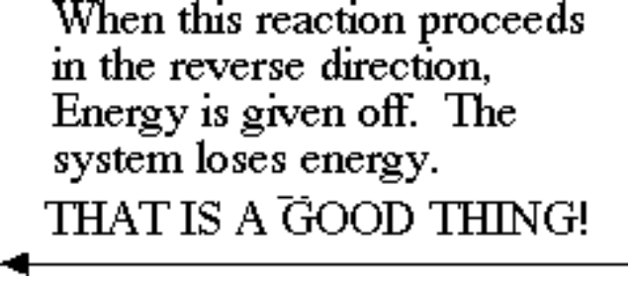 | 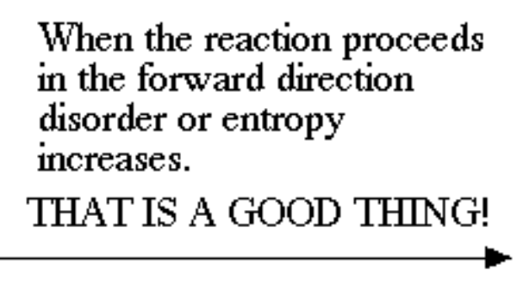
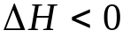 | 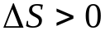

• Is equilibrium influenced by reaction direction?

In a the following generic reaction where A(g) produces B(g), it does not matter whether or not the system begins with only A(g) or only B(g).

A (g)<====> B(g)

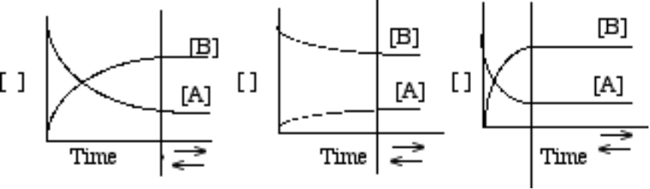

• Is there a quantitative relationship between the products and reactants at equilibrium? Of Course......

The Law of Mass Action:

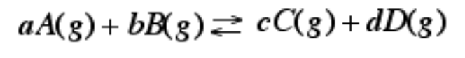

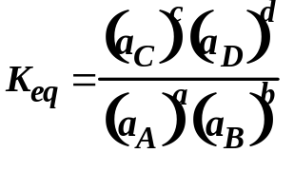

The Activity (a): (aq) ♠ [concentration, mol/L]
(g) ♠ [concentration, mol/L] or Pressure
(s) = 1
(l) = 1
OR

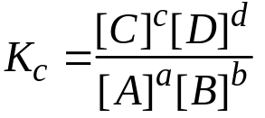

Question: Write equilibrium expression for the following reactions.

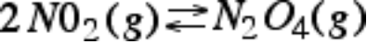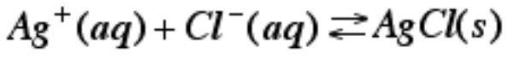

• Determination of Kc

At equilibrium the following conditions exist: [A] = 0.10 M
[B] = 0.50 M
[C] = 0.60 M
[D] = 0.60 M

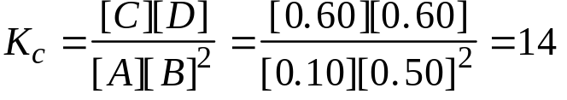

As a rule Kc .> 103 mean products favored, Kc < 10-3 means reactants favored.

Kc = 14

• What happens when a system at equilibrium is disturbed?

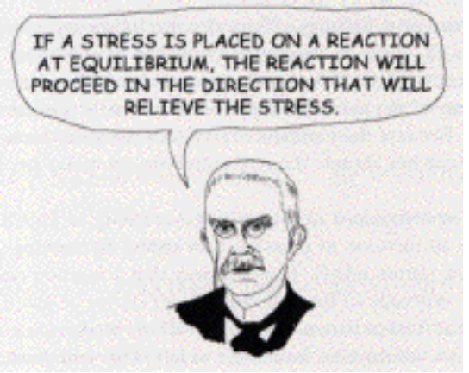
LeChatelier

• The dynamic balance between products and reactants in a system at equilibrium can be disturbed by the following:

A. Change the concentration of products or reactants.
B. In a system that involves the gas state, change the pressure.
C. In a system that involves the gas state, change the volume
(B. and C. are related. Increasing volume will decrease the pressure.)
D. Change the temperature.

• How does a closed system react to these changes?

A. Shift forward to make more products.
B. Shift backward to make more reactants.
C. No shift (possible in a system that involves the gas state.)

• Why does a closed system react to these changes?
A. Reestablish Equilibrium
B. Reestablish Equilibrium
C. Reestablish Equilibrium

• Henri Louis Le Chatelier proposed the following general rules to predict how a system at equilibrium will respond to stress.

If an external stress is applied to a system at equilibrium, the system adjusts in a way to relieve the stress as the system reaches a new equilibrium position.

The System:

The Stress: [N2] is increased (or added).

The Shift: Reverse reaction favored.
The system needs to remove N2.
The reverse reaction USES N2.

The Effect: The system reestablishes equilibrium
[N2] is reduced, but still higher than before.
[NH3] is increased.
[H2] is decreased.

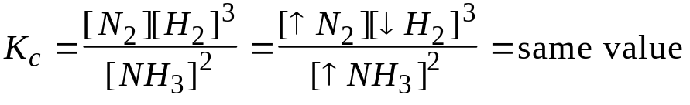
The Stress: Pressure is increase or Volume decreased

The Shift: Reverse reaction favored.
Reactant side has 2 moles of gas compared to product
side with 4 total moles of gas. Favoring reactants will
produce less gas, relieving the pressure increase.

The Effect: The system reestablishes equilibrium.
All the concentrations increase, but the [NH3] increases more.

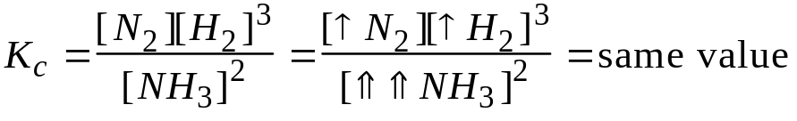

The Stress: The temperature is increased.

22 kcal +

The Shift: As written, the reaction uses energy.
Therefore the forward reaction is favored.
Increasing temperature favors the endothermic
process.

The Effect: The system reestablishes equilibrium.
[N2] is increased
[H2] is increased.
[NH3] is decreased.

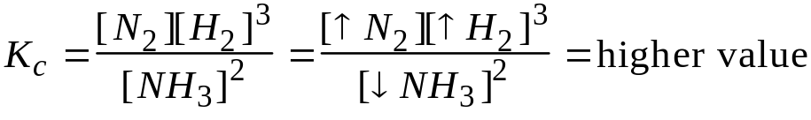

Note: As long as the temperature remains constant, the equilibrium constant (Keq) does not change. If the above system is cool down, the reverse, exothermic reaction is favored, and the Keq will be lower.

Changes that DO NOT affect the equilibrium are using a catalyst in the reaction or adding/removing solid state reactants or products.

