KEY EXAM 1 CHEMISTRY 102 July 10, 2009
NAME: PRINT ___________________________ Sign _____________________________________

FREE RESPONSE SECTION (18x5= 90pt)

- The half-life of radioactive ⁴⁵Ca is 162.7 days. How long would it take for 95%/90% of 12.5 microgram/cc of ⁴⁵CaCl₂ to decay away?
Radiation always 1st order independent of Concentration

 |  | 162.7days
t=ln2/k
k= ln2/t |  | 0.00426
t₉₅=-ln(0.05)/k= |  | 703.2 | Day
t₉₀= -ln(0.10)/k = |  | 540.5Day

- Four beakers are placed in a open container, and .
Beaker A is filled with 150mL of pure water
Beaker B is filled with 150ml of 3.5 molal calcium chloride
Beaker C is filled with 150mL of 3.5 molal potassium nitrate
Beaker D is filled with 150mL of 3.5 molal sucrose(non-electrolyte)
The container is left for several days and then examined to the discovery that the four beakers no longer contain equal volumes. Now remember Raoult’s Law, What would you predict to be the relationship of the volumes in beakers A, B, C and D? Write Order with inequality symbols between AND explain in one sentence WHY! B>C>D>A The more ions/species in solution the lower the VP/slower the evaporation

3) Match up the following solutes based upon their influence on Freezing Point Depression of Water
0.12 m AgNO₃ | a) Lowest freezing point | 0.24 | e
0.20 m MnBr₂ | b) Second lowest freezing point | 0.60 | a
0.16 m NiBr₂ | c) Third lowest freezing point | 0.48 | d
0.17 m H₂SO₄ | d) Fourth lowest freezing point | 0.51 | c
0.58 m Albumin (nonelectrolyte) | e) Highest freezing point | 0.58 | b

4) Circle Appropriate Choice:
Dissolution of |  | Primary Driving Force |  | Solubility Decreases with  Temperature If
Non-Volatile Solids  in Liquid Solution |  | Enthalpy or Entropy |  | Endothermic or Exothermic
Gases in Liquid Solution |  | Enthalpy or Entropy |  | Endothermic or Exothermic

5) In which colligative properties does the value decrease as more solute is added? (MINUS one pt for ones missed) (WILL ADD ONE POINT TO EXAM GRADE FOR a) & d)
- The vapor pressure of the solvent when a volatile solute is added
- Boiling point
- Freezing point
- The partial pressure of the solvent when a volatile solute is added.
- Osmotic pressure of the solution
- The vapor pressure of the solvent when a nonvolatile solute is added.

6-7) 5 grams of sodium chloride are added to 90 grams of water. The density of the final density of the above solution is found to be 1.0359g/ml. What is the molality and molarity of the solution? (10pts)
5 grams of Salt(58.44) |  | 1.25 g/cc | 4 | ml | 94.0 ml total before mixing
95 grams of solution |  | 1.0359 | 91.71 | ml | After mixing
90 grams of water
Molality = | 0.0856 | moles/ | 0.09 | kg/water= | 0.951 | m
Molarity= | 0.0856 | moles/ | 0.0917 | L | 0.933 | M

8) What is the molar mass of a non-electrolyte if 1.5grams in 350 ml of solution results in an osmotic pressure of 196 torr at 25 C

MW= gRT/(PV)
P=196/760= 0.258 atm
T=298 K
=1.5*0.0821*(25+273)/((196/760)*0.35)
406.6

9 Rate Law for Hydrogen Peroxide(5pts)

) Find the Rate Order for the following reaction AND Rate Law for this reaction: H₂O₂ ➔ ½ O₂ + H₂O

Second Order

Rate = d[H₂O₂]/dt = k[H₂O₂]²

Thus 1/[H₂O₂] = 1/[H₂O₂]₀ + kt

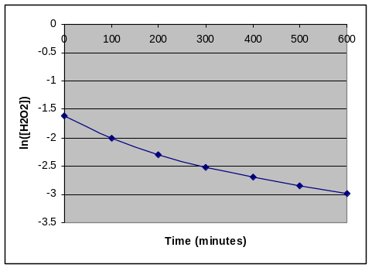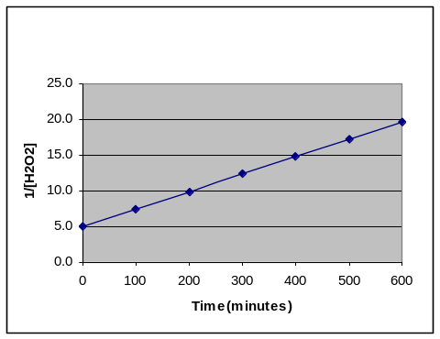

10-11) Vapor Pressure of a Solution of Benzene & Toluene at 25C (10 pts)

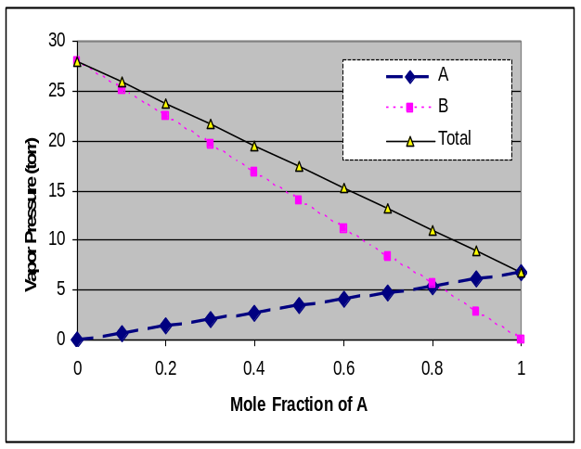

Using the below information(5pts total):
Toluene (MW= 92.14 ) BP 173.3 ºC
Benzene(MW= 78.11 ) BP 110.6 ºC

What are the vapor pressures for Toluene at 25ºC (4pts) 7 torr because it is lower relating to higher BP

Which has the STRONGER intermolecular force? (2pts) Toluene because it has a higher BP

If equal masses of the two liquids are combined into a solution, what would be the Total Vapor Pressure? (4pts)

Assume 50grams each
0.542652 | n toluene | x_{toluene}= | 0.458796
0.640123 | n benzene x_{benzene}= |  | 0.541204
1.182775 | n total
Pt= 7*0.459+28*0.541
Pt= | 18.4 | torr

12) The activation energy for the gas phase decomposition of dinitrogen pentoxide is 50.5 kJ.
N₂O₅ 2 NO₂ + 1/2 O₂
The rate constant at 400 K is 1.5e-2 sec⁻¹. What is the Rate Constant at 320 K.
k₂= k₁*exp(-E_{act}/R*(1/T₂-1/T₁)) = 3.38E-04 sec⁻¹

13-14) The following initial rate data are for the oxidation of stanate ion by manganic ion in solution(10pts)
SbO₃³⁻ + 2 Mn³⁺ + H₂O ➔ SbO₄³⁻ + 2 Mn²⁺ + OH⁻

Experiment | [SbO₃³⁻]_{o}, M |  | [Mn⁺³]_{o}, M | Initial Rate, Ms⁻¹
1 | 0.0457 |  | 0.5362 | 4.83E-06
2 | 0.0914 |  | 0.5362 | 1.93E-05
3 | 0.0457 |  | 0.2681 | 6.04E-07
4 | 0.0914 |  | 1.0724 | 1.55E-04
k[SnO₃³⁻]² |  | [Mn⁺³]³
Rate Constant(k)= |  | 1.50E-02 or 0.015

15) The gas phase decomposition of dimethyl ether at 480 ºC
CH₃OCH₃ CH₄ + H₂ + CO
is first order in CH₃OCH₃ with a rate constant of 2.41x10⁻⁴ s⁻¹. If the initial concentration of CH₃OCH₃ is 741mM, what will the concentration of CH₃OCH₃ be after 129.7 seconds have passed.

= 0.741*EXP(-0.000241*129.7) | 0.718Mor  718 mM

16) If the reaction A + 2E --> C + 2B products is first-order in A and first-order in E, then the Rate Law will have the form
Rate = k [A][E]

17) In the Second Order Reaction the Initial concentration of reactant is 0.5M and decreases to 0.125 M in 125 microseconds. What is the rate constant for this reaction (include UNITS) ?
=1/0.125-1/0.5 |  | =6.0
k=6.0/0.000125= | 48000 M⁻¹sec⁻¹  or 0.048 M⁻¹ usec⁻¹
MUST HAVE UNITS if in usec

18) Why are mole fraction and molality the preferred concentration units in contrast to Molarity when looking at colligative properties such as the alteration of freezing and boiling pts of a solvent.
Molarity looks at the solute concentration alone in relationship to total volume. Important if we are looking at effect of solute reactivity alone. Both molality and mole fraction look at the ratio of composition of solute to solvent. Thus allowing us to look at the effect of changing the solute on the PROPERTIES OF THE SOLVENT

TRUE OR FALSE WITH EXPLANATION 10* 2 = 20 points
1) Using Raoult’s law, doubling the mole fraction of a non-volatile solute introduced into a solvent will double the partial pressure of the solvent

False, doubling the solute mole fraction with approximately half the partial pressure

2) The rate law for a reaction is not based upon the stoichiometry of the overall/net reaction, but rather based upon the stoichiometry of the fasted elementary step/reaction.

False, the slowest link in the chain/step is responsible for the difference.

3) The concentration units of Molarity and Molality are NOT be influenced by Temperature?

False, only Molality since it only involves mass.

4) The Osmotic Pressure is the result of SOLVENT molecules pushing on the semi-permeable membrane in an osmotic cell

False, The pressure is due to the water molecules trying to dilute the solute molecules by moving across the membrane. There is no pressure on the membrane UNLESS the system is totally enclosed in which the increase VOLUME will result in a force in all directions.

5) The Entropy of a reaction must be positive AND the Enthalpy must be negative for any reaction to take place on it’s own (so-called spontaneous)

False, the Free energy = H-TS must be negative only

6) Knowing the mass in grams of the solute is adequate to access the Osmotic Pressure of any solutions once corrected for the van’t Hoff factor.

Osmotic pressure is related to the MOLARITY/MW and NOT the MASS. There is only a one to one relationship if one is looking at the SAME chemical!

7)A Catalysis in a reaction is responsible for reducing the overall Enthalpy of the Reaction thus allowing molecules to react more readily.
False, A Catalysis reduces the activation energy of the reaction and NOT the enthalpy

8) If the activation energy of a reaction is decreased by the introduction of a catalysis, the rate constant will increase
TRUE and also will the Rate

9) The driving force largely responsible for the dissolution of a Gas into Solutions is Enthalpy.
TRUE

10) In the Conversion of Molarity to Molality, in addition to the unit molarity of the solution, one ADDITIONALLY needs: the density of the solution and the molecular weight the solvent

False, we also need the molecular weight of the solute not solvent.

EC-5pts) Henry’s law tells us that the solubility of a gas increases with the pressure of that gas above it. Assuming that air is simply a 4::1 ratio of N₂ ::O₂ (80%/20% by Volume) at one atmosphere. What would need to be the partial pressure of N₂ in a compressed air tank so as to maintain the SAME ABSORPTION of N₂ in the blood(water) at 8 atmosphere? Hint: Remember that Absorption dependent only on partial pressure of relevant gas

Absorption dependent only on partial pressure of relevant gas thus P= 0.1 atm
Since 0.1*8=0.8 atm of partial pressure at P_{total} of 8 atm

