The following initial rate data are for the oxidation of stanate ion by manganic ion in solution
SbO₃³⁻ + 2 Mn³⁺ + H₂O ➔ SbO₄³⁻ + 2 Mn²⁺ + OH⁻

Experiment | [SbO₃³⁻]_{o}, M |  | [Mn⁺³]_{o}, M | Initial Rate, Ms⁻¹
1 | 0.0457 |  | 0.5362 | 4.83E-06
2 | 0.0914 |  | 0.5362 | 1.93E-05
3 | 0.0457 |  | 0.2681 | 6.04E-07
4 | 0.0914 |  | 1.0724 | 1.55E-04
k[SnO₃³⁻]² |  | [Mn⁺³]³
Rate Constant(k)= |  | 1.50E-02

Four beakers are placed in a open container. , and .
Beaker A is filled with 100 mL of pure water
Beaker B is filled with 100 ml of 2.1 molal calcium chloride
Beaker C is filled with 100 mL of 2.1 molal potassium nitrate
Beaker D is filled with 100 mL of 2.1 molal sucrose(non-electrolyte)
The container is left for several days and then examined to the discovery that the four beakers no longer contain equal volumes. What would you predict to be the relationship of the volumes in beakers A, B, C and D? Write Order with inequality symbols between: B>C>D>A The more ions/species in solution the lower the VP/slower the evaporation

Match up the following solutes based upon their influence on Freezing Point Depression of Water
0.12 m AgNO₃ | a) Lowest freezing point | 0.24 | e
0.19 m MnBr₂ | b) Second lowest freezing point | 0.57 | b
0.16 m NiBr₂ | c) Third lowest freezing point | 0.48 | d
0.17 m H₂SO₄ | d) Fourth lowest freezing point | 0.51 | c
0.58 m Albumin (nonelectrolyte) | e) Highest freezing point | 0.58 | a

Circle Appropriate Choice:
Dissolution of |  | Primary Driving Force |  | Solubility Decreases with  Temperature If
Non-Volatile Solids  in Liquid Solution |  | Enthalpy or Entropy |  | Endothermic or Exothermic
Gases in Liquid Solution |  | Enthalpy or Entropy |  | Endothermic or Exothermic

Henry’s law tells us that the solubility of a gas increases with the pressure of that gas above it. Assuming that air is simply a 4::1 ratio of N₂ ::O₂ (80%/20% by Volume) at one atmosphere. What would need to be the partial pressure of N₂ in a compressed air tank so as to maintain the SAME ABSORPTION of N₂ in the blood (water) at 8 atmosphere?

Absorption dependent only on partial pressure of relevant gas thus P= 0.1 atm

Since 0.1*8=0.8 atm of partial pressure at P_{total} of 8 atm

a) Find the Rate Order for the reaction AND Rate Law for this reaction: 2H₂O₂ ➔ O₂ + 2H₂O
Using this, what is the TIME DEPENDENT Concentration of Hydrogen Peroxide?

m =20-5/(600) =15/600 = 0.025 =k
1/A0 =5.0 A0 = 0.2

Second order

[H₂O₂]= 1/0.2 + 0.025t

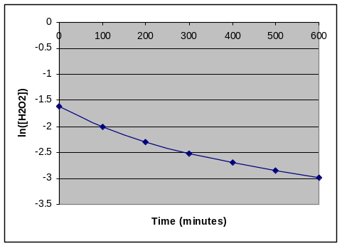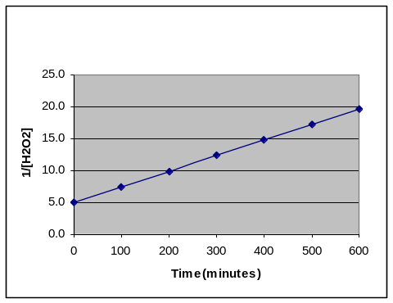

Vapor Pressure of a Solution of Benzene & Toluene at 25C

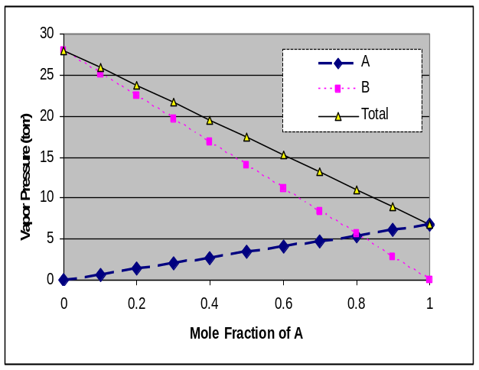

Using the below information(5pts total):
Toluene (MW= 92.14 ) BP 173.3 ºC
Benzene(MW= 78.11 ) BP 110.6 ºC

What are the vapor pressures for Toluene at 25ºC (4pts) 7 torr because it is lower relating to higher BP

Which has the STRONGER intermolecular force? (2pts) Toluene because it has a higher BP

If equal masses of the two liquids are combined into a solution, what would be the Total Vapor Pressure? (4pts)

50grams of each
0.542652 | n toluene | xtoluene= | 0.458796
0.640123 | n benzene |  | 0.541204
1.182775 | n total
Pt= 7*0.459+28*0.541
Pt= | 18.37 | torr

What is the molar mass of a non-electrolyte if 1.5grams in 350 ml of solution results in an osmotic pressure of 196 torr at 25 C

MW= gRT/(PV)
=1.5*0.0821*(25+273)/((196/760)*0.35)
406.57
5 grams of sodium chloride are added to 90 grams of water. What is the percent weight of salt? The density of solid salt is 1.25 g/cc and the final density of the above solution is found to be 1.0359g/ml. What is the volume of the solution before and after mixing the components? What is the molality and molarity of the solution?
5 grams of Salt(58.44) |  | 1.25 g/cc | 4 | ml | 94.0 ml total before mixing
95 grams of solution |  | 1.0359 | 91.71 | ml | After mixing
90 grams of water
Molality = | 0.0856 | moles/ | 0.09 | kg/water= | 0.951 | m
Molarity= | 0.0856 | moles/ | 0.0917 | L | 0.933 | M

The activation energy for the gas phase decomposition of dinitrogen pentoxide is 50.5 kJ.
N₂O₅ 2 NO₂ + 1/2 O₂
The rate constant at 400 K is 1.5e-2 sec⁻¹. What is the Rate Constant at 320 K.

k₂= k₁/exp(E_{act}/R*(1/T₂-1/T₁)) = 3.37E-04 sec⁻¹

Given the following information for a first order reaction, what is the Activation Energy for this reaction? What can be said about the Enthalpy for this reaction?
k₁ (T=300K) ₌ | 2.12E-04 sec⁻¹
k₂ (T=400K) ₌ | 1.23E-02 sec⁻¹

E_{act} = R*ln(k₁/k₂)/ (1/T₂-1/T₁) = 40.5 kJ

The gas phase decomposition of dimethyl ether at 480 ºC
CH₃OCH₃ CH₄ + H₂ + CO
is first order in CH₃OCH₃ with a rate constant of 2.41x10⁻⁴ s⁻¹. If the initial concentration of CH₃OCH₃ is 741mM, what will the concentration of CH₃OCH₃ be after 129.7 seconds have passed.

= 0.741*EXP(-0.000241*129.7) | 0.718M 718 mM

If the reaction A + 2E --> C + 2B products is first-order in A and first-order in E, then the Rate Law will have the form
Rate = k [A][E]

What does that tell us about the Rate Determining step?

Biomolecular and Possibly A+E ➔ ???

The half-life of radioactive ⁴⁵Ca is 162.7 days. How long would it take for 95% of 1microgram/cc of ⁴⁵CaCl₂ to decay away?
 |  | 162.7days
t=ln2/k
k= ln2/t |  | 0.00426
t₉₅=-ln(0.05)/k= |  | 703.18 | day
Radiation always 1st order independent of Concentration

In the Second Order Reaction the Initial concentration of reactant is 0.5M and decreases to 0.125 M in 125 microseconds. What is the rate constant for this reaction?

=1/0.125-1/0.5 |  | =6.0
k=6.0/0.000125= | 48000 sec⁻¹  or 0.048 usec⁻¹
MUST HAVE UNITS if in usec

The Kf for water is 1.86; What would need to be the PERCENT WEIGHT of Sodium Chloride( molar mass=58.44) in water to reduce the Freezing Point of water by 18oF ( ΔT=18F)? = 10K
10= 2* 1.86*(g/58.44)/1kg
g= 10*58.44/(2*1.86)= |  | 157.0968 |  | g
157.097/1157.09
0.135768
13.57%

In which colligative properties does the value decrease as more solute is added?
- The vapor pressure of the solvent when a volatile solute is added
- Boiling point
- Freezing point
- The partial pressure of the solvent when a volatile solute is added.
- Osmotic pressure of the solution
- The vapor pressure of the solvent when a nonvolatile solute is added.

What is the osmotic pressure in atm produced by a 1.20 M glucose (C₆H₁₂O₆) solution at 25°C?

- 29.3 atm
- 2.46 atm
- 20.4 atm
- 0.163 atm
- 26.9 atm

In the Convertion of Molarity to Molality, in addition to the unit molarity of the solution, one ADDITIONALLY needs:
  - the molecular weight of the solvent and the density of the solvent
  - the volume and number of moles of solvent
  - the density of the solution and the molecular weight the solute.
  - the number of grams of solute and specific heat of the solvent
  - the volume and molecular weight of the solvent
  - the mole fraction of the solute

Which of the following forms of concentration would NOT be influenced by Temperature?
- Molarity b) Molality
- Mole Fraction d) PPM
e) Weight Percent f) Volume Percent

Which one of the following statements is incorrect?
- More molecules in a reaction will have energies above E_{act} as the temperature is decreased
- Activation energies of simple reactions can be negative.
- The rates of two reactions can be equal at one temperature but differ at another.
- The rate does not depend on the magnitude of the Enthalpy.
- The lower the activation energy, the faster the rate if equal numbers of collisions are involved.

TRUE OR FALSE WITH EXPLANATION:
The fraction of molecules with energies greater than the Activation Energy E_{act} are responsible for the temperature dependence of the rate of a reaction as defined by the Arrhenius Relationship

TRUE The integrated fraction of molecules in the Boltzmann distribution greater than E_{act} defines the Arrhenius Equation

Using Raoult’s law, doubling the mass of a non-volatile solute introduced into a solvent will double the partial pressure of the solvent

Raoult’s law works in mole fraction of the SOLVENT! Doubling the mass and mole fraction of the solute does not Double or Half mole fraction of the solvent and thus does not half the vapor pressure

The fraction of molecules with energies greater than the Activation Energy of a reaction are responsible for the Arrhenius Relationship of Rate with temperature?
True The fraction of the molecules with energies greater than the Activation Energy E_{ac} are responsible.

One of the common threads behind colligative properties is that both the solute and solvent play active roles in the chemical process.
True, this is why such properties utilize concentration factors that include both solute and solvent

The Osmotic Pressure is the result of solute molecules pushing on the semi-permeable membrane in an osmotic cell

False, Solute molecules are not directly responsible for effect. The pressure is due to the water molecules trying to dilute the solute molecules by moving across the membrane

The Entropy of a reaction must be positive AND the Enthalpy must be negative for any reaction to take place on it’s own (so-called spontaneous)

False, the Free energy = H-TS must be negative only

Knowing the mass of the solute is adequate to access the Osmotic Pressure of any solutions once corrected for the van’t Hoff factor.

Osmotic pressure is related to the MOLARITY and NOT the MASS. There is only a one to one relationship if one is looking at the SAME chemical!

A Catalysis in a reaction is responsible for reducing the overall Enthalpy of the Reaction thus allowing molecules to react more readily.
False, A Catalysis reduces the activation energy of the reaction and NOT the enthalpy

The Enthalpy of dissolution of many solids is actually Endothermic (positive) because the sum of solvation/hydration processes is greater than those associated with disruption/breaking of inter and intra-bonds.
False, the sum would need to be less for the overall enthalpy to be positive.

If two volatile solvents are mixed together, the resulting TOTAL vapor pressure is always greater than the individual vapor pressures for the PURE solvents. (True or False AND Explain Answer)

VP(total) = X_{A}P_{A}⁰ + X_{B}P_{B}⁰
X_{A} and X_{B} are less than one thus the total pressure is never greater than the most volatile solvent

The half life for all reactions is independent on the initial concentration by definition.
False, this is ONLY true for 1st order reactions.

The rate law for a reaction is not based upon the stoichiometry of the overall/net reaction, but rather based upon the stoichiometry of the fasted elementary step/reaction.

False, the slowest link in the chain/step is responsible for the difference.

The rate of a reaction is increased when the temperature is increased; irrespective of the activation energy of the reaction.

True, this is the principle of the Arrhenius relationship

