1) Place highlighted elements in the periodic table below in order from the smallest atomic radius to the largest? 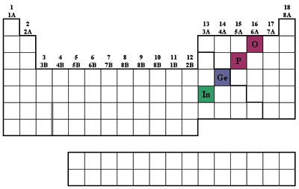
O <P<Ge<In In<Ge<P<O O<P<In<Ge All Have approximately equivalent radius Inadequate Information

2) Which one of the following elements has two or more unpaired electrons in the ground state?
zinc titanium neon scandium cadmium
3) Which of the waves below has the lower wavelength and which has the lower energy?
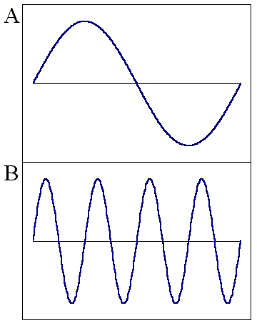
B, A A,A A,B B,B
4) List the following types of electromagnetic radiation in order of increasing frequency:
(i) the gamma rays produced by a radioactive nuclide used in medical imaging
(ii) radiation from an FM radio station at 93.1 MHz on the dial
(iii) a radio signal from an AM radio station at 680 kHz on the dial
(iv) the yellow light from sodium-vapor streetlights
(v) the red light of a light-emitting diode, such as in a calculator display

3,2,5,4,1 1,4,5,2,3 1,2,3,4,5 5,4,3,2,1 2,3,4,5,1

5) What is the lowest n shell in which l=2 and how many ml values are possible
2,1 2, 3 3,3 3,5 not possible

6) Which one of the following representation(s) contains an impossible set of quantum numbers for an electron in an atom (arranged as n, l, m_{l}, and m_{s})?
1, 0, 0, 0
5, 4, -3, 1/2
3, 4, -3, 1/2
2, 1, -1, -1/2

7) Explain why the effective nuclear charge experienced by a 3p electron in sulfur is larger than that experienced by a 3p electron in silicon.
S has a larger nuclear charge than Si.
Sulfur has more electrons than Silicon.
The average number of electrons between a 3p electron and the nucleus is greater in Si than in S.
Not true since Sulfur is larger than Silicon since it has more repulsive non-bonding electrons
8) Which of the following transitions in the Bohr hydrogen atom model affords emission of the highest-energy photon?
E(photon)= -2.18e-18*(1/n_{upper})² –(1/n_{lower})² ergs

n_{i} = 1 --> n_{f} = 6
n_{i} = 4 --> n_{f} = 3
n_{i} = 5 --> n_{f} = 4
n_{i} = 3 --> n_{f} = 6
n_{i} = 3 --> n_{f} = 4
9) Which of these elements has the highest first-ionization energy and which has the highest electron affinity?
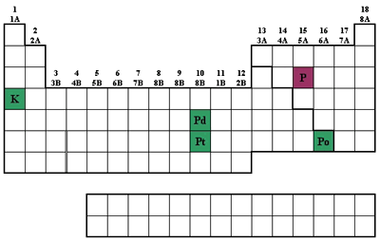
P and P P and Po K and K Po and P Po and Po

10) In which choice below are the elements ranked in order of decreasing first-ionization energy?
Al, S, Si, Cl, Ar
Cl, S, Al, Ar, Si
Ar, Cl, S, Si, Al
Al, Si, S, Cl, Ar
11) Which combination of atoms can form a polar covalent bond?
1. H and H
2. H and Br
3. N and N
4. Na and Br
12) In which atom do we find the largest occupied 3d orbital?

Ga Al Ca Mg As

13) If Na reacts with element X to form an ionic compound with the formula Na₂X, then Ca will react with X to form
Ca₂X₃
Ca₃X₂
CaX
CaX₂

14) Which of the following has the highest ionization energy? Na, Na⁺, K⁺, Mg²⁺ , Mg?
K⁺
Na
Na⁺
Mg²⁺
Mg

17) Refer to the partial periodic table reproduced below. Which element has the greatest metallic character?
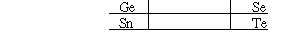

Te Ge Sn Se

Which of the following is the least reactive?
Ca Sr Ba Mg

18) On the television news; it was notes that when the detailed information about bank robberies was reported it might affect future robberies. This illustrates which principle?

  - Boyles’s Law
  - Conservation of Mass
  - Heisenberg Uncertainty Principle
  - Pauli Exclusion Principle FREE RESPONSE

1) Draw the hydridized orbital structure for CH₃CH=CH₂ and note the angles between the relevant bonds.

2) Fill in the following Missing Information
 | nm | λ meters | Frequency (υ)
RED | 750
YELLOW | 570
BLUE | 4 | 4.3E-07
UltraViolet x |  |  | 4.0E+15
X-rays | x | 2.20E-09
 | x
Infrared | x | 1.5e-3
Microwave x |  |  | 3.5e+8

4) How was the Electro-negativity Table designed (from what pieces and why) and why was it developed?. Using the Electronegativity Table, show four covalent bonds that would be non-polar and explain. Extra Credit: Suggest molecule for each that might include this bond.
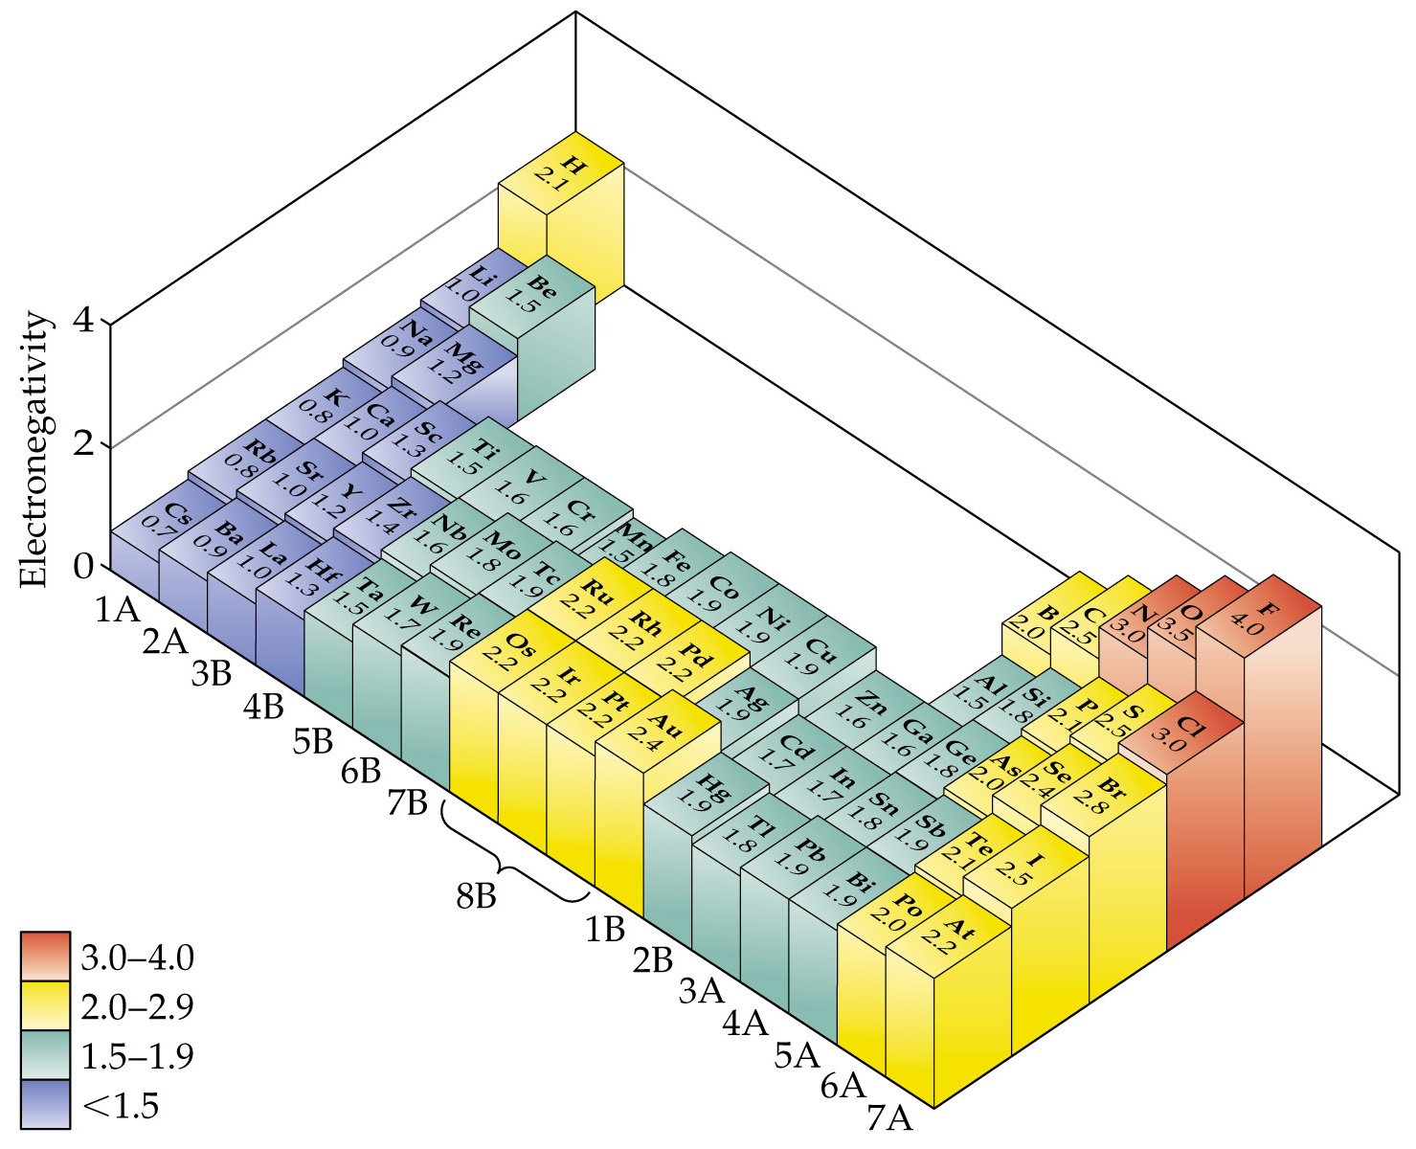

Electronegativity is a theoretical construct or model developed by Pauling to describe the sharing of electrons within bonds. The model is based upon the use of experimental data coming from the Ionization potential (tendency to lose electrons) and the Electron Affinity (tendency to gain electrons).

Choose any pairing of electronegativity were the difference is LESS than 0.5. CH, PH, SiH CP etc…

6) Explain how the Heisenberg Uncertainty Principle influences all experiments and in simple terms why. What is this concept called and who rejected the concept and on what basis. Is this logic sound or not? (Personal opinion here)
ΔxΔp > h or ΔtΔΕ > h Subjective Realism tells us that every experiment changes and influences the object we are measuring and thus dependent on the measurement conditions. Objective Realism tells us that everything has a established set of equations that specifically and completely predict what and where things are and how they will change. Einstein as well as others tended more towards the objective side; while Quantum Mechanics supports subjective realism. Experimental observation tells us that we need to accept the subjective interpretation.

8) Draw a ground-state orbital diagram for Carbon which violates BOTH Hund's rule and the Pauli-exclusion Principle.

Any configuration of Carbon in which electrons are NOT added SEPERATELY in each subshell to each orbital before doubling AND electrons are incorrectly placed with SAME spin in SAME orbital

12) Using your general knowledge of quantum levels of atoms, explain why some elements have unique flame test colors while others do not.
Each element has it’s UNIQUE set of quantum states, both occupied and unoccupied (available for excited states). When exciting any element, electrons are promoted to higher orbitals and then fall back down to the original levels RELEASING unique E&M radiation. SOMETIMES these freqencies just happen to fall in the visible. But there are always transitions that can be see by more sensitive detectors than our eyes---spectroscopy/spectrophotmeters.

13) The biggest jumps in atomic size for elements is found between noble gas atoms the immediate alkali metal that follows in the periodic table. Explain why this jump is so much bigger than any other. You need to be very specific here, not an completely transparent question.
The step between a noble gas and the next larger element which is a alkali metal is a big one in size since it involves bringing a whole NEW AND LARGER n shell into place.

16) Discuss the Schrodinger equation; where do the conventional atomic orbitals and quantum numbers come from and why do some electron structures not follow the simpliest order in occupancy. Need substantial detail for full credit

HΨ=EΨ which is a COMPLEX differential equation with ONLY an exact solution for the Hydrogen Atom. This solution(s) results in the quantum numbers which we use to try to interpret all of the larger elements. Obviously the further we are away from H on the periodic table, the greater is the error.

A 2.20-g sample of quinone, C6H4O2, is burned in a bomb calorimeter whose total heat capacity is 7.854 kJ/°C. The temperature of the calorimeter increases from 23.44°C to 30.57°C.
What is the heat of combustion per gram of quinone? Per mole of quinone? (Molecular weight of quinone is 108.1.)
 | -25.5 kJ/g, -.235 kJ/mol
 | -3.24 kJ/g, -350 kJ/mol
 | -123 kJ/g, -13300 kJ/mol
 | -25.5 kJ/g, -2750 kJ/mol
 | -3.57 kJ/g, -385 kJ/mol
 | 23.44°C to 30.57
 | dT= | 7.13
 |  | 55.99902 | 25.4541
The fuel used in spacecraft must contain as much energy per gram of material as possible. Based on this consideration ONLY which of the following fuels is best suited to be a spacecraft fuel?
(i) dimethylhydrazine, (CH3)2NNH2 Hcombustion = -1694 kJ/mol
(ii) methanol, CH3OH Hcombustion = -726 kJ/mol
(iii) ethanol, C2H5OH Hcombustion = -1371 kJ/mol
Hydrazine | N₂H₄ | 50,626

(iv) octane, C8H18 Hcombustion = -5500 kJ/mol
(v) ethylene glycol, C2H6O2 Hcombustion = -1190 kJ/mol
From the following heats of reaction,
N₂(g) + 2O₂(g) --> 2NO₂(g)
  H = +67.6 kJ
2NO(g) + O₂(g) --> 2NO₂(g)
  H = -113.2 kJ
calculate the heat of the reaction
N₂(g) + O₂(g) --> 2NO(g)
Correct Answer:
180.8 kJ

**A volume of 50.0 mL of 0.400 M HBr at 24.35°C is added to 50.0 mL of 0.400 M NaOH, also at 24.35°C. The final temperature is 27.06°C. Calculate the enthalpy change, H, in kJ for the following reaction:
HBr(aq) + NaOH(aq) --> NaBr(aq) + H₂O(l) Assume that the heat capacity of solution is the same as water 4.18J/g*T

Correct Answer: |  | 56.7

http://www.chem.purdue.edu/gchelp/115exams/cbond2.html

