KEY EXAM 3 (Chemistry 101)
1) For the following reaction: 3SnO₄⁻ + 4CO_{(g)} + 8H⁺ ➔ 3Sn⁺³ + 4 CO₃⁻² + 4H₂O
What is being OXIDIZED CO_{(g)}

How many electrons are involved in the reaction 12

2) Draw the Lewis Dot Structure for H₃PO₄ (Hint: what is the formal charge on P)

Remember one P=O bond and 3 H-O-P

3) The cyanate ion NCO⁻ has two primary structures. Show the formal charges on each atom in both structures and explain which structure is preferred and why?

6-7 4-4 5-2-3 6-4-2 4-4 5-4-2

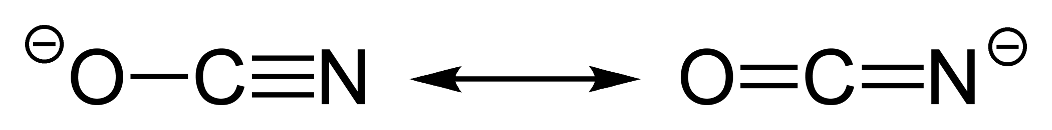

First structure is preferred is Oxygen is more electronegative than nitrogen.

4) Draw a ground-state orbital diagram for Nitrogen which violates BOTH Hund’s rule and the Pauli-exclusion Principle at the SAME TIME and Identify violates

Hund’s rule: fill shell with single occupation before doubling up
Pauli-Exclusion Principle: Electrons in same orbital must have opposite spins.

5) The Heisenberg Uncertainty Principle influences all experiments but is more critical at the atomic level, explain why and illustrate by example AND formal equation!

ΔpΔp > hbar/2 AND the magnitude of test particles( photons/electrons) is large compared to measured objects for atomic/molecular sized systems.

6) Identify 4 ions that are Isoelectronic with Xe? I⁻, Cs⁺, Ba²⁺, La³⁺
7) Which of the following statements are incorrect?
- Atoms tend to get smaller as one goes across the Periodic Table from left to right in a given period.
- Atoms get smaller as one proceeds up a given group.
- For a given pair of isoelectronic ions, cations are larger than anions.
- The first ionization energy for a given element tends to be smaller than the second ionization energy.
- Less electronegative elements tend to have smaller ionization energies.
- The highest Ionization Potentials are in the lower left hand corner of Period Table
8) Illustrate by Reaction Mechanism the BOTH the Electron affinity AND Ionization Energy of Ne

No EA for Ne
IP: Ne ➔ Ne⁺ + 1e⁻

9-11) Estimate the geometric structures AND approximate angles for each of the following structures Make sure to note positions of lone pairs and their effects on angles. ( 15pts)
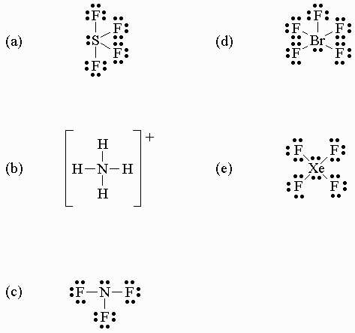

a) Trigonal bipyramidal with lone pair on equatorial position. FSF equatorial < 120 FSF axial-equi <90
b) Tetrahedral with all angles 109.5
c) Distorted tetrahedral with FNF angle less than 109.5
d) Octahedral with lone pair reducing reducing all angles below 90
e) Octahedral with lone pairs canceling and resulting in planar molecule with FXeF = 90 angles.

12 Estimate the enthalpy change for the reaction 2CO + O₂ 2 CO₂ given the following bond energies:

BE(C-O) = 358 kJ/mol
BE(C=O) = 802 kJ
BE(C=O) = 802 kJ
BE(CO) = 1074 kJ,
BE(O=O) = 499 kJ

=-(4*802-2*(1074)-499)
-561

13) Discuss how the Lewis Structure for Molecular Oxygen does not correct explain the reactivity/stability nor its magnetic properties?
- Lewis structure shows no unpaired electrons (contains antibonding occupied orbitals)
- MO theory shows 2 unpaired electron
- O2 is magnetic (paramagnetic)
14) Explain both the shape and polarity of the carbon disulfide, CS₂, molecule linear and non-polar ::S=C=S::

15) What are the Electron Configurations for Fe and Fe⁺³

[Ar] 3d⁶ 4s² [Ar] 3d⁵ 4s⁰
16) Which of these elements has the highest first-ionization energy(3pts) and which would have the highest second ionization energy(2pts)
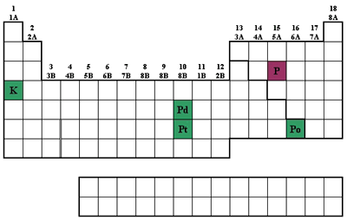
1st IP palladium platinum polonium potassium phosphorus
2nd IP palladium platinum polonium potassium phosphorus

17) What types of hybrid orbitals are involved in bonding of PF₅? dsp³

18) Ozone O₃ consists of a central oxygen atom bonded to the two other atoms.
Draw a resonance structures conforming to the Lewis octet rule.
.. .. .. .. .. ..
:O=O-O:: < == > ::O-O=O: (can not draw lower pair so put on one side)

19) Consider the following molecule(s) and select those that are non-polar AND WHY?
1) PCl₃
2) PCl₅ (no lone pairs)
3) ClF₃
4) ClF₅
No LONE PAIRS and P-Cl polar bonds cancel out

- Draw the Lewis Structure for the molecule O₂NF which has a central Nitrogen atom.

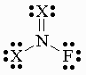 where X is Oxygen

21-22) Step-up in detail the HYBRIDIZED ORBITALS for all atoms in the below amide structure. Show all electrons and note types bonding hybridization; bonding type/order (sigma/pi) as well a angles. (10pts)

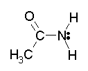C=O both are sp² ; other N and C(CH₃) are sp³

23) Liquid bromoform has a density of 2.89 g/mL. How high a column of bromoform will be supported by a pressure of 730 torr? (density of mercury = 13.6 g/mL).
3435.3 mm
=730*(13.6/2.89)

