1) Place highlighted elements in the periodic table below in order from the smallest atomic radius to the largest? 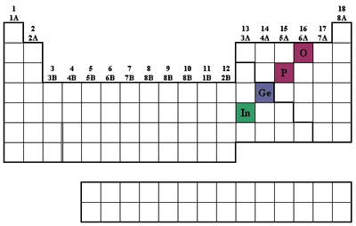
O <P<Ge<In In<Ge<P<O O<P<In<Ge All Have approximately equivalent radius Inadequate Information

2) Which one of the following elements has two or more unpaired electrons in the ground state?
zinc titanium neon scandium cadmium
3) Which of the waves below has the lower wavelength and which has the lower energy?
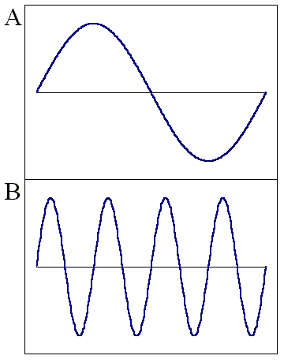
B, A A,A A,B B,B
4) List the following types of electromagnetic radiation in order of increasing frequency:
(i) the gamma rays produced by a radioactive nuclide used in medical imaging
(ii) radiation from an FM radio station at 93.1 MHz on the dial
(iii) a radio signal from an AM radio station at 680 kHz on the dial
(iv) the yellow light from sodium-vapor streetlights
(v) the red light of a light-emitting diode, such as in a calculator display

3,2,5,4,1 1,4,5,2,3 1,2,3,4,5 5,4,3,2,1 2,3,4,5,1

5) What is the lowest n shell in which l=2 and how many ml values are possible
2,1 2, 3 3,3 3,5 not possible

6) Which one of the following representation(s) contains an impossible set of quantum numbers for an electron in an atom (arranged as n, l, m_{l}, and m_{s})?
1, 0, 0, 0
5, 4, -3, 1/2
3, 4, -3, 1/2
2, 1, -1, -1/2

7) Explain why the effective nuclear charge experienced by a 3p electron in sulfur is larger than that experienced by a 3p electron in silicon.
S has a larger nuclear charge than Si.
Sulfur has more electrons than Silicon.
The average number of electrons between a 3p electron and the nucleus is greater in Si than in S.
Not true since Sulfur is larger than Silicon since it has more repulsive non-bonding electrons
8) Which of the following transitions in the Bohr hydrogen atom model affords emission of the highest-energy photon?
E(photon)= -2.18e-18*(1/n_{upper})² –(1/n_{lower})² ergs

n_{i} = 1 --> n_{f} = 6
n_{i} = 4 --> n_{f} = 3
n_{i} = 5 --> n_{f} = 4
n_{i} = 3 --> n_{f} = 6
n_{i} = 3 --> n_{f} = 4
9) Which of these elements has the highest first-ionization energy and which has the highest electron affinity?
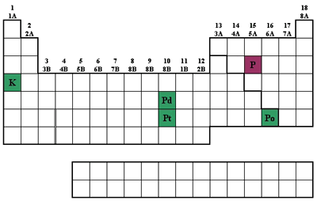
P and P P and Po K and K Po and P Po and Po

10) In which choice below are the elements ranked in order of decreasing first-ionization energy?
Al, S, Si, Cl, Ar
Cl, S, Al, Ar, Si
Ar, Cl, S, Si, Al
Al, Si, S, Cl, Ar
11) Which combination of atoms can form a polar covalent bond?
1. H and H
2. H and Br
3. N and N
4. Na and Br
12) In which atom do we find the largest occupied 3d orbital?

Ga Al Ca Mg As

13) If Na reacts with element X to form an ionic compound with the formula Na₂X, then Ca will react with X to form
Ca₂X₃
Ca₃X₂
CaX
CaX₂

14) Which of the following has the highest ionization energy? Na, Na⁺, K⁺, Mg²⁺ , Mg?
K⁺
Na
Na⁺
Mg²⁺
Mg

15) What is the product of alkali metal with water?
H₂
metal hydroxide
acid
oxygen
does not dissolve
neutral salt

16) Which are not true of alkali metals?
They all are strong reducing agents.
They are found naturally in the pure elemental form in many crystals.
They form hydrides when reacting with hydrogen.
Their reactions with water are very endothermic.
They have brightly colored emissions in a flame.

17) Refer to the partial periodic table reproduced below. Which element has the greatest metallic character?
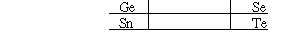

Te Ge Sn Se

Which of the following is the least reactive?
Ca Sr Ba Mg

18) On the television news; it was notes that when the detailed information about bank robberies was reported it they may be affecting future robberies. This illustrates which principle?

  - Boyles’s Law
  - Conservation of Mass
  - Heisenberg Uncertainty Principle
  - Pauli Exclusion Principle FREE RESPONSE

1) Draw the hydridized orbital structure for Acetic Acid and note the angles between the relevant bonds

2) Fill in the following Missing Information
 | λ = c
 | nm | λ meters | Frequency ()
RED | 750
YELLOW | 570
BLUE | 4 | 4.3E-07
UltraViolet x |  |  | 4.0E+15
X-rays | x | 2.20E-09
 | x
Infrared | x | 1.5e-3
Microwave x |  |  | 3.5e+8

3) Balance the following Redox reaction, showing number of electrons transferred as well as which species is oxidized and which reduced.
Al (s) + MnO₄¯ (aq) → MnO₂ (s) + Al(OH)₄¯ (aq)

Al (s) → + Al(OH)₄¯ (aq)
(0) (+3)
Al (s) → + Al(OH)₄¯ (aq) +3e-

MnO₄¯ (aq) → MnO₂ (s)
(+7) (+4)
3e + MnO₄¯ (aq) → MnO₂ (s)

Al (s) + MnO₄¯ (aq) –3e→ MnO₂ (s) + Al(OH)₄¯ (aq)
4 O + 0 H 6 O + 4H

2H₂O + Al (s) + MnO₄¯ (aq) –3e→ MnO₂ (s) + Al(OH)₄¯ (aq)

4) How was the Electro-negativity Table designed (from what pieces and why) and why was it developed?. Using the Electronegativity Table, show four covalent bonds that would be non-polar and explain. Extra Credit: Suggest molecule for each that might include this bond.
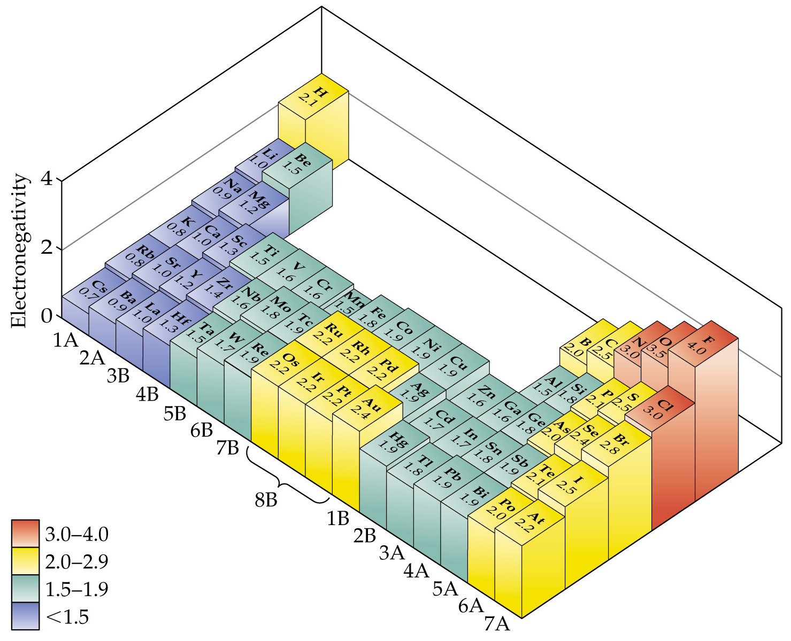

Electronegativity is a theoretical construct or model developed by Pauling to describe the sharing of electrons within bonds. The model is based upon the use of experimental data coming from the Ionization potential (tendency to lose electrons) and the Electron Affinity (tendency to gain electrons).

Choose any pairing of electronegativity were the difference is LESS than 0.5. CH, PH, SiH CP etc…

5) Draw the Lewis Dot structures and hybridized orbitals for N₂ and O₂. Extra Credit N₂O

N₂ is sp with a triple bond while O₂ is sp² with a double bond (O2 a little more complicated as found in nature due to molecular orbitals but this structure largely correct)
O=N=O with a sp N and two sp² O

6) Explain how the Heisenberg Uncertainty Principle influences all experiments and in simple terms why. What is this concept called and who rejected the concept and on what basis. Is this logic sound or not? (Personal opinion here)
ΔxΔp > h or ΔtΔΕ > h Subjective Realism tells us that every experiment changes and influences the object we are measuring and thus dependent on the measurement conditions. Objective Realism tells us that everything has a established set of equations that specifically and completely predict what and where things are and how they will change. Einstein as well as others tended more towards the objective side; while Quantum Mechanics supports subjective realism. Experimental observation tells us that we need to accept the subjective interpretation.

7) Bond Enthalpy
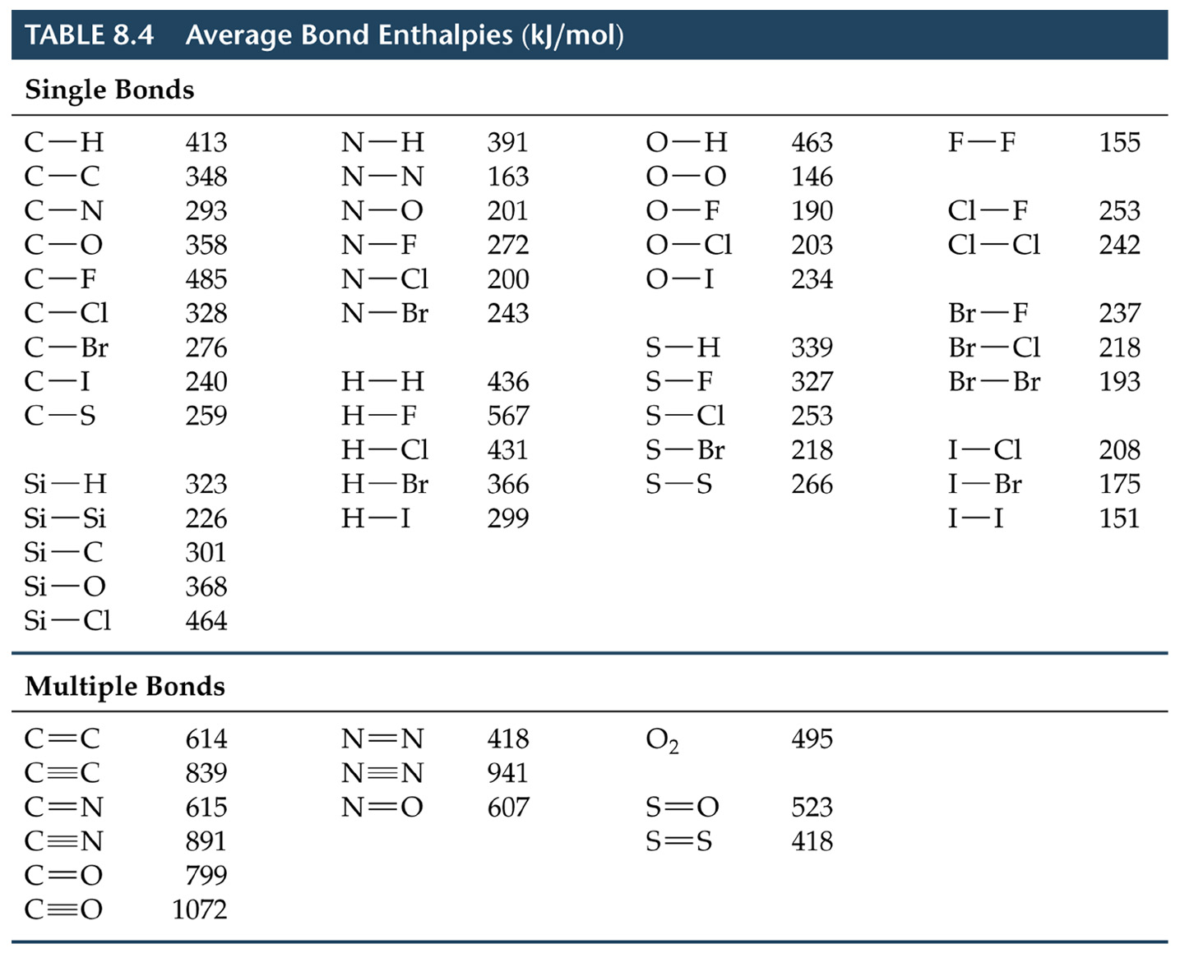
Using the bond enthalpies above, illustrate using Hess’s Law the partial oxidation stages of methane to first CO and water and then CO₂ and water. (Hint the process as two balanced step equations/processes and the compare with NET reaction)

2CH₄ + 3O₂ ➔ 2CO + 4H₂O
2CO + O₂ ➔ 2CO
_
2CH₄ + 4O₂ ➔ 2CO₂+ 4H₂O

2CH₄ + 3O₂ ➔ 2CO + 4H₂O |  |  |  |  | -1059 |  | 2*1072+8*463- (8*413+3*495)
2CO + O₂ ➔ 2CO₂ |  |  |  |  | -557 |  | 4*799-(2*1072+495) |  |  |  |  | sum= |  | -1616
_
2CH₄ + 4O₂ ➔ 2CO₂+ 4H₂O |  |  |  |  | -1616 |  | 4*799+8*463-(8*413+4*495)
 |  |  |  |  |  | CH | 413
 |  |  |  |  |  | OH | 463
 |  |  |  |  |  | O2 | 495
 |  |  |  |  |  | C=O | 799
 |  |  |  |  |  | C=O | 1072

8) Draw a ground-state orbital diagram for Carbon which violates BOTH Hund's rule and the Pauli-exclusion Principle.

Any configuration of Carbon in which electrons are NOT added SEPERATELY in each subshell to each orbital before doubling AND electrons are incorrectly placed with SAME spin in SAME orbital

9) Explain the concept of Electron Exchange and how it influences the occupation of orbitals and thus the reactivity of atoms and molecules. (HINT: Radials etc)

Even though electrons largely repel each other, there is a NON-CLASSICAL force called exchange in which electrons can exchange among themselves if they have opposite spins. This results in a slight attraction between the electrons allowing them to exist with opposite spins within the same orbital

10) Use the VSEPR model to discuss the angles in CO₂;Benzene; NH₃ and SF₅
CO₂ is linear (2 domains) Benzene (C₆H₆) is sp² and thus each C has 3 domains ➔ 120 º
NH₃ is tetrahedral(4 domains) but distorted due to one nonbo0nding pair thus angle is 107º and not 109.5
SF5 is trigonal bipyramidal (5 nodes)

11) Using your knowledge of atomic size and electronegativity, EXPLAIN the trend of the alkali metals to go from oxides to peroxides to superoxides as we move through through the periodic table. Be specific here to get full credit

Going down alkali metals results in more and more reactive metals. Resulting in metals near the bottom which react so fast with O2 that they never allow the O – O bond to break and form first peroxides and then superoxides. These are reactive but somewhat stable intermediates which do decompose to oxides with time.

12) Using your general knowledge of quantum levels of atoms, explain why some elements have unique flame test colors while others do not.
Each element has it’s UNIQUE set of quantum states, both occupied and unoccupied (available for excited states). When exciting any element, electrons are promoted to higher orbitals and then fall back down to the original levels RELEASING unique E&M radiation. SOMETIMES these freqencies just happen to fall in the visible. But there are always transitions that can be see by more sensitive detectors than our eyes---spectroscopy/spectrophotmeters.

13) The biggest jumps in atomic size for elements is found between noble gas atoms the immediate alkali metal that follows in the periodic table. Explain why this jump is so much bigger than any other. You need to be very specific here, not an completely transparent question.
The step between a noble gas and the next larger element which is a alkali metal is a big one in size since it involves bringing a whole NEW AND LARGER n shell into place.

14) What is the Enthalapy of Formation of LiF_{(s)}

Sublimation energy for Li is | +159.4 kJ mol⁻¹,
The first Ionization Potential for Li is | +520 kJ mol⁻¹,
The Electron Affinity of F is | -328 kJ mol⁻¹,
Bond dissociation energy for F₂ is | +158 kJ mol⁻¹).
Lattice Energy is | -1080 kJ mol⁻¹

Remember to include half of the bond dissociation energy of F₂
Li(s) + 0.5F₂(g → LiF(s) ΔH°_{f} = - 570.6 kJ/mol

Extra Credit: Using the general definition of lattice energy.
Suggest at what RELATIVE bond length might this reaction NOT be exothermic.
As we increase the bond length the lattice energy decreases. If we decrease the lattice energy by roughly two the other enthalpies would overwhelm it.
In order to decrease the lattice energy by two we would need to increase the bond length the two.

15) Show all of the possible oxidation states of Fe and discuss which TWO of these are most common and why one is most stable.
Iron has 2 4s electrons and 6 3d electrons. Thus there could be as many as 5 oxidation states since we start with +2 where we lose to 4s. The most likely are Fe⁺² where we leave only the 4s⁰3d⁶ electrons and THE MOST STABLE 4s⁰3d⁵ where we have a HALF FILLED d subshell.

16) Discuss the Schrodinger equation; where do the conventional atomic orbitals and quantum numbers come from and why do some electron structures not follow the simpliest order in occupancy. Need substantial detail for full credit

HΨ=EΨ which is a COMPLEX differential equation with ONLY an exact solution for the Hydrogen Atom. This solution(s) results in the quantum numbers which we use to try to interpret all of the larger elements. Obviously the further we are away from H on the periodic table, the greater is the error.

