Experiment 2: Spectrophotometric Determination of Iron

February 15, 2012
Purpose:
The goal of this experiment is to collect the absorbance of solutions with varying iron concentrations and create an absorbance vs. concentration graph. This graph will then be used to determine the concentration of an unknown iron solution based on its absorbance.
Materials:
Equipment:
- Parafilm
- 10 mL graduated cylinder
- 25 mL volumetric flasks
- Pipet
- 50 mL burette
- 100 mL beaker
- Cuvette and cover
- Genesys 20 Spectrophotometer
- Kimwipes

Chemicals:
- Nano-pure water
- 0.0001803 M Iron Solution
- 1.44 M Hydroxylamine hydrochloride
- Sodium acetate solution
- Orthophenanthroline
- Unknown # 3

Procedure:
Begin by adding the appropriate amount of iron solution into each volumetric flask. Then add, in this order, hydroxylamine hydrochloride, sodium acetate solution, and orthophenanthroline. Fill the remainder of the flask with nano-pure water. Invert solution using parafilm. Let the solutions sit for at least 5 minutes. While waiting, begin warming up the spectrophotometer. Run for at least 5 minutes before initial use. Place the blank solution into a clean cuvette. Clean with a kimwipe. Place the cuvette into the spectrophotometer. Set to appropriate wavelength for optimal absorbance. Press the 0 ABS 100% T button and make sure the read out is set to 0.000 A. Dispose of the blank solution into a waste breaker. Rinse the cuvette with the least concentrated solution and place into the waste beaker. Fill with the same solution and clean the cuvette with a kimwipe. Place cuvette into the spectrophotometer and record its absorbance value into data table 1. Dispose of the solution into a waste beaker and again fill the cuvette with blank solution. Set the absorbance so that the readout is once again 0.000 A. Repeat the above process for the remaining four iron solutions being sure to use the least concentrated solution first. Using the data from data table 1, create an absorbance vs. concentration graph (figure 1).
For the unknown determination, obtain an unknown iron solution. Fill the cuvette with blank solution and place into the spectrophotometer. Make sure the absorbance readout is 0.000A before placing the unknown solution into the cuvette. Rinse the cuvette with the unknown iron solution and dispose of into a waste beaker. Refill the cuvette with the unknown solution and place into the spectrophotometer. Record the absorbance value and place in data table 1. Using the graph, determine the concentration of the unknown iron solution.

Results:
Table 1: Absorbance Values for Various Concentrations of Iron
mL Iron in solution | Absorbance Value | Concentration of Iron (M)
0.00 | 0.000 | 0.00
2.50 | 0.198 | 1.80 x 10⁻⁵
5.00 | 0.406 | 3.61 x 10⁻⁵
7.50 | 0.573 | 5.41 x 10⁻⁵
10.00 | 0.750 | 7.21 x 10⁻⁵
12.50 | 0.625 | 5.97 x 10⁻⁵
Unknown # 3 | 0.722 | 6.92 x 10⁻⁵
Determination of concentrations:
M₁V₁=M₂V₂
Blank: (0.0001803 M) (0.00 mL) = M₂ (25.00 mL)
M₂= 0.00 M Iron
2.50 mL: (0.0001803 M) (2.50 mL) = M₂ (25.00 mL)
M₂= 1.80 x 10⁻⁵ M Iron
5.00 mL: (0.0001803 M) (5.00 mL) = M₂ (25.00 mL)
M₂= 3.61 x 10⁻⁵ M Iron
7.50 mL: (0.0001803 M) (7.50 mL) = M₂ (25.00 mL)
M₂= 5.41x 10⁻⁵ M Iron
10.00 mL: (0.0001803 M) (10.00mL) = M₂ (25.00 mL)
M₂= 7.21x 10⁻⁵ M Iron
12.50 mL: (0.0001803 M) (12.50 mL) = M₂ (25.00 mL)
M₂= 5.97x 10⁻⁵ M Iron
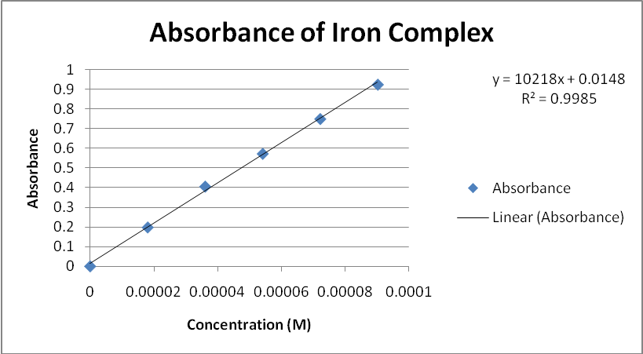
Figure 1: Absorbance of Iron Complex

Determination of Unknown Iron Concentration:
Y= mx + b {y= unknown absorbance; x= unknown iron concentration; m= molar absorptivity}
Y= 10218x +0.0148
0.722= 10218x +0.0148
0.7072= 10218x
X= [concentration unknown # 3] = 6.92 x 10⁻⁵ M Iron
The absorbance values for varying iron concentrations were determined and recorded in data table 1. As the concentration of the iron increased, so did the absorbance value. The unknown iron solution’s concentration was calculated using the equation generated by the graph depicted in figure 1. The data shows a fairly linear correlation. Unknown # 3 was determined to have a concentration of 6.92 x 10⁻⁵ M Iron.

Conclusion:
The absorbance values of solutions with various iron concentrations were recorded and used to create a graph of absorbance vs. concentration. As the concentrations of the solutions increased, so did their absorbance values. The line depicted in the figure shows a linear correlation between absorbance and concentration. An equation was generated based on the data. The resulting equation was y= 10218x + 0.0148. This equation was used to determine the concentration of iron in the unknown solution. The absorbance of the unknown was placed in the equation for y and x, the unknown iron concentration, was solved for. The concentration of the iron unknown solution was calculated to be 6.92 x 10⁻⁵ M.
No experiment is 100% accurate and thus an analysis of error must be conducted. Volumetric flasks can be rather difficult to use when trying to create a precise solution. One extra drop to the standard could produce an incorrect concentration. If there was a drop more than the 25 mL mark, the concentration would be more dilute and the solution would give a slightly lower absorbance reading that expected. This reading would adjust the equation line regarding the graph and would affect the calculated unknown concentration. When using the spectrophotometer, using a cuvette with a scratch or crack it in could result in error. A scratched cuvette might affect the path of light through the solution and thus give an incorrect absorbance reading. This again would affect the graph as well as the equation of the line. Each compound has a wavelength at which the compound reaches its maximum absorbance. For the Iron (II) phenanthroline complex, the maximum absorbance occurs at a wavelength of 508 nm. Failing to record the various absorbance values at the wavelength of 508 nm would result in values that were lower than it should be. As seen before, this would affect the equation of the line and would give a lower concentration for the unknown iron solution.
In order to try and resolve the sources of error there are numerous things that could be done. Squatting down at eye level and using a pipet to get the exact volume will ensure the best results and help to reduce error when using the volumetric flask. Picking a good cuvette and taking care of it will help to ensure that all light will pass through the solution. A good cuvette is one that has no scratches or marks and is thoroughly cleaned with kimwipe after being picked up. After determining the maximum absorbance value for a solution, making sure the spectrophotometer is set at that wavelength is vital. In order to confirm that the correct value is chosen, going up or down a couple wavelengths can help confirm the correct wavelength max was chosen.

Experiment 3: EDTA Determination of Total Calcium and Determination of Individual Calcium and Magnesium

February 29, 2012

Purpose:
The goal of this experiment is to prepare a standardized ethylendiaminetetraacetic acid (EDTA) solution and use it to determine the total hardness of an unknown solution. The unknown solution will also be analyzed through an ion chromatogram to determine the individual calcium and magnesium concentrations in addition to total hardness.
Materials:
Equipment:
- Analytical balance # 1
- Scoopula
- 1L Volumetric Flask
- Glass stopper
- 50 mL burette
- 100 mL beaker
- 50 mL burette
- 1L storage bottle
- 250 mL Erlenmeyer flask
- Parafilm
- 25 mL volumetric pipet
- 10 mL graduated cylinder
- 25 mL volumetric flask
- Pipet
- Ion Chromatogram
- Micropipette with tips
- Hot plate
- Stirring rod
- 400 mL beaker
- Drying oven
- Desiccator
Chemicals:
- Ethylenediaminetetraacetic acid (EDTA)
- MgCl₂ ∙ 6 H₂O disodium salt
- Nano-pure water
- CaCO₃
- 12 M HCl
- pH 10 NH₄/ NH₄Cl buffer
- Ascorbic acid
- Calmagite indicator
- Unknown letter G

Procedure:
Standardization of EDTA
Weight the correct amount of EDTA and MgCl₂ ∙ 6 H₂O disodium salt. Place solids into a 400 mL beaker and begin to dissolve into nano-pure water. Place beaker on a hot plate in order to assure that the solid completely dissolves. Cool to room temperature on an inverted beaker. Transfer the contents in the beaker to a volumetric flask and fill the remainder of the flask with nano-pure water. Cover with parafilm and mix by inversion. Transfer the EDTA solution into a clean storage bottle and cap with a glass stopper. To prepare your calcium standard, weight the appropriate amount of CaCO₃ and place into a beaker filled with nano-pure water. Once partially dissolved, transfer to a volumetric flask. Using a graduated cylinder, measure the correct amount of 12 M HCl and place into the volumetric flask. Dilute solution with nano-pure water. Cover with parafilm and mix by inversion. Using a beaker, transfer the EDTA solution to a burette. Obtain a clean volumetric pipet and measure the correct amount of CaCO₃ solution. Place into an Erlenmeyer flask. Using a graduated cylinder, add buffer solution. Next add the appropriate amount of ascorbic acid. Add Calmagite indicator and titrate until a deep blue persists. Note the start and stop volumes of EDTA and record these results in data table 1. Conduct at least 4 trails.
Determination of Total Hardness by Titration with Standardized EDTA
Obtain an unknown solution of CaCO₃. Transfer the correct amount of unknown solution, using a volumetric pipet, into an Erlenmeyer flask. Add the correct amount, by use of a graduated cylinder, of buffer into to an Erlenmeyer flask. Weight the correct amount of ascorbic acid and also place into the Erlenmeyer flask. Add Calmagite indicator and titrate until a deep blue persists. Note the start and stop volumes of EDTA and record these results in data table 2. Conduct at least 4 trails. Report total hardness in ppm.
Analysis of a the Unknown via Ion Chromatography
Obtain the appropriate amount of unknown using a micropipette to create a 10 times dilution. Fill to the line with nano-pure water. Cover with parafilm and invert to mix. The unknown solution will be run thought the ion chromatogram. Once complete, place the results for each individual ion concentration values, in ppm, into data table 3. Calculate total hardness in ppm.
Results:
Determination of Calcium Carbonate Standard solution
Mass EDTA: 3.7529 g EDTA
Mass MgCl₂ ∙ 6 H₂O disodium salt: 0.1025 g MgCl₂ ∙ 6 H₂O
Mass CaCO₃: 1.0010 g CaCO₃
M CaCO₃ = = = 0.010001 M

Table 1: Standardization of EDTA
Trail Number | Mass of Ascorbic Acid (grams) | EDTA Volume needed (mL) | Molarity EDTA
1 | 0.0106 g | 26.10 mL | 0.009580 M
2 | 0.0111 g | 26.00 mL | 0.009616 M
3 | 0.011 g | 26.15 mL | 0.009561 M
4 | 0.0116 g | 26.05 mL | 0.009598 M

Mean Molarity: 0.009589 M EDTA
STD: 2.360 x 10⁻⁵
Ppt: 2.464
Molarity of EDTA:
(V_{EDTA}) (M_{EDTA}) = (V_{Ca} _{solution})(M _{ca solution})
Trial 1: (26.10 mL EDTA)( M_{EDTA}) = (25 mL Ca solution) ( 0.010001 CaCO₃) = 0.009580 M EDTA
Trial 2: (26.00 mL EDTA)( M_{EDTA}) = (25 mL Ca solution) ( 0.010001 CaCO₃) = 0.009616 M EDTA
Trial 3: (26.15 mL EDTA)( M_{EDTA}) = (25 mL Ca solution) ( 0.010001 CaCO₃) = 0.009561 M EDTA
Trial 4: (26.05 mL EDTA)( M_{EDTA}) = (25 mL Ca solution) ( 0.010001 CaCO₃) = 0.009598 M EDTA

Mean Molarity of EDTA :
Mean value=
= 0.009589 M EDTA

Standard Deviation for EDTA:
Standard deviation= 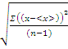
= 0.00002360

Parts Per Trillion (EDTA):
Ppt (EDTA) = 1000 x (standard deviation)/mean= 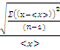 where n is the number of trails
ppt= 1000 x = 2.464

Table 2: Determination of total Hardness of Unknown by Titration with Standardized EDTA
Trail Number | Mass of Ascorbic Acid (grams) | Volume of EDTA Needed (mL) | M Ca/Mg | Total Hardness (Ppm)
1 | 0.0120 g | 32.00 mL | 0.01227 M | 491.757 ppm
2 | 0.0122 g | 32.00 mL | 0.01227 M | 491.757 ppm
3 | 0.0104 g | 32.05 mL | 0.01229 M | 492.558 ppm
4 | 0.0118 g | 32.00 mL | 0.01227 M | 491.757 ppm

Mean Total Hardness of Water: 491.957 ppm
Mean M Ca/ Mg: 0.01228 M Ca/Mg
STD: 1.000 x 10 ⁻⁶
Ppt: 0.08147
Molarity of Ca/Mg:
(X M Ca/Mg) (V_{soln}) = (M _{EDTA})(V_{EDTA})
Trail 1, 2, 4: (X M Ca/Mg)(25 mL Soln) = (0.009589 M EDTA) (32.00 mL EDTA)
= 0.01227 M Ca/Mg
Trail 3:(X M Ca/Mg)(25 mL Soln)=(0.009589 M EDTA)(32.05 mL EDTA) = 0.01229 M Ca/Mg
Standard Deviation for M Ca/Mg :
Standard deviation=
=
Parts Per Trillion (EDTA):
Ppt (EDTA) = 1000 x (standard deviation)/mean= where n is the number of trails
ppt= 1000 x = 0.08147

Total Hardness:
M Ca/Mg * 40.078 g/mol * 1000 mg/g
Trial 1, 2, 4: 0.01227 mol/L * 40.078 g/mol * 1000 mg/g = 491.757 ppm
Trial 3: 0.01229 mol/L * 40.078 g/mol * 1000 mg/g = 492.558 ppm

Mean Total Hardness:
Mean value=
= 491.957 ppm

Analysis of a Unknown via Ion Chromatography:
Data Table 3: Analysis of an Unknown via Ion Chromatography
Trial Run | Concentration Calcium (ppm) | Concentration Magnesium (ppm) | Total Hardness in terms of Ca⁺² (ppm)
1 | 8.092 ppm | 24.466 ppm | 484.4 ppm
2 | 8.192 ppm | 24.454 ppm | 485.2 ppm
Mean Total Hardness in terms of Ca⁺²: 484.8 ppm
Figure 1: Conductivity vs. Time for Run #1: Unknown G

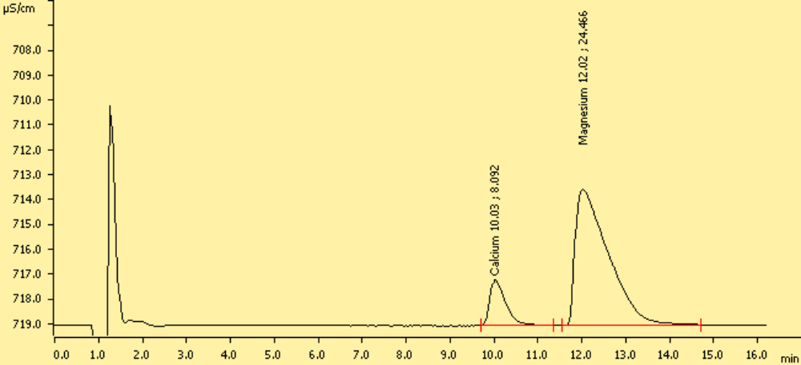
Values displayed on chromatogram, in order: Ion name, retention time (minutes), concentration in ppm
Calcium, 10.03 minutes, 8.092 ppm
Magnesium, 12.02 minutes, 24.466 ppm

Figure 2: Conductivity vs. Time for Run #2: Unknown G

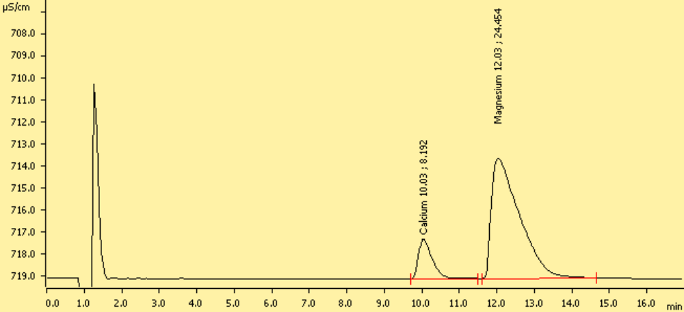
Values displayed on chromatogram, in order: Ion name, retention time (minutes), concentration in ppm
Calcium, 10.03 minutes, 8.192 ppm
Magnesium, 12.03 minutes, 24.454 ppm

Total Hardness as Ca⁺²:

10*(Ca⁺² ppm + Mg⁺² ppm (40.078/24.3050))

Trial 1:

10*(8.092 + 24.466(40.078/24.3050)) = 484.4 ppm Total Hardness as Ca⁺²

Trial 2:

10*(8.192+ 24.454 (40.078/24.3050)) = 485.2 ppm Total Hardness as Ca⁺²

Mean Total Hardness as Ca⁺²:
Mean value=
=

Average total hardness as Ca⁺² ppm: 484.8 ppm

The calcium carbonate standard solution was determined to be 0.010001 M. The mean molarity of the standardized EDTA was determined to be 0.009589M. The standard deviation of the EDTA molarity was 2.360 x 10⁻⁵ and the ppt was calculated to be 2.464. The mean value of total hardness of the unknown by titration was found to be 491.957 ppm. Figure one displays the concentration values of both calcium and magnesium via ion chromatography. For the trial one, the concentration of calcium was found to be 8.092ppm and the concentration of magnesium was found to be 24.466 ppm. The mean molarity of Ca/Mg was found to be 0.01228 M. Figure two also the concentration values of both calcium and magnesium via ion chromatography. Trial 2 was found to have calcium concentration of 8.192 ppm and magnesium concentration 24.454ppm. Mean total hardness as Ca⁺² determined from the ion chromatogram was found to be 484.8 ppm.
Conclusion:
The lab began by creating a standardized calcium carbonate solution that would act as the primary standard for EDTA. The determined molarity of the calcium carbonate solution was found 0.010001 M. The mean EDTA molarity was determined to be 0.009589M. The standard deviation was found to be 2.360 x 10⁻⁵. This relatively low standard deviation means that there was not a very large variation between the values of each trial and mean value. The ppt for the molarity of EDTA was found to be 2.464 and this is under the accepted value of 5. The next portion of the lab was to determine the total hardness of unknown by titration. The mean molarity Ca/Mg was determined to be 0.01229 M. The average total hardness was calculated to be 491.957 ppm. The standard deviation for this molarity was found to be 1.000 x 10⁻⁶. This very low standard deviation means that there was not a very large variation between the values of each trial and mean value. The ppt for this data set was 0.08147. This value is well below the accepted value of 5. An ion chromatography was conducted on the unknown solution. Two separate trials were conducted. The first trial had a calcium concentration of 8.092 ppm, a magnesium concentration of 24.466 ppm, and had a total hardness 484.4 ppm. The second trial had a calcium concentration of 8.192 ppm, a magnesium concentration of 24.454 ppm, and had a total hardness 485.2 ppm. The mean total hardness resulting from ion chromatography was found to be 484.8 ppm Ca⁺².
No experiment is 100% accurate and thus an analysis of error must be conducted. EDTA did not readily dissolve in solution and as such, it had to be dissolved in a small beaker before entering the volumetric flask. Upon transfer, there were a few undissolved EDTA crystals left along the sides. Leaving these crystals in the beaker would cause the mass of the EDTA in solution to be less and as such, the concentration of the EDTA solution would be less than the calculated value. When determining the concentration of the unknown calcium carbonate solution poor burette readings could affect the results. Improper burette usage could result in too little EDTA solution reacting with the calcium carbonate solution. If the number was higher than the actual value, the concentration would be lower. If the burette reading was lower than the actual value, the concentration would be higher than it should be. Another source of error could occur when making the 10 times diluted unknown solution for ion chromatography. Incorrectly using the micropipette would result in the wrong calcium and magnesium concentrations. An example of which could be not pushing down all the way on the trigger in order to ensure the right amount of solution went into the tip. Have less than 2.5 mL of unknown in your solution would make the concentration of each ion be less than actually is present in the unknown.
In order to try and resolve the sources of error there are numerous things that could be done. When transferring the beaker filled with EDTA solution into the volumetric flask, washing the sides of the beaker with nano-pure water into the volumetric flask will help ensure the maximum amount of EDTA in the solution. Practicing good burette skills using a burette card could help eliminate misreadings. It would be a good idea when using the micropipette to test drawing up the correct amount of fluid in order to greatly reduce error and ensure the correct amount of unknown is used for the dilution.

