Examples of Reaction Kinetics

Consider a reaction of Butyl chloride in water to form butyl alchohol:
C₄H₉Cl + H₂O ⇒ C₄H₉OH + HCl

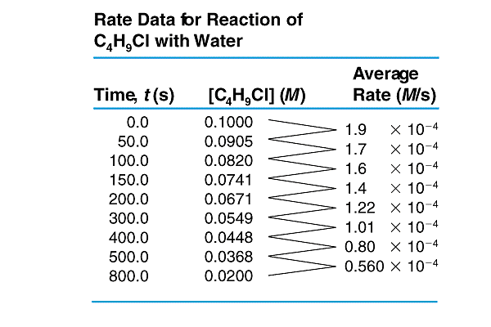
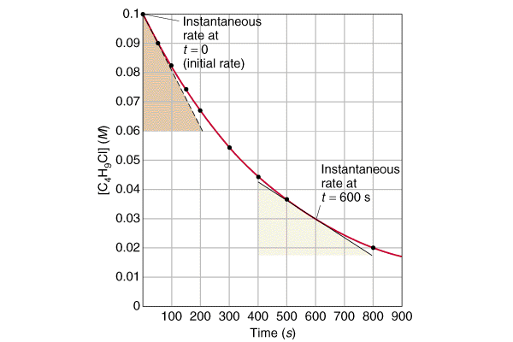

- The Rate Law tells us the instantaneous rate (the slope of the curve) as a function of concentration.
- The Integrated Rate Law tells us the concentration as a function of time (the curve itself)

Time, t(s) | [C₄H₉Cl] | ln[C₄H₉Cl]
0 | 0.100 | -2.303
50 | 0.091 | -2.402
100 | 0.082 | -2.501
150 | 0.074 | -2.602
200 | 0.067 | -2.702
300 | 0.055 | -2.902
400 | 0.045 | -3.106
500 | 0.037 | -3.302
800 | 0.020 | -3.912

k = -m = (-3.912- -2.303)/ (800-0) = 0.00201 sec⁻¹
[C₄H₉Cl](time) = 0.1* exp[-0.00201*t]
.

Consider the ISOMERIZATION of
Methyl Isonitrile to Acetonitrile
CH₃NC ⇒ CH₃CN

For Gases one can use Pressure instead on Concentrations.
P_{f} /P_{i} = M_{f} RT/M_{i} RT = M_{f} /M_{i}

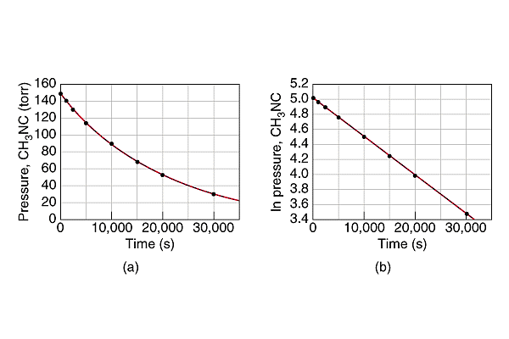
k= - m = -(3.40-5.01)/(30,000-0) = 5.36 x 10⁻⁵ sec⁻¹
p(CH₃NC) = 152 torr* exp(- 5.36x10⁻⁵*t)

Another way to look at the same data is to determine the HALF LIFE of the reaction, i.e. the time it takes to deplete half of the reactants.
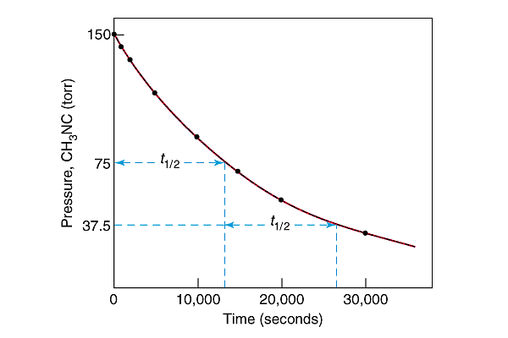
the half life, or t_{1/2} can be derived from the integrated rate law as:
t_{1/2} = (ln 2) / k = 0.693/5.36 x 10⁻⁵ sec⁻¹ = 12,929 sec ~ 13,000 sec
The half life is a constant (independent of concentration) for a first-order reaction only!
Now let’s consider the Second-order reaction is that of the gas-phase decomposition of NO₂
2 NO₂ ⇒ 2 NO + O₂
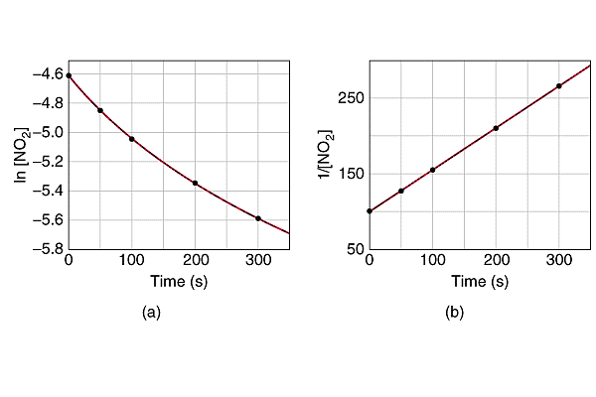
k= m=(265-100)/300 = 0.55 M⁻¹sec⁻¹

^{1/[NO}₂^{] = 1/0.01 + 0.55*t}

Panel (a) shows a plot of the log of the concentration of reactant versus time. It is NOT a straight line and the reaction is NOT first order in reactant.
Panel (b) shows the inverse of the concentration versus time which is a straight line for a second order reaction. This plot is a straight line because the integrated rate law for a second order reaction is

Kinetics of Simple Rate Laws: A Summary
Consider the reaction of A ⇒ Products.
The rate of this reaction is defined as the negative time rate of change of the reactant concentration or
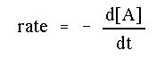
If the reaction had a more complicated stoichiometry, it will still have a rate that can be defined in terms of any one of the reagents or products.
For instance, if a reaction 2A + 3B -> C + 4D is observed, the rate of that reaction is defined as:
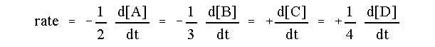
The kinetics of any reaction depend on the reaction mechanism, or rate law, and the initial conditions. If we assume for the reaction A -> products there is there is an initial concentration of reactant of [A]₀ at time t=0, and the rate law is an integral order in A, then we can summarize the kinetics of the reaction as follows:
 | Zeroth Order | First Order | Second Order
Rate Law | 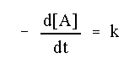 | 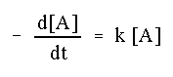 | 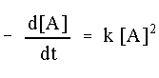
Integrated Rate Law | 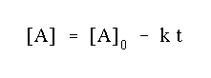 | 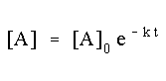 | 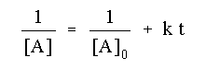
Units of Rate Constant {k} |  |  | 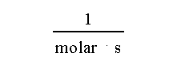
Linear Plot | [A] vs. t | ln([A]) vs. t | 1/[A] vs. t
Half-life | 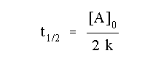 | 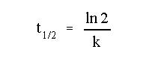 | 