Exploring Excel and how it can be Applied to Your Data

You will be utilizing Excel to perform some common basic calculations and plot data for graphical representation and analysis. You will use two different methods to find a linear regression model for real data and compare the results. You will learn how to display error bars in a graph using Excel. And you will explore how Excel can be used for basic statistical analysis of data.

All equations must be programmed into Excel. If possible, use short-cut formulas and methods. For example the standard deviation of a set of data can be found using =stdev(A1:F1) instead of the long hand equation. Explore Excel and try to find other built in functions and keyboard short-cuts to make things faster.
THE BASICS
Use the data found below to determine the mean, standard deviation, percent relative standard deviation, and the ppt. Use formulas and equations in Excel to determine these values.

The above data is taken from repeated analysis of the same sample. What would you say about the precision of the data? Is this acceptable? Why or why not?
Calculations Using Excel
Excel can be very useful for rapidly performing necessary and/or repeated calculations. Use the data to below to perform the requested calculations in Excel. Remember to program all formulas into excel. Use “shortcut” formulas were possible.

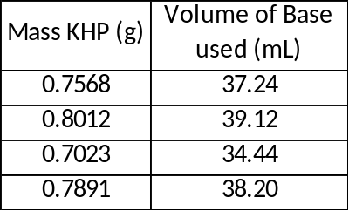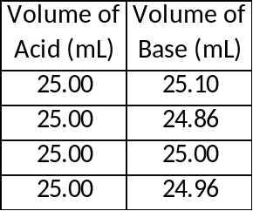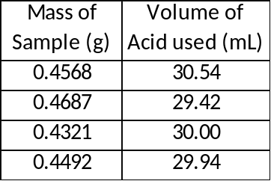
For the first set of data determine the average concentration of the base and the average, standard deviation, and ppt of the measurements. The molecular weight of KHP is 204.22 g/mol. Assume the base reacts in a one-to-one ratio with KHP.
For the second set of data determine the average concentration of the acid and the average, standard deviation, and ppt of the measurements. Assume the acid and base react in a one-to-one ratio.
For the final set of data determine the average percent of unknown that is present in the sample and the average, standard deviation, and ppt of the measurements. Assume for every 2 moles of acid reacted, 1 mole of unknown is formed. Further assume that the molecular weight of the unknown is 106 g/mole.
How good is the precision of these data sets? What would you recommend doing to improve the statistics determined (average, standard deviation, and ppt)?
LINEAR REGRESSION MODELS
The data below is spectrophotometric data of a solution containing an iron complex with a maximum absorbance at 510 nm and will be utilized in this exercise.

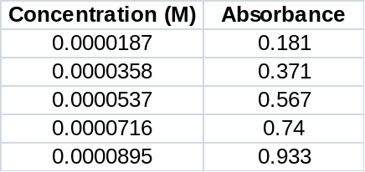

Plot the above data appropriately (Abs vs. Conc.) and display the line of best fit, the equation for the line and the correlation coefficient on the graph. Be sure to appropriately title the graph and label the axis. What is the determined line of best fit?

There are two other methods to find the linear regression model using Excel. Identify one and perform the necessary calculations to get the linear regression model and correlation coefficient. What is the equation for the line of best fit and the value for the correlation coefficient?

Is the linear regression model found above a good representation for the data? Is the data useable for a calibration curve? Why or why not? Do the two methods used for finding the linear regression model agree with each other?

SOME STATISTICAL MANIPULATIONS USING EXCEL
Tables with some applicable test values are found at the end of the assignment

Grubbs test for an outlier
Data points which appear to be an outlier in the set are often encountered. But these points cannot simply be removed from the data set without some form of justification. It may be easiest to find error in the techniques used, such as over titrating, but this may not always be the case. The Grubbs Test is a statistical analysis of the data point believed to be an outlier. The Q-test can also be used, but the Grubbs Test is more widely accepted and recommended.

The Grubbs Test uses the mean () and standard deviation (s) of the complete data set:
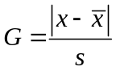
where x is the questionable value. If G_{calc} is greater than G_{table} (G_{calc} > G_{table}), the suspect value can be removed from the data set. Generally the value for the 95% confidence interval is used for G_{table}. A table of values for G can be found in the Harris textbook on page 92. Note that you need at least 4 trials before you can determine if an outlier exists.

From the following two sets of data, determine if any point can be removed from either set. In the Excel worksheet, use formulas and equations for all calculations.

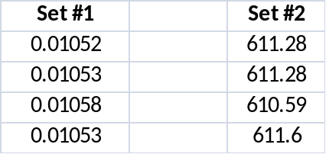

Which point(s) from which set(s) can be removed? Why or why not?

The F-Test
The F-test is used to determine if the standard deviations from two data sets are significantly different from each other. The information found from this test can be used to determine which T-test needs to be performed (discussed later).
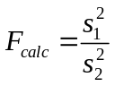
The larger standard deviation is always placed in the numerator so that F ≥ 1. If F_{calc} > F_{table} then the difference is significant. The table below gives values for F various levels of significance.

For the data below, are the standard deviations significant? Program Excel with all the necessary formulas and equations to determine this.

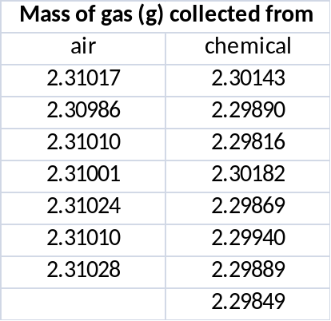

The T-tests
The T-test, or student’s t, is used to compare two sets of measurements to decide whether or not they are the “same” and can be considered together as a single set. The basis of the T-test is that we are testing a null hypothesis, which states that the mean values from the two sets of measurements are not different. Typically a p value of 0.05 is used for analysis. If T_{calc} > T_{table} the difference is significant. See the table below for the table values at four different confidence levels.

There are three different cases of the T-test, two of which will be explored here.

Case 1
A quantity is measure several times by a single method and an average value is obtained. We want to compare our value to the accepted value. Does the measured value agree with the actual value within experimental error?

A sample was measured 4 times resulting in values of 3.29, 3.22, 3.30, and 3.23. The accepted value for the sample is 3.19. Use Excel to find all necessary values. Does the measured value agree with the actual value within experimental error (using 95% confidence)?

Case 2
A quantity is measured several times by two different methods that result is two different average values each with a unique standard deviation. Do the two results agree with each other within experimental error?

Use the data from the F-test exercise. Analyze the data using both T-tests (assuming equal variance and assuming unequal variance). This can be found in the Data Analysis Tool Pack. From each method, do the results agree with each other within experimental error? If the standard deviations are significantly different, the T-test for unequal variances must be used. Based on your results from the F-test which method of T-test should be used? For further explanation, consult section 4-3 in the Harris textbook.

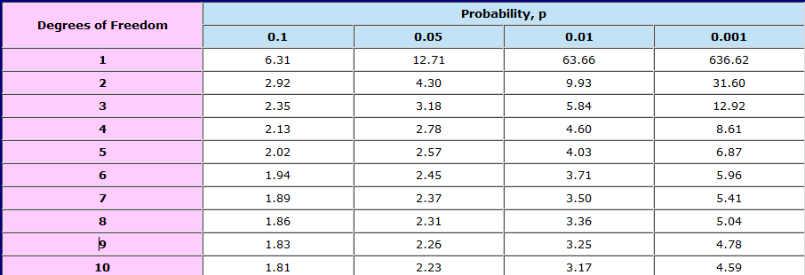
Table for T-test
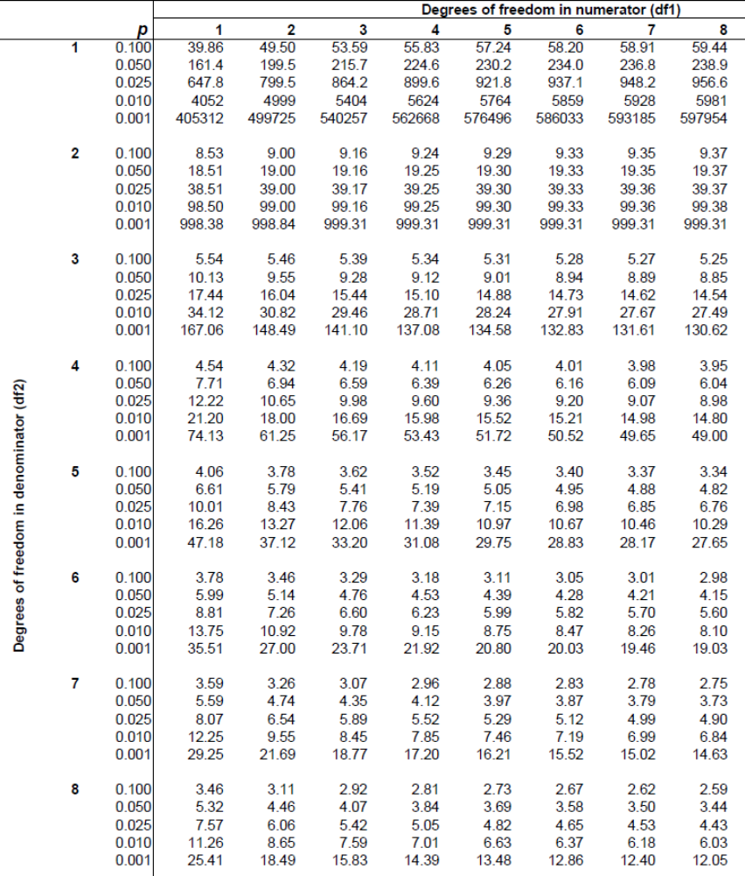
Table for F-Test

