Utilizing Excel for Graphical and Basic Statistical Analysis of Data

You will be utilizing Excel to perform some common basic calculations. Excel can also be used to plot data for graphical representation and analysis. You will use three different methods to find a linear regression model for real data and compare the results. Finally, you will learn how to display error bars in a graph using Excel. All instructions are based on Excel 2007.
THE BASICS
Use the data found below to determine the mean, standard deviation, percent relative standard deviation, and the ppt. Use formulas and equations in Excel to determine these values.

The above data is taken from repeated analysis of the same sample. What would you say about the precision of the data? Is this acceptable? Why or why not?
LINEAR REGRESSION MODELS
The data below is spectrophotometric data of a solution containing an iron complex with a maximum absorbance at 510 nm and will be utilized in this exercise.

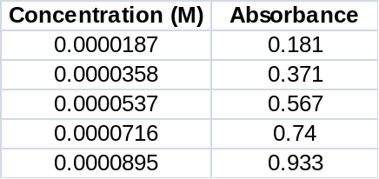

Copy the above data into an Excel worksheet. To perform the least squares analysis, highlight a 3-row x 2-column region which contains no data. Select the Formula tab and click insert function. Search for and select the LINEST function. In the dialogue box that comes up select the proper cells for the x and y values. In the remaining two boxes type “TRUE”. Press Control + Shift + Enter (DO NOT CLICK OK), and Excel should display a 2 x 3 matrix of values. These values (defined below) relate to the linear regression model and various indices of how well it represents the data. (Note: The values below are not the values you should be getting.) What is the calculated line of best fit?

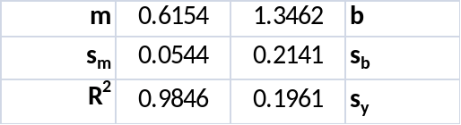

Plot the data appropriately (Abs vs. Conc.) and display the line of best fit, the equation for the line and the correlation coefficient on the graph. Be sure to appropriately title the graph and label the axis. What is the determined line of best fit?

Identify a third way to find the linear regression model using Excel Functions and perform the necessary calculations. What is the equation for the line of best fit?

Is the linear regression model found above a good representation for the data? Is the data useable for a calibration curve? Why or why not? Do the three methods for finding the linear regression model agree with each other?

ERROR BARS
The addition of error bars to a graphical representation helps us to better judge the quality of the data and fit a curve to the data. Copy the data in Table 4-6 in the Harris text into an Excel worksheet. Calculate the 95% confidence interval for the data using the equation found in the margin of the text on page 100. You must use a formula in Excel to do this.

Create a plot of the data with absorbance vs. mass. Appropriately title the graph and label the axis.

The following steps will add the error bars to the graph.
- On your xy scatter plot click in the chart area. This select the series to add error bars to as well as displays the Chart Tools, adding the Design, Layout, and Format tabs.
- On the Format tab, in the Current Selection group, click the arrow next to the Chart Elements box, and then click series 1.
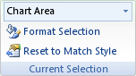
- On the Layout tab, in the Analysis group, click Error Bars and select More Error Bar Options.
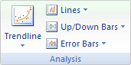
- In the dialogue box, select the display direction as both and the desired end style. Select the custom error amount.
- In this dialogue box assign both the positive and negative error amounts to correspond to the values of the 95% confidence interval
NOTE: The direction of the error bars depends on the chart type of your chart. For scatter charts, both horizontal and vertical error bars are displayed by default. You can remove either of these error bars by selecting them, and then pressing DELETE.
Based on the above analysis, what mass range of protein would you feel most confident in analyzing? What would you propose doing to increase this range? Why will this proposal increase the applicable range of analysis?
Grubbs Test for an Outlier
Data points which appear to be an outlier in the set are often encountered. But these points cannot simply be removed from the data set without some form of justification. It may be easiest to find error in the techniques used, such as over titrating, but this may not always be the case. The Grubbs Test is a statistical analysis of the data point believed to be an outlier. The Q-test can also be used, but the Grubbs Test is more widely accepted and recommended.

The Grubbs Test uses the mean () and standard deviation (s) of the complete data set:
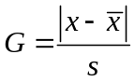
where x is the questionable value. If G_{calc} is greater than G_{table} (G_{calc} > G_{table}), the suspect value can be removed from the data set. Generally the value for the 95% confidence interval is used for G_{table}. A table of values for G can be found in the Harris textbook on page 92. Note that you need at least 4 trials before you can determine if an outlier exists.

From the following two sets of data, determine if any point can be removed from either set. In the Excel worksheet, use formulas and equations for all calculations.

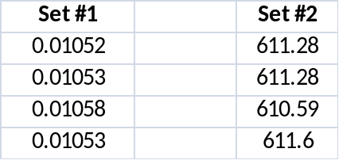

Which point(s) from which set(s) can be removed? Why or why not?

