Utilizing Excel for “Pseudo-Advanced” Statistical Analysis

You will be utilizing Excel to perform some “advanced” statistical analysis on data sets. The following exercises will introduce you to the F-test and the T-tests and how they can be applied to data to better understand what is shown.

The F-Test
The F-test is used to determine if the standard deviations from two data sets are significantly different from each other. The information found from this test can be used to determine which T-test needs to be performed (discussed later).
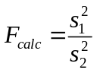
The larger standard deviation is always placed in the numerator so that F ≥ 1. If F_{calc} > F_{table} then the difference is significant. The table below gives values for F various levels of significance.

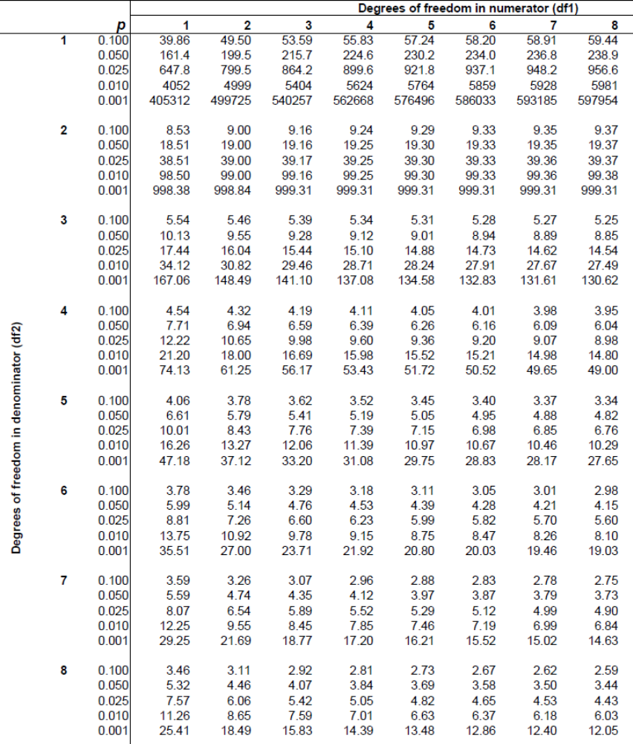

From the data below, are the standard deviations significant? Program Excel with all the necessary formulas and equations.

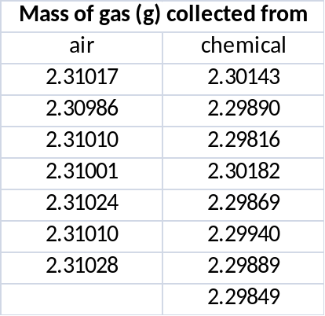

The T-tests
The T-test, or student’s t, is used to compare two sets of measurements to decide whether or not they are the “same” and can be considered together as a single set. The basis of the T-test is that we are testing a null hypothesis, which states that the mean values from the two sets of measurements are not different. Typically the 95% confidence is used. If T_{calc} > T_{table} the difference is significant. See the table below for the table values at four different confidence levels.

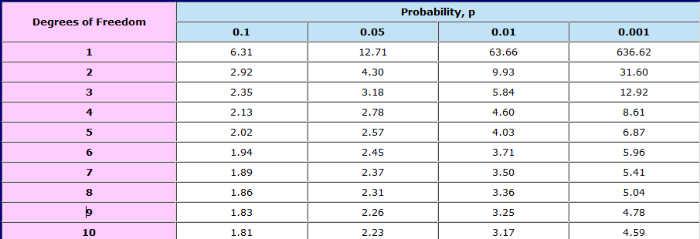

There are three different cases of the T-test.

Case 1
A quantity is measure several times by a single method and an average value is obtained. We want to compare our value to the accepted value. Does the measured value agree with the actual value within experimental error?

A sample was measured 4 times resulting in values of 3.29, 3.22, 3.30, and 3.23. The accepted value for the sample is 3.19. Use Excel to find all necessary values. Does the measured value agree with the actual value within experimental error (using 95% confidence)?

Case 2
A quantity is measured several times by two different methods that result is two different average values each with a unique standard deviation. Do the two results agree with each other within experimental error?

Use the data from the F-test exercise. Analyze the data using both T-tests (assuming equal variance and assuming unequal variance). This can be found in the Data Analysis Tool Pack. From each method, do the results agree with each other within experimental error? If the standard deviations are significantly different, the T-test for unequal variances must be used. Based on your results from the F-test which method should be used? For further explanation, consult section 4-3 in the Harris textbook.

Case 3
A sample is measured once by two different methods resulting in different values. The same happens with a second sample. This is repeated n different times each time resulting in the two values being different. Do the methods agree with each other within experimental error?

Use the data below and use Excel to solve all equations and formula.

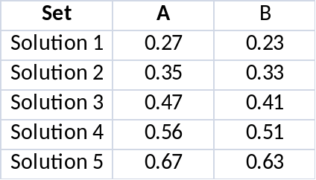

Perform the appropriate T-test and compare techniques A and B. Do the methods agree with each other within experimental error? Which method would you choose and why?

