EXPERIMENT 2: Iodination of Acetone

Good Initial Site For Kinetics

KINETICS OF THE IODINATION OF ACETONE

ADVANCED: DETAILS OF THE KINETICS OF I2 & ACETONE

Method of Initial Rates

Method of Initial Rate (2)

Have a go at this question…
The reaction between NO_{(g)} and Cl_{2(g)} has been studied at 50 °C, recording the initial rate of formation of NOCl_{(g)} for the initial concentrations of reactants as shown in the table.
NO_{(g)} + ½Cl_{2(g)} → NOCl_{(g)}
[NO_{(g)}] (mol dm⁻³) | [Cl_{2(g)}] (mol dm⁻³) | Initial Rate (mol dm⁻³ s⁻¹)
0.250 | 0.250 | 1.43 x 10⁻⁶
0.250 | 0.500 | 2.86 x 10⁻⁶
0.500 | 0.500 | 11.4 x 10⁻⁶
Rate = [NO_{(g)}]^{m} [Cl_{2(g)}]^{n}
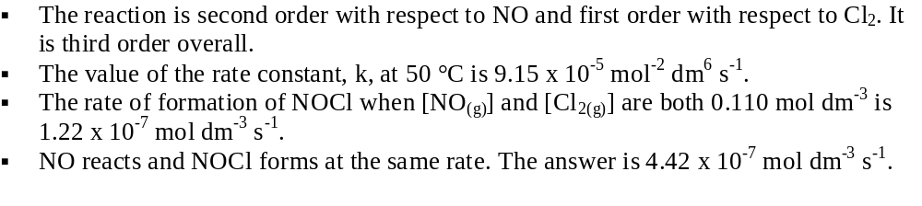
ANSWER UP-SIDE-DOWN

Basic Arrhenius Theory
Arrhenius XLS File (Example)

ln k(t=1) – ln k(t=2) = ln(k₁/k₂) = (E_{a}/R ) {1/T₂ - 1/T₁}

