Experiment 4: Spectrophotometric Determination of Iron

Add in any order the following to each of six 25 mL flasks using a 10 mL graduated cylinder:

2.5 mL hydroxylamine hydrochloride (reducing agent)
2.5 mL sodium acetate solution (slightly basic)
2.5 mL orthophenanthroline (complexing agent)

Use a buret to add 12.5, 10, 7.5, 5, 2.5, 0 (blank) mL of standard iron solution to six respective flasks. Read the buret to 2 decimal places to know the exact amount of iron added. Dilute each flask to volume with MilliQ water. Mix and let stand for at least 5 minutes. Follow the procedure below to adjust the Genesys 20 Spectrophotometer and determine the absorbance of each solution.

- Turn the power switch on. This switch is located on the lower left in the back of the instrument. It is a black toggle button. Allow five minutes for the instrument to warm up.

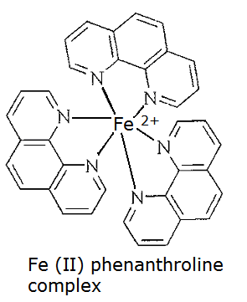
- Push the up or down toggle arrow button that is labeled as nm (nanometers) to select the proper wavelength for maximum absorbance. Determine the wavelength for this experiment by consulting the color chart. The color of the Iron(II) phenanthroline complex is orange.
- Violet: 400 - 420 nm
- Indigo: 420 - 440 nm
- Blue: 440 - 490 nm
- Green: 490 - 570 nm
- Yellow: 570 - 585 nm
- Orange: 585 - 620 nm
- Red: 620 - 780 nm

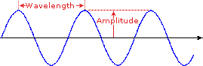 | 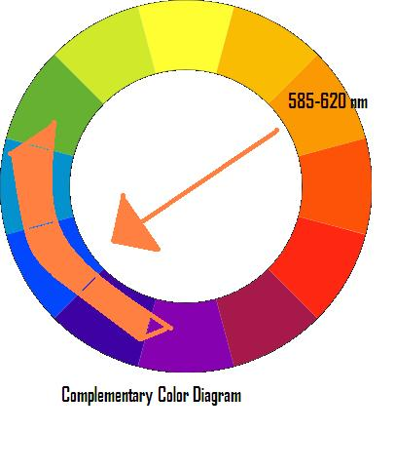
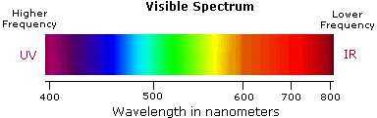

- Withdraw any test tube or cuvette that is in the instrument and close the cover to the cell compartment. Place a cuvette filled with the blank solution with a cuvette cover on it into the cell compartment. Be sure to close the cover to the cell compartment. Press the 0 ABS 100 % T button. The readout should say 0.000 A. If not, adjust by pushing the up down arrows directly below the readout display.

- Next, using the same cuvette, fill with the LEAST concentrated standard solution (this solution will be the lightest orange color), and rinse the cuvette into a waste beaker. Then refill with this same standard solution and place the cuvette into the cell compartment, and close the cover.

- Determine the highest absorbance (peak value) by systematically increasing the wavelength in increments of 10 nm starting at 400nm. Record the absorbance values and make plot of absorbance spectra to determine peak value. Use this peak value consistently throughout remainder of experiment.
- Continue this same procedure with the remaining 5 standard solutions, always reading absorbances from the lowest to most concentrated standard. Also, always fill the cuvette with standard and then rinse the solution into a waste beaker before filling with standard that will be read on the spectrophotometer.

- Lastly, fill the cuvette with the unknown iron solution, and record the absorbance. If the unknown absorbance does not fall within the range of the standards of known concentration, a dilution of the unknown will need to be completed. The standards should all have absorbances less than 1.00. To dilute the unknown, measure out 1 mL of unknown solution using either a glass pipet or a micropipette. Dispense this amount into the cuvette. Then measure out 1 mL of MilliQ water and add this amount to the cuvette. Since you are measuring 1 part of unknown in a total of 2 parts (1 part unknown and 1 part MilliQ water), this dilution process is called a 1:2 dilution. How would you make a 1:3 dilution of the unknown?

Added Notes:

- Also periodically check and adjust the 0 absorbance with the blank solution.

- Plot the Fe concentration (x axis) vs. absorbance points (y axis) on the computer, using excel software. Use a least squares fit or linear regression line to “draw the best straight line” through the points. DO NOT estimate this line with a straight edge.

- After obtaining the line for the standards (y = mx + b), use the unknown absorbance (y value) to substitute into the linear equation in order to mathematically determine the concentration of the Fe unknown in Molarity (x value). The slope of the line (m) is the molar absorptivity of the
- Iron (II) phenanthroline complex. Also determine standard deviations (s_{b} and s_{m})

- Remember: If a 1:2 dilution was made on the unknown, the concentration determined from the standard curve is based on the diluted unknown. To determine the real UNDILUTED unknown concentration, the value obtained mathematically from the calibration curve line should be multiplied by 2 (for a 1:2 dilution), or 3 for a 1:3 dilution, etc.

Atomic Absorption:

Next, you will need to obtain a SECOND unknown iron sample. You will run this on the Atomic Absorption Spectrophotometer (AA); however you will need to “substantially” dilute your unknown sample into the optimal and calibrated range 0-25ppm. Your TA will assist you with recommended procedure here. Note that since the AA measures the atomic spectra of the iron atom, you will not need to either reduce it or complex it!

Tips for Obtaining Good Calibration Standard Curves
and Unknown Absorbances:

- Make sure that the cuvette is clean before using.

- Always put a cap on the cuvette and close the cell compartment to prevent stray light from entering the solution, which will skew the results.

- Always handle the cuvette by the ribbed sides only.

- Wipe off the clear sides of the cuvette with a kimwipe to wipe off any oils from fingerprints.

- Always place the cuvette with into the holder with the ribbed sides toward the left and right, and use the SAME cuvette for all absorbance readings.

- Always place the cuvette in the holder with the arrow facing toward you.

- Always rinse out the cuvette to a waste beaker with the solution that will be tested before taking an absorbance reading.

- Always test a blank solution first before standards or unknowns.

- Always test the solutions from LEAST to MOST concentrated.

- When finished, remove the cuvette and rinse out several times with MilliQ water and turn over to dry.

- NEVER dry a cuvette with a paper towel, as towel fibers can get stuck onto the sides. ALWAYS leave the cuvette turned over to drain.

- Remember to set the wavelength to the proper setting for the experiment being performed.

