ACID BASE HANDOUT 2
NAME: PRINT________________________________ First Letter of Last Name [ ___ ]

- pH definitions:

pH is defined as _____________ pOH is defined as ______________

The Autoionization Equilibrium Constant for water @20 is defined as ______________________

pH + pOH = ______ and [H₃O⁺][OH⁻] = _________

- What is the [H+] and [OH-] in a solution whose pH = 4.40 and further what is the pOH?
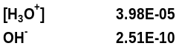

- What is the pH of the following STRONG ACIDS
0.02 M Nitric Acid solution 0.02M Sulfuric Acid Solution
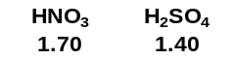

4) Calculate the [H+]/pH and [OH-]/ pOH for:

0.015 M HBr, (assume 100% dissociation) 0.02 M NaOH.

0.02 M Ba(OH)2. (assume100% dissociation) 0.03 M H₂SO₄
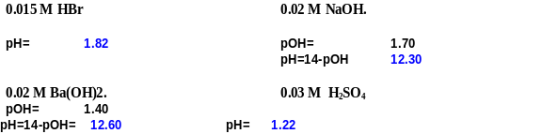

5) MOST acids and all ORGANIC acids are WEAK/STRONG Acids.
These means they DO/DO NOT dissociate totally.
This results in a Keq with is GREATER or SMALLER than ONE since
The reaction favors the PRODUCTs/REACTANTs

6) The K_{a} for Formic Acid is 1.80x10^{-4 ;} what is the pK_{a} for this Acid

7) What is the GENERAL DISSOCIATION EQUATION for ACIDS? ________________________________________

8) What is the pH of an aqueous solution of 0.341 M formic acid, HCOOH, K_{a} =(1.80x10⁻⁴)
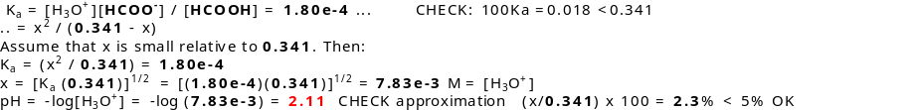

9) What is the H3O+ and pH concentration in a solution labeled: ( Do all meet the 100Ka Rule?)
0.1 M HClO, Hypochlorous acid (K_{a}= 3.0x10⁻⁸) 0.1M HC₂H₃O₂, Acetic Acid (K_{a} = 1.8 x 10⁻⁵)

10) Calculate the pH of a 0.0412 M aqueous solution of Nitrous Acid (HNO₂, K_{a} =4.5x10⁻⁴).

11) What is the GENERAL DISSOCIATION EQUATION for BASES ?

12) How does Ka and Kb defer in their PRODUCT? __________________________

13) Calculate the pH of a 0.352 M aqueous solution of Diethylamine ((C₂H₅)₂NH, K_{b} = 6.9x10⁻⁴).

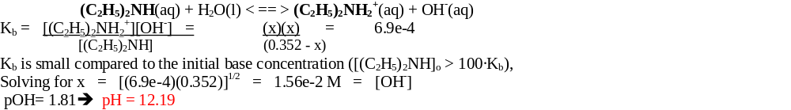

14) What is the H3O+ and pH concentration in a solution labeled: ( Do all meet the 100Ka Rule?)

0.1 M NH₃(aq), Ammonia Solution (Kb= 1.8x10⁻⁵) 0.01 M Hydrazine (Kb= 1.26 x10⁻⁶)

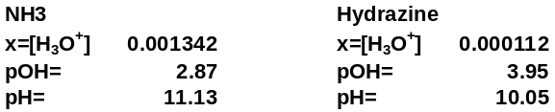

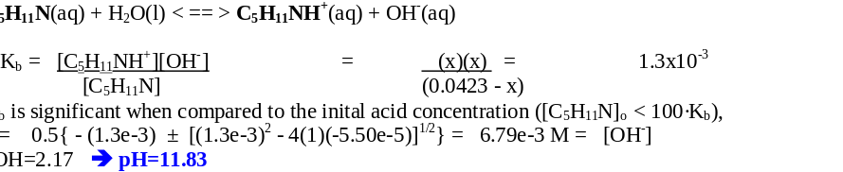
15) Calculate the pH of a 0.0423 M aqueous solution of the weak base Piperidine (C₅H₁₁N, K_{b} = 1.3x10⁻³).

