HANDOUT 3 (Discussion Period)
1) The following reactions all have Kc < 1.

1) ClO⁻ (aq) + C₆H₅OH (aq) < ==.> HClO (aq) + C₆H₅O⁻ (aq)
2) CH₃COO⁻ (aq) + C₆H₅OH (aq) < ==.> C₆H₅O⁻ (aq) + CH₃COOH (aq)
3) HClO (aq) + CH₃COO⁻ (aq) < ==.> CH₃COOH (aq) + ClO⁻ (aq)
Arrange the substances based on their relative strength.

ClO⁻ (aq)
C₆H₅O⁻ (aq)
CH₃COO⁻ (aq)
C₆H₅OH (aq)
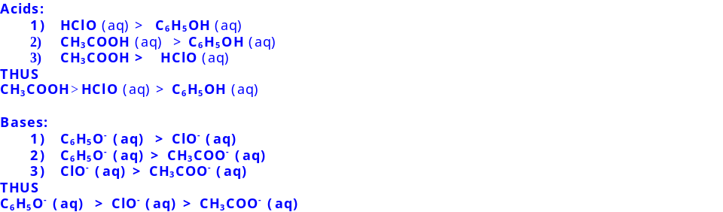
CH₃COOH (aq)
HClO(aq)

1) strongest base
2) intermediate base
3) weakest base
4) strongest acid
5) intermediate acid
6) weakest acid

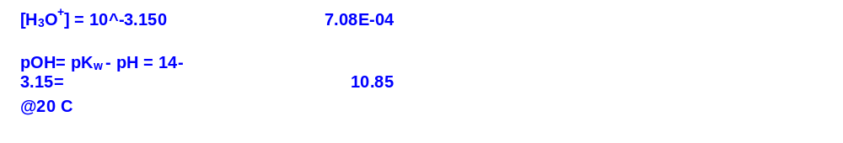
2) What is the hydronium ion concentration and pOH in an aqueous Nitric acid solution with a pH of 3.150 ? (Nitric Acid is Strong Acid)

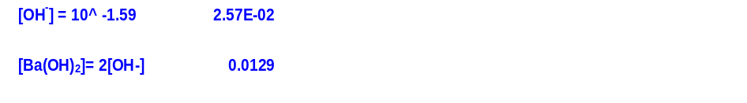
3) What concentration of barium hydroxide is needed to give an aqueous solution with a pOH of 1.590 (Assume Complete Dissociation/Strong Base)

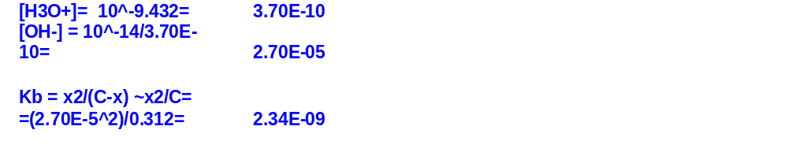
4) In the laboratory, a general chemistry student measured the pH of a 0.312 M aqueous solution of Isoquinoline , C₉H₇N to be 9.432. Use the information she obtained to determine the K_{b} for this base.

5) The pOH of an aqueous solution of 0.419 M phenol (a weak acid), C₆H₅OH, is

