ACID BASE HANDOUT 4B

Draw a rough pH titration curve for the neutralization of a STRONG ACID(1M) and a STRONG BASE(1M)
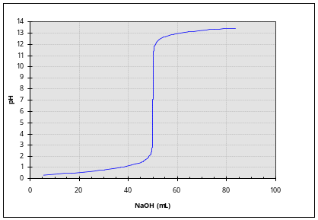
Now include(above) the rough titration curve for the neutralization of a WEAK ACID (1M) with a STRONG BASE (1M)
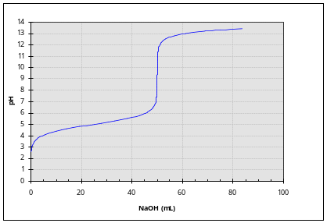

When you add 100ml of a 0.1M H₂SO₄ solution to 150 ml of 0.2M NaOH solution what is the pH?
0.1*0.1*2 = 0.02 moles of H3O+
0.2*0.15 = 0.03 moles of OH-
0.01 moles of OH- excess
0.01/0.25 = 0.04 M in OH- ➔ pH=12.6

When you add 100ml of a 0.1M H₂SO₄ solution to 150 ml of 0.2M Ca(OH)₂ solution what is the pH?
0.1*0.1*2 = 0.02 moles of H3O+
0.2*0.15*2 = 0.06 moles of OH-
0.04 moles of OH- excess
0.04/0.25 = 0.16 M in OH- ➔ pH=13.2

Henderson Hasselbalch Equation :pH = pKa+ log[A⁻ ]/[HA ]
When is this equation EXACT and when is it approximate. When in the Approximate form can it be utilized?
Exact when [A⁻ ] and [HA ] are the ACTUAL equilibrium concentrations
Approximate when we are assuming both are equal to INITIAL concentrations
Thus for both (C-x)=C

When is the pH equal to the pKa?
When [A⁻ ]/[HA ] =1 no matter what each are (not unique)

Point to that portion of the ABOVE titration curve for a weak acid/strong base where the HH equation can be used and note why it illustrates the role of a BUFFER
In the middle of the titration curve where some of the ACID has been neutralized and converted into the anion (conjugate base).

What are the THREE CASES/CONDITIONS that can be identified in determining the pH of a weak acid/strong base titration up until equivalence?
 | CASE 1 | CASE 2 | CASE 3
CONDITIONS: | HA +H₂O == H₃O⁺ +A⁻  ACID ALONE | HA +H₂O == H₃O⁺ +A⁻  ACID and ANION(C-Base) | A⁻ +H₂O == HA +OH⁻  ANION(C-Base) ALONE

What are the EQUATIONS FOR pH FOR THE THREE CASES/CONDITIONS FOR
WEAK ACID ?
CASE 1 | CASE 2 | CASE 3
Approximate {x<<[HA]_{init} }  x=sqrt(K_{a*}C) = [H₃O⁺]  pH = 0.5*{pKa-log[HA]_{init}}  Exact (Quadratic)  x=0.5{-K_{a}+sqrt(K_{a}²+4K_{a}[HA]_{init}))}  x = [H₃O⁺] | EXACT if ([HA]/[A-]) are ACTUAL EQ concentrations  APPROXIMATE if ([HA]/[A])are the INITIAL concentrations  pH = pKa – log([HA]/[A⁻]) | Approximate {x<<[A⁻]_{init} }  [OH-] = x= sqrt ( K_{b}[A⁻]_{initial} )  pOH= 0.5* (pK_{b}- log([A-]_{initial} )  pH=14-pOH

Comparison of Strong-Weak Acid/Strong Base Titration
STRONG ACID | INIITIAL | MIDPOINT | EQUIVALENCE
0.1 M HCl | 100 ml | 100 ml | 100ml
0.1 M NaOH | 0 ml | 50 ml | 100ml
What are pH’s at
INITIAL
0.1M*0.1L =0.01 moles H₃O⁺
0.1M [H₃O⁺] pH= 1

MIDPOINT
0.1M*0.1L =0.01 moles H₃O⁺
0.1M*0.05L =0.005 moles OH-
0.005 moles EXCESS of H₃O⁺
0.005/.15L = 0.0333 M H₃O⁺ pH= 1.48

EQUIVALENCE
0.1M*0.1L =0.01 moles H₃O⁺
0.1M*0.1L =0.01 moles OH-
NO ACID & NO BASE ➔ NEUTRAL pH=7.0

WEAK ACID | INIITIAL | MIDPOINT | EQUIVALENCE
0.1 M Acetic Acid * | 100 ml | 100 ml | 100ml
0.1 M NaOH | 0 ml | 50 ml | 100ml
* pKa =4.76 What are pH’s at
INITIAL
0.1M*0.1L =0.01 moles H₃O⁺
pH= 0.5*(4.76 – log(0.1) ) = 2.88

MIDPOINT
0.1M*0.1L =0.01 moles H₃O⁺
0.1M*0.05L =0.005 moles OH-
0.005 moles EXCESS of H₃O⁺
0.005/.15L = 0.0333 M H₃O⁺
But ALSO : 0.005moles of Acetate ➔ 0.005/0.15 = 0.0333 M Ac⁻
pH= 4.76 – log( 0.0333/0.0333) = 4.76

EQUIVALENCE
0.1M*0.1L =0.01 moles H₃O⁺
0.1M*0.1L =0.01 moles OH-
NO ACID & NO BASE ➔ NOT NEUTRAL SINCE Ac⁻ is not neutral

pOH= 0.5* (pK_{b}- log([A-]_{initial} )
pOH= 0.5* {14-4.76- log(0.01/.2L) } = 0.5*{9.26- log (0.05)} =5.28
pH= 8.72

