ACID BASE HANDOUT 4

What is the Dissociation Reaction & Equation for a Weak Acid?
HA + H₂O < == > H₃O⁺ + A⁻
K_{a} = [H₃O⁺][A⁻]/[HA]

What is the Hydrolysis Dissociation Reaction & Equation for a the Anion(Conjugate Base) of a Weak Acid
A⁻ + H₂O < == > HA +OH⁻
K_{h} = K_{b} =[HA][OH⁻ ] / [A⁻]

Write BOTH Reactions & Equations for Formic Acid HCOOH

HCOOH + H₂O < == .> HCOO⁻ + H₃O⁺
K_{a} = [HCOO⁻][H₃O⁺ ]/[ HCOOH ]

HCOO⁻ + H₂O < == > HCOOH + OH⁻
K_{h} = K_{b} = [HCOOH ][OH-]/ [HCOO⁻]

What is the Dissociation Reaction & Equation for a Weak Base ?

B + H₂O < == > BH⁺ + OH⁻
K_{b} = [BH⁺][ OH⁻]/ [B]

What is the Hydrolysis Dissociation Reaction & Equation for a the Anion(Conjugate Acid) of a Weak Base
BH⁺ + H₂O < == > B + H3O+
K_{h} = K_{a} = [ B ][H3O+ ]/ [BH⁺ ]

Write BOTH Reactions & Equations for Methyl Amine CH₃NH₂
CH₃NH₂ + H₂O < == > CH₃NH₃⁺ + OH⁻
K_{b} = [CH₃NH₃⁺ ][OH⁻]/ [CH₃NH₂]

CH₃NH₃⁺ + H₂O < == > CH₃NH₂ + H₃O⁺
K_{h}=K_{a}= [CH₃NH₂ ][H₃O⁺ ]/ [CH₃NH₃⁺ ]

Henderson Hasselbalch Equation :pH = pKa+ log[A⁻ ]/[HA ]
When is this equation EXACT and when is it approximate.

Exact when [A⁻ ] and [HA ] are the ACTUAL equilibrium concentrations
Approximate when we are assuming both are equal to INITIAL concentrations
Thus for both (C-x)=C

When is the pH equal to the pKa?
When [A⁻ ]/[HA ] =1 no matter what each are (not unique)

How does this EQUATION illustrate BUFFERS
When [A⁻ ]/[HA ] =1 small changes in added acid or base which will interchange HA and A will not largely alter the pH.

When can and can not you use this equation when utilized in a titration curve

The Henderson Hasselbalch Equation can be used when we have moderate amounts of BOTH A- and HA (Buffer region of curve)

Draw a rough pH titration curve for the neutralization of a STRONG ACID(1M) and a STRONG BASE(1M)
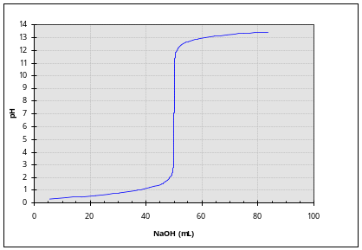
Now include(above) the rough titration curve for the neutralization of a WEAK ACID (1M) with a STRONG BASE (1M)
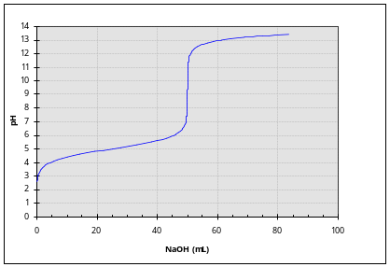

When you add 100ml of a 0.1M HCl solution to 50 ml of 0.05M NaOH solution what is the pH
0.1*0.1 = 0.01 moles H₃O⁺
0.05*0.05 = 0.0025 moles of OH⁻
Resulting in an excess of 0.0075 moles of H₃O⁺
0.0075 moles /0.150L = 0.05 M pH=1.30

When you add 100ml of a 0.1M HCl solution to 200 ml of 0.4M NaOH solution what is the pH
0.1*0.1 = 0.01 moles H₃O⁺
0.2*0.4 = 0.08 moles of OH⁻
Resulting in an excess of 0.07 moles of OH⁻
0.07 moles /0.30L = 0.233 M pH=13.4

When you add 100ml of a 0.4M HCl solution to 40 ml of 0.1 NaOH solution what is the pH
0.1*0.4 = 0.04 moles H₃O⁺
0.04*0.1 = 0.004 moles of OH⁻
Resulting in an excess of 0.036 moles of H₃O⁺
0.036 moles /0.14L = 0.257 M pH= 0.6

When you add 100ml of a 0.1M H₂SO₄ solution to 200 ml of 0.4M NaOH solution what is the pH
0.1*0.1*2 = 0.02 moles H₃O⁺
0.2*0.4 = 0.08 moles of OH⁻
Resulting in an excess of 0.06 moles of OH⁻
0.06 moles /0.30L = 0.20 M pH=13.3

When you add 100ml of a 0.1M H₂SO₄ solution to 150 ml of 0.2M Ca(OH)₂ solution what is the pH
0.1*0.1*2 = 0.02 moles H₃O⁺
0.15*0.2*2 = 0.06 moles of OH⁻
Resulting in an excess of 0.04 moles of OH⁻
0.04 moles /0.25L = 016 M pH=13.2

