HANDOUT

SOLUBILITY TABLE:
s=Soluble ss= Slightly Soluble i=Insoluble d= decompose n= not found

 | NO₃- | acetate |  | Cl⁻ | Br | I |  | SO₄ | S⁼ | CO₃ | PO₄ | OH⁻ |  | CrO₄
NH₄ | s | s |  | s | s | s |  | s | s | s | s | s |  | s
Na | s | s |  | s | s | s |  | s | s | s | s | s |  | s
K | s | s |  | s | s | s |  | s | s | s | s | s |  | s
Ba | s | s |  | s | s | s |  | i | d | i | i | s |  | i
Ca | s | s |  | s | s | s |  | ss | d | i | i | ss |  | s
Mg | s | s |  | s | s | s |  | s | d | i | i | i |  | s
Sr |  |  |  |  |  |  |  | i
Al | s | ss |  | s | s | s |  | s | d | n | i | i |  | n
Pb | s | s |  | ss | ss | ss |  | i | i | i | i | i |  | i
Cu | s | s |  | s | s | n |  | s | i | i | i | i |  | i
Fe(II) | s | s |  | s | s | s |  | s | i | i | i | i |  | n
Fe(III) | s | s |  | s | s | n |  | ss | d | n | i | i |  | i
Hg(I) | s | ss |  | i | i | i |  | ss | i | i | i | n |  | ss
Hg(II) | s | s |  | s | ss | i |  | d | i | i | i | i |  | ss
Ag | s | ss |  | i | i | i |  | ss | i | i | i | n |  | ss
Zn | s | s |  | s | s | s |  | s | i | i | i | i |  | s

1) Which of the following Reactions will occur, and then balance:
a) Sodium Phosphate and Lead Nitrate

b) Potassium Carbonate and Silver Acetate

c) Calcium Chloride and Sodium Sulfide

d) Barium Carbonate and Ammonium Chloride

2) How could one separate a solution that contained Al, Ag and Ba?

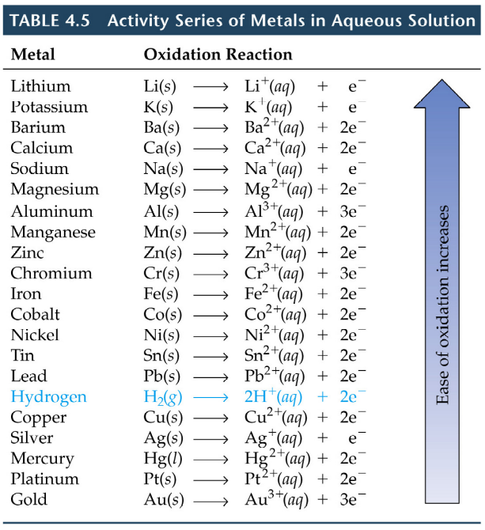

3) A sample contains metallic Zinc, Tin and Copper. Which metals will react with Acid

4) You are given Ca, Al and Ni as well as solutions containing the chlorides of each of these metals. Show ALL THREE of the possible BALANCED reactions and the total ionic reactions.

- What are the oxidation numbers for the elements in the following molecules:
P₂O₅ SO₂ KMnO₄ N₂O NO₂

- Show the oxidation number for the carbons in the following molecules AND order them from the least to the most OXIDIZED.
Methanol Formic Acid Methane Carbon Dioxide Formaldehyde
CH₃OH HCOOH CH₄ CO₂ H₂CO

