HANDOUT TITRATIONS:

What ARE the HYDROLYSIS REACTIONS for the SALT of a WEAK ACID and WEAK BASE?

- + H₂O == HA +OH⁻ K_{h}(for HA) = K_{b} = K_{w}/K_{a}
BH⁺ + H₂O == B +H₃O⁺ K’_{h}(for B) = K’_{a} = K_{w}/K_{b}

Setup a TABLE of Conditions to access the Final Acidity/Basicity of such a salt based on K_{a},K_{b}, pK_{a},pK_{b}, pK_{h}

ACIDIC | BASIC | NEUTRAL
K’_{h}(for B) > K_{h}(for HA) | K_{h}(for HA) > K’_{h}(for B) | K_{h}(for HA) ~ K’_{h}(for B)
K’a(for B) > K_{b}(for HA) | K_{b}(for HA) > K’_{a}(for B) | K_{b}(for HA) ~ K’_{a}(for B)
K_{b}(for B) < K_{a}(for HA)  Thus pK_{b} > pK_{a} | K_{a}(for HA) < K_{b}(for B)  Thus pK_{a} > pK_{b} | K_{a}(for HA) ~ K_{b}(for B) less than 10  Thus pK_{a} ~ pK_{b} (less than 1 pH unit)

Draw a rough titration curve for a WEAK ACID and define relevant conditions and equations

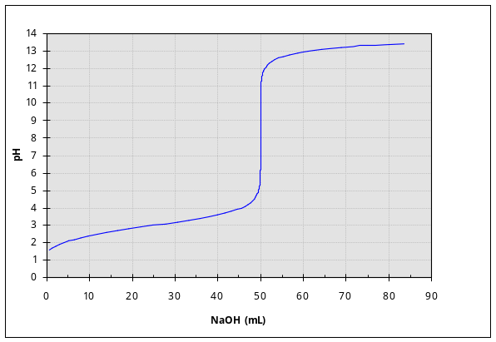

pH(Equivalence point; only anion)= 7+ ½(pKa+ log([A⁻])

pH(acid and anion region) = pK_{a}- log{ [HA]/[A-] }=HH eq

pH (only acid) = ½( pK_{a} + log([HA]))

Draw a rough titration curve for a WEAK Base and define relevant conditions and equations
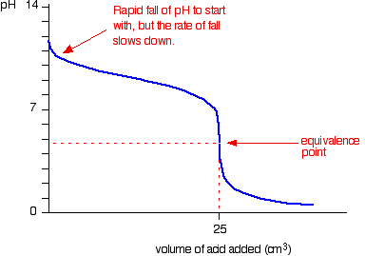

How do pH Indicators work and how do we select them?

HA + H₂O == A- +H₃O⁺

HA and A- compounds are DIFFERENT COLOR. The weak acid changes color at the pKa!!!
pKa is used to define the practicality of the choice of indicator

Use Le Chatelier’s Principle to describe the degree of dissociation of a Acid/Base as a function of pH

Adding Acid to a solution contain 1) a weak acid; 2) a weak acid and anion; or anion(salt) of weak acid
Plus the reaction to the UNDISSOCIATED form !! HA + H₂O <== A- +H₃O⁺

When the pH = pKa HALF of the acid is the form of the ion and half as the undissociated acid!
pH BELOW pKa have more Acid and also MORE HA
pH ABOVE pKa have less Acid and also LESS ION !!

Draw a rough titration curve for a for a Polyproton Acid Such as H₃PO₄ and note important conditions and equations
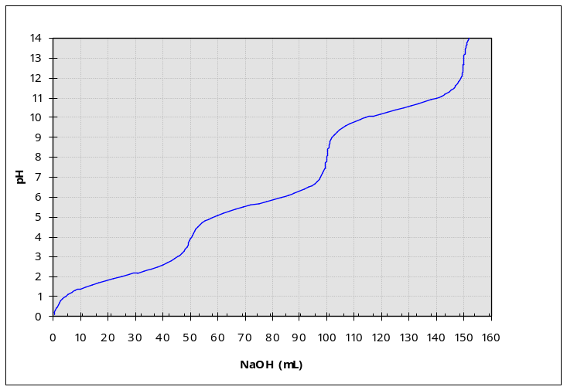

What are LEWIS ACIDS and LEWIS BASES and how do they relate to Lowry-Bronsted Acid/Bases?

More general definition of an acid and base.

Lewis acid ACCEPTS pair of electrons to form new bond
Lewis base DONATES/SHARES pair of electrons to form new bond

H⁺ + :NH₃ === NH₄⁺
Lewis Acid Lewis Base Lewis Adjunct

