HANDOUT: INITIAL OVERVIEW OF THERMODYNAMICS
What is the First Law of Thermodynamics?
ΔE_{univ} = ΔE_{sys} + ΔE_{surr} = 0
Energy cannot be created nor destroyed only transferred between a defined “system” and its environment/surrounding

Definition in terms of INTERNAL ENERGY
ΔE_{internal energy} =ΔE_{system} = q + w

Let’s Go Back to Entropy and Look at its Origin!
What is ENTROPY? (Statistical vs. Outcome Definitions)
where is the total number of microstates. The entropy is thus
Boltzmann and Available States
The statistical definition of entropy. Because a uniform probability distribution reflects the largest randomness, a system with allowed states will have the greatest entropy when each state is equally likely. In this situation, the probabilities become
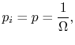where is the total number of microstates. The entropy is thus S= k ln
The outome of entropy is the degree of disorder/order. The higher the disorder, the greater the entropy. The relationship between is based upon the fact that more probably system have the higher disorder/ possible situations/micostate
Let’s Look at some nomenclature needed for 2nd Law
Reversible vs. Irreversible Reactions
In a reversible process the system changes in such a way that the system and surroundings can be put back in their original states by exactly reversing the process.

Irreversible processes cannot be restored by exactly reversing the change to the system

Spontaneous vs Non-Spontaneous ➔ Entropy
Spontaneous processes are those that can proceed without any outside intervention; whereas non-spontaneous reactions require outside intervention in the form of heat and/or work.

Now what now is the Second Law of Thermodynamics!
The entropy of the universe increases for irreversible (spontaneous) process.
For irreversible processes: ΔS_{univ} = ΔS_{sys} + ΔS_{surr} > 0
For reversible processes: ΔS_{univ} = ΔS_{sys} + ΔS_{surr} = 0

Implication of 2nd ➔ What is the Third Law of Thermodynamics
Because entropy decrease as temperature decrease (fewer microstates/less disorder) Thus, the 3rd Law of Thermodynamics states that the entropy of a pure crystalline substance at absolute zero is 0.

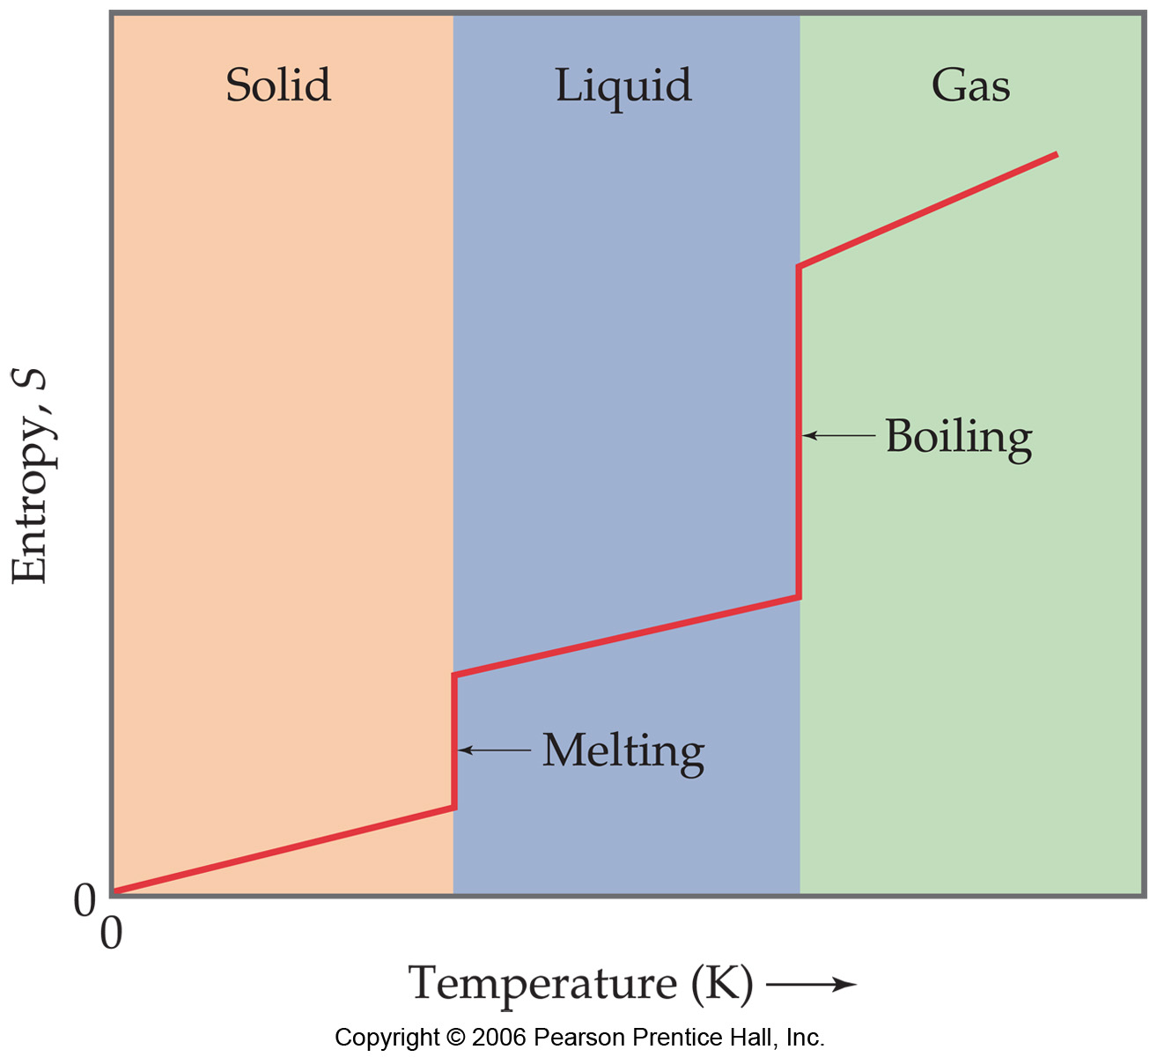
Let’s Plot the Change of entropy with temperature on a substance

Definition of Free Energy
ΔG = ΔH – TΔS

Free Energy and its source (Entropy of Universe)
For irreversible processes: ΔS_{univ} = ΔS_{sys} + ΔS_{surr} > 0 SPONTANEOUS
For reversible processes: ΔS_{univ} = ΔS_{sys} + ΔS_{surr} = 0 NONSPONTANEOUS

ΔS_{univ} = ΔS_{sys} + ΔS_{surr} multiple both sides by –T
-TΔS_{univ} =-T ΔS_{sys} -TΔS_{surr}
Now define ΔG= -TΔS_{univ} and ΔH= -TΔS_{surr}
we get Gibbs Equation
ΔG = - T ΔS_{sys} + ΔH = ΔH - T ΔS_{sys}

Calculations of Standard Free Energy (ΔG⁰) from Standard Molar Entropies and Enthalpies

ΔG° = Σ_{n}ΔG°(products) − Σ_{m}ΔG°(reactants)

Or ΔG°(T) = ΔH° -T ΔS°
Where ΔH° = Σ_{n}ΔH°(products) − Σ_{m}ΔH°(reactants)
and ΔS° = Σ_{n}ΔS°(products) − Σ_{m}ΔS°(reactants)

Generalized Free Energy in terms of Temperature and Reaction Quotient
ΔG = ΔG°(T) + RT lnQ

Special Case at Equilibrium ➔Temperature dependence of K_{eq} and relationship to free energy

0 = ΔG°(T) + RT lnK_{eq}
thus assuming H and S are temperature independent:

K_{eq} = exp(-ΔG°/RT) = exp(-ΔH°/RT)* exp(-ΔS°/R)

