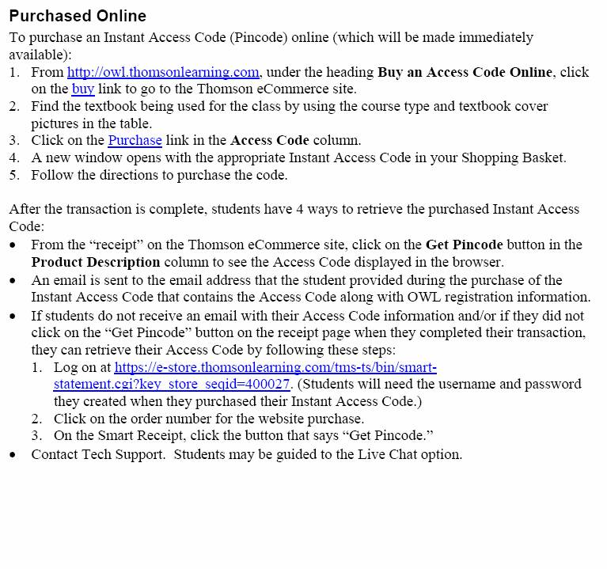
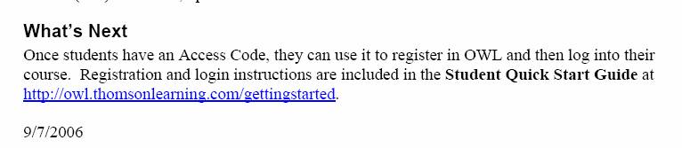
Erin Ryan
Sales Representative
Thomson Duxbury & Brooks/Cole
c: 773-562-9741
e: erin.ryan@thomson.com
sales support: 800-423-0563

