SOLUBILITY TABLE:
s=Soluble ss= Slightly Soluble i=Insoluble d= decompose n= not found

 | NO₃- | acetate |  | Cl⁻ | Br | I |  | SO₄ | S⁼ | CO₃ | PO₄ | OH⁻ |  | CrO₄
NH₄ | s | s |  | s | s | s |  | s | s | s | s | s |  | s
Na | s | s |  | s | s | s |  | s | s | s | s | s |  | s
K | s | s |  | s | s | s |  | s | s | s | s | s |  | s
Ba | s | s |  | s | s | s |  | i | d | i | i | s |  | i
Ca | s | s |  | s | s | s |  | ss | d | i | i | ss |  | s
Mg | s | s |  | s | s | s |  | s | d | i | i | i |  | s
Sr |  |  |  |  |  |  |  | i
Al | s | ss |  | s | s | s |  | s | d | n | i | i |  | n
Pb | s | s |  | ss | ss | ss |  | i | i | i | i | i |  | i
Cu | s | s |  | s | s | n |  | s | i | i | i | i |  | i
Fe(II) | s | s |  | s | s | s |  | s | i | i | i | i |  | n
Fe(III) | s | s |  | s | s | n |  | ss | d | n | i | i |  | i
Hg(I) | s | ss |  | i | i | i |  | ss | i | i | i | n |  | ss
Hg(II) | s | s |  | s | ss | i |  | d | i | i | i | i |  | ss
Ag | s | ss |  | i | i | i |  | ss | i | i | i | n |  | ss
Zn | s | s |  | s | s | s |  | s | i | i | i | i |  | s

1) Which of the following Reactions will occur, and then balance:
a) Sodium Phosphate and Lead Nitrate
2 Na₃PO₄ + 3 Pb(NO₃) ₂ ➔ Pb₃ (PO₄) ₂ + 6 NaNO_{3 (Aq)}

b) Potassium Carbonate and Silver Acetate
K₂CO₃ + 2AgAc ➔ Ag₂CO₃ +2 KAc _{(Aq)} ( But AgAc is slightly soluble so reaction will be hindered)

c) Calcium Chloride and Sodium Sulfide
CaCl₂ + Na₂S ➔ (CaS decomposes) + 2NaCl POSSIBLY forming H₂S but not enough information to confirm

d) Barium Carbonate and Ammonium Chloride
BaCO₃ ( INSOLUBLE) thus reaction is unlikely or if it takes place would be substantially hindered.

2) How could one separate a solution that contained Al, Ag and Ba?

Add Chloride to precipitate AgCl, leaving Al and Ba in solution, then precipitate Al as Al(OH)3 leaving Ba in solution. Ba could be then precipitated with Sulfate if you wish.

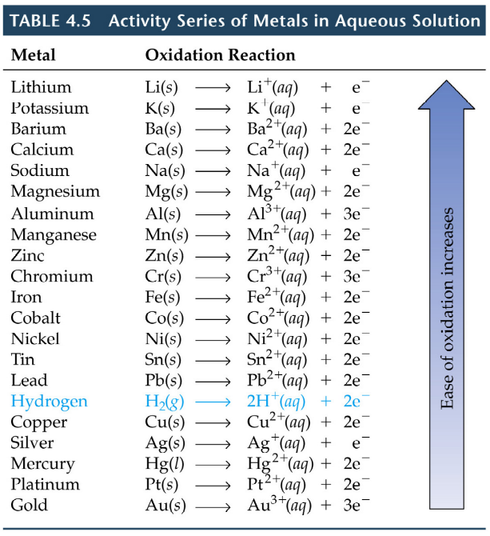

3) A sample contains metallic Zinc, Tin and Copper. Which metals will react with Acid

Zn and Sn will react with acid but NOT Copper

4) You are given Ca, Al and Ni as well as solutions containing the chlorides of each of these metals. Show ALL THREE of the possible BALANCED reactions and the total ionic reactions.

3Ca + 2Al⁺³ ==6e➔ 3 Ca⁺² + 2Al

Ca + Ni⁺² ==2e➔ Ca⁺² + Ni

2Al + 3Ni⁺² == 2Al⁺³ +3Ni

- What are the oxidation numbers for the elements in the following molecules:
P₂O₅ SO₂ KMnO₄ N₂O NO₂

P=+5 S=+4 K=+1; Mn=+7 N=+1 N=+4

- Show the oxidation number for the carbons in the following molecules AND order them from the least to the most OXIDIZED.
Methanol Formic Acid Methane Carbon Dioxide Formaldehyde

Methane ➔ Methanol ➔ Formaldehyde ➔ Formic Acid ➔ Carbon Dioxide

C=-4 C=-2 C=0 C=+2 C=+4

Least Oxidized ================================================== > Most Oxidized

Most Reduced < ================================================= Least Reduced

