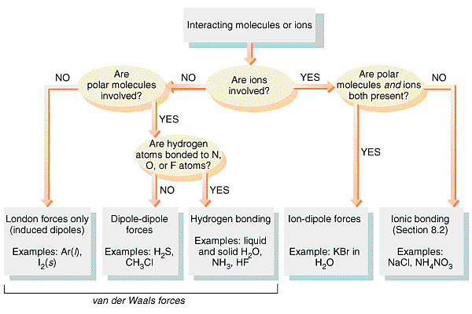
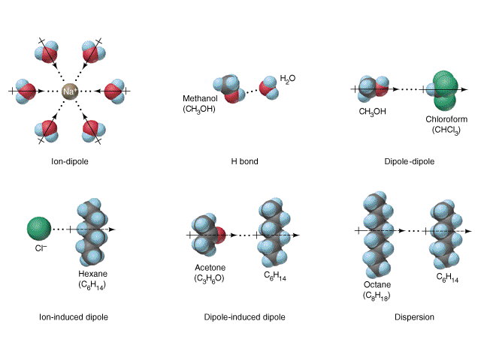

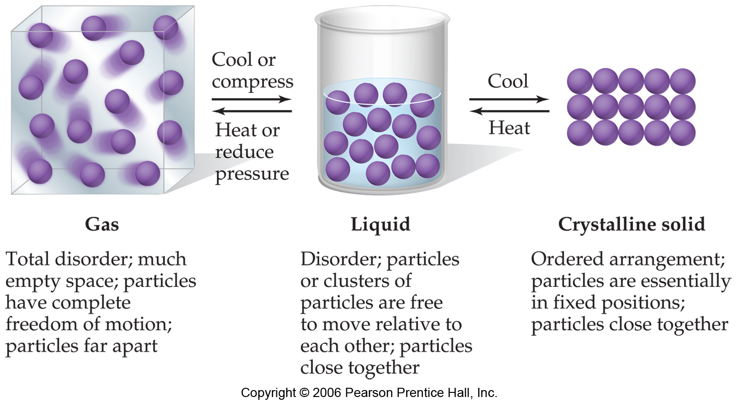
Intermolecular and Intramolecular Forces
Force | Model | Basis of Attraction | Energy (kJ/mol) | Example
Intramolecular
Ionic | 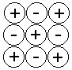 | Opposite charges | 4000 – 400 | NaCl
Covalent |  | Nuclei – shared e⁻ pair | 1100 – 150 | H - H
Metallic | 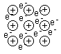 | Metal cations and delocalized electrons | 1000 – 75 | Au
Intermolecular
Ion-dipole |  | Ion and polar molecule | 600 – 40 | Na⁺ & H₂O
Dipole-dipole | 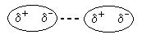 | Partial charges of polar molcules | 25 – 5 | HCl & HCl
Hydrogen bond | 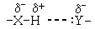 | H bonded to N, O, or F, and another N, O, or F | 40 – 10 | H₂O & NH₃
London dispersion | 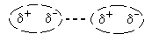 | Induced dipoles of polarizable molecules | 40 – 0.05 | Xe & Xe

