MULTIPLE CHOICE QUESTIONS(64)
Answers maybe SCRAMBLED/Different from those in Specific Exams
POLARITY
3) Which of the following will have the smallest dipole moment?
- HCl
- HBr
- HI
- HF
4) Which of the following is a non-polar covalent compound?
- CF₄
- HCN
- CH₃CN
- HCl
- NaCl
LEWIS STRUCTURES
5) Which of the following molecules requires two resonance hybrid Lewis structures to account for the bonding?
- SO₂
- CO₂
- O₂
- CH₄
- C₂H₄

TYPES OF BONDS
1) Which of the following elements forms bonds with fluorine that are the most covalent?
- Al
- Ca
- O
- P
- Se
2) Which of the following pairs of atoms are most likely to form a covalent compound?
- Ni, O
- Na, F
- Cu, Cl
- C, O
- Li, F
6) How many lone (unshared) pairs are there in the best Lewis structure of ClF₃?
- 11
- 10
- 9
- 8
- 7
7) Which of the following could be the atom X in the following neutral (uncharged) molecule?
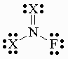
- H
- F
- C
- N
- O
8) Which of the following Lewis structures is least plausible?
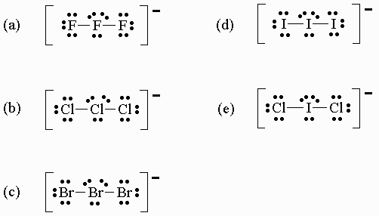
FORMAL CHARGE
10) What is the oxidation number and formal charge of iodine in the IF₄⁺ ion?
 | oxidation state (number) | formal charge
(a) | -1 | -1
(b) | +1 | +5
(c) | +3 | 0
(d) | +5 | +1
(e) | +5 | +5
REACTIONS
11) Which pair of elements react to form an ionic compound?
- calcium and copper
- calcium and chlorine
- nitrogen and chlorine
- argon and oxygen
- fluorine and iodine
ELECTRONEGATIVITY
9) The symbols and respective electronegativities for elements in a hypothetical universe are given in the table below:
element | electronegativities
L | 2.0
M | 3.5
Q | 1.6
R | 2.5
Which of the following bonds is least polar (i.e. most nonpolar)? _____LQ____
POLARITY
12) CO₂ is a nonpolar molecular (µ=0) whereas SO₂ is polar (µ=1.62 D). This difference is due to the fact that:
- C and O have approximately the same electronegativity while S and O have different electronegativities.
- CO₂ has an even number of double bonds whereas SO₂ has an odd number of double bonds.
- C and O are in different groups whereas S and O are in the same group.
- the C-O bond is nonpolar while the S-O bond is polar.
- CO₂ is linear whereas SO₂ is not linear.
HYBRIDIZATION
13) Which one of the following statements is incorrect?
- The electrons involved in pi bonding are more delocalized in benzene than in ethylene.
- The bond order of the carbon - carbon bond in ethane, C₂H₆ , is two.
- Pi orbitals involve the overlap of un-hybridized p atomic orbitals.
- 2s atomic orbitals tend to be lower in energy than 2p orbitals.
14) πorbital overlap involves:
- "end-on" bonding with s orbitals.
- overlap of an s with a p orbital.
- production of a bonding orbitals due to overlap of two sp² orbitals.
- "sideways" approach of pairs of p orbitals.
- None of the above.
ELECTRON CONFIGURATION
15) The electron configuration of Plutonium is:
- [Rn]7s²6d¹⁰5f⁶
- [Xe]7s²5f⁶
- [Rn]7s²5f⁵
- [Xe]6s²5d¹⁰4f⁶
- none of these
16) What is the electron configuration of Fe³⁺?
- [Ar]4s²3d⁹
- [Ar]4s¹3d⁵
- [Ar]4s²3d³
- [Ar]3d⁶
- [Ar]3d⁵

17) The electron configuration of a certain element is [X]4s²3d¹⁰4p², where X stands for a noble gas. The element in question and the noble gas X are, respectively:
- Ga and Ar
- Ge and Ar
- Sn and Kr
- Ge and Kr
- Si and Ar
18) The electron configuration of S²⁻ is (the Periodic Table should help you):
- 1s²2s²2p⁶3s²3p⁵
- 1s²2s²2p⁶3d¹⁰
- 1s²2s²2p⁶
- 1s²2s²2p⁶3s²3p⁶3d¹⁰
- 1s²2s²2p⁶3s²3p⁶
METALS
19) Which pair of elements react to form an ionic compound?
- calcium and copper
- calcium and chlorine
- nitrogen and chlorine
- argon and oxygen
- fluorine and iodine
20) Which of the following elements is not a metal?
- Na
- Cu
- Pb
- Mg
- C
ISOELECTRONIC
21) Which of the following pairs is isoelectronic?
- Li, Be²⁺
- F⁻, Na⁺
- O, F⁻
- Li⁺, Na⁺
ATOMIC DIMENSION
22) Place highlighted elements in the Periodic table below
in order from the largest atomic radius to the smallest?
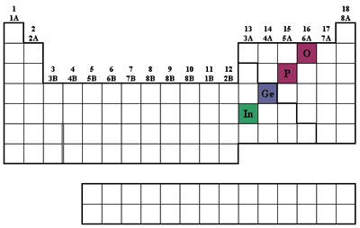
a) O >P>Ge>In b)In>Ge>P>O
c) O>P>In>Ge d) All Have approximately equivalent radius
23) Which of the following has the largest radius?
- Na⁺
- Li⁺
- Cl
- H
- Cl⁻
IONIZATION POTENTIAL
24) Which of the following has the largest first ionization energy?
- Cs
- Ne
- Na
- Si
- F
ELECTRON AFFINITY:
25) The ability of an element to act as an oxidizing agent tends to:
- increase as the ionization energy decreases.
- increase as the atom becomes larger.
- increase as the element becomes more metallic
- increase as the electronegativity increases. .
- decrease as the electronegativity increases.
ATOMIC THEORY:
26) Calculate the wavelength of light that corresponds to the radiation that is given off during the transition of an electron from the n = 2 to n = 5 of the state of the hydrogen atom.
Rydberg constant in joules | 2.18E-18
Rydberg constant in eV | 13.6057
- 305 nm
- 275 nm
- 183 nm
- 434 nm
- not enough info is given
27) Below are several principles or concepts and matching descriptions. Which answer correctly matches the entries in the two columns?
principle | description
1. Heisenberg Uncertainty Principle | a. Bodies can lose energy only in quantized amounts.
2. Pauli Exclusion Principle | b. It is impossible to determine simultaneously the position and speed of a particle with extreme accuracy.
3. Hund's Rule | c. The electrons in a given atom must differ in the value of at least one of their 4 quantum numbers.
4. Planck's Hypothesis | d. Electrons fill orbitals with the same energy so that one e⁻ occupies a different orbital before any orbital is occupied by 2 e⁻.
- 1-a, 2-b, 3-c, 4-d
- 1-b, 2-d, 3-a, 4-c
- 1-c, 2-d, 3-a, 4-b
- 1-b, 2-c, 3-d, 4-a
- 1-d, 2-c, 3-b, 4-a
28) If it takes 243.4 kJ of energy to break bonds in a Cl₂ molecule, what is the frequency of the energy used to break the bonds?
- 3.673 x 10³⁸ s⁻¹
- 2.727 x 10²⁹ s⁻¹
- 3.673 x 10³⁵ s⁻¹
- 8.174 x 10⁻³¹ s⁻¹
- 6.626 x 10⁻³⁴ s⁻¹
29) Which of the following has the largest wavelength?
- visible light
- x-rays
- infrared light
- ultraviolet light
MOLECULAR GEOMETRY
30) Which of the following is a tetrahedral molecule or ion? (b)
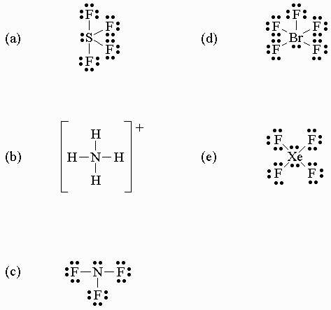
31) Which of the following molecules or ions is not linear? (b)
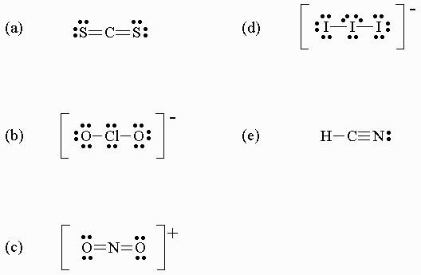
32) Which of the following best describes the shape and polarity of the
carbon disulfide, CS₂, molecule?
- bent and polar
- linear and non-polar
- pyramidal and polar
- bent and non-polar
- linear and polar

TYPES OF BONDS
1) Which of the following pairs of atoms are least likely to form an ionic compound?
- Ni, O
- Na, F
- Cu, Cl
- Li, Mg
- Li, F
2) Which of the following oxides is ionic?
- XeO₃
- SO₂
- N₂O
- Y₂O₃
- P₂O₅
POLARITY
3) Which of the following molecules has a non-zero dipole moment?
- Cl₂O
- I₂
- BF₃
- CO₂
- SF₆
4) In which of the following molecules are the bonds most polar?
- H₂
- HF
- CH₄
- NH₃
- H₂O
LEWIS STRUCTURES
5) The number of equivalent resonance structures connected with the best Lewis structure of SO₃ is:
- 0
- 1
- 2
- 3
- 4
6) The number of bonding electron pairs in the best Lewis structure of CS₂ is:
- 1
- 2
- 3
- 4
- 5
- 5
7) Which of the following compounds (or ions) contains an atom that does NOT follow the octet rule?
- BrF₃
- CBr₄
- NO⁺
- BF₄⁻
- NCl₃
8) Which of the following Lewis structures is least plausible? (a)
ELECTRONEGATIVITY
9) The symbols and respective electronegativities for elements in a hypothetical universe are given in the table below:
element | electronegativities
L | 2.0
M | 3.5
Q | 0.9
R | 2.5
Which of the following bonds is least polar (i.e. most non-polar)? LR
FORMAL CHARGE
10) What is the formal charge on carbon in the preferred structure of CO₂?
- -1
- +2
- -3
- 0
- +4
REACTIONS
11) Hydrogen reacts with both active metals and nonmetals, e.g.
(1) H₂(g) + 2Na(s) --> 2NaH(s)
(2) H₂(g) + Cl₂(g) --> 2HCl(g)
Consider the following statements pointing out possible similarities between these two reactions:
- The products of the two reactions are covalent molecules.
- The products of the two reactions are ionic species.
- Both reactions involve oxidation-reduction.
- The oxidation number of hydrogen decreases in reaction (1) and increases in reaction (2).
Which of these are correct?
- 3 and 4
- 1, 3 and 4
- 2, 3 and 4
- 1 and 3
- only 3
POLARITY
12) CO₂ is a nonpolar molecular (µ=0) whereas SO₂ is polar (µ=1.62 D). This difference is due to the fact that:
- C and O have approximately the same electronegativity while S and O have different electronegativities.
- CO₂ has an even number of double bonds whereas SO₂ has an odd number of double bonds
- CO₂ is linear whereas SO₂ is not linear. .
- C and O are in different groups whereas S and O are in the same group.
- the C-O bond is nonpolar while the S-O bond is polar.
HYBRIDIZATION
13) The C=C double bond in ethene (or ethylene), C₂H₄, is composed of:
- two bonds.
- one bond + one sigma bond.
- 3p³ hybridization.
- two sigma bonds.
- only unhybridized p orbitals.
14) Indicate the number and kinds of bonds present in HCN.
- 1 sigma and 1
- 1 sigma and 2
- 1 sigma and 3
- 2 sigma and 1
- 2 sigma and 2
ELECTRON CONFIGURATION
15) The electron configuration of Europium is:
- [Xe]6s²4f⁷
- [Rn]7s²6d¹⁰5f⁶
- [Rn]7s²5f⁷
- [Xe]6s²5d¹⁰4f⁶
- none of these
16) The ion correctly matched with its grounded state electron configuration is:
- Al³⁺: [Ne]3s²3p⁶
- Cr³⁺: [Ar]4s²3d¹
- Ni²⁺: [Ar]3d⁸
- Fe³⁺: [Ar]3d⁶
- Zn²⁺: [Ar]4s²3d⁸
17) Which of the species below has the electronic configuration 1s²2s²2p⁶?
- Na⁺
- O²⁻
- Ne
- N³⁻
- All of the above
METALS (2)
18) Which of the following elements has the most nonmetallic character?
- F
- Ge
- Hg
- In
- S
19) Which pair of elements react to form an ionic compound?
- calcium and copper
- calcium and chlorine
- nitrogen and chlorine
- argon and oxygen
- fluorine and iodine
ISOELECTRONIC
20) Which of the following sets is isoelectronic with Xe?
- Br⁻, I⁻, Cs, Cs⁺
- He, Ne, Ar, Kr
- I⁻, Cs⁺, Ba²⁺, La³⁺
- Sn²⁺, Sb³⁺, Te²⁻, I⁻
- Sn⁴⁺, Sb⁵⁺, Te²⁻ , I
ATOMIC DIMENSION
21) Which of the following has the largest radius?
- K
- K⁺
- Cl⁻
- Cl
- Ne
22) Which of the following statements are incorrect?
- Atoms tend to get larger as one goes across the Periodic Table from left to right in a given period.
- Atoms get larger as one proceeds down a given group.
- For a given pair of isoelectronic ions, cations are smaller than anions.
- The first ionization energy for a given element tends to be smaller than the second ionization energy.
- Less electronegative elements tend to have smaller ionization energies.
IONIZATION POTENTIAL
23) Which of the following has the lowest ionization energy?
- Li
- K⁺
- K
- Ne
- O
ELECTRON AFFINITY
24) The electron affinity of F is, in effect, the energy required for which of the following reactions?
- F₂(g) --> 2F(g)
- F(g) --> F⁺(g) + e⁻
- F⁺(g) --> F₂⁺(g) + e⁻
- F⁻(g) --> F(g) + e⁻
- F₂(g) + e⁻ --> F⁻(g) + F(g)
ATOMIC THEORY
25) A Na lamp emits yellow light with a wavelength of 589 nm. What is the energy of a single photon in this light?
h= | 6.63E-34
- 3.37 x 10⁻¹⁹ Joules.
- 1.12 x 10⁻²⁵ Joules.
- 1.17 x 10⁻³³ Joules.
- 5.09 x 10¹⁵ Joules.
- 5.09 x 10¹⁴ Joules.
26) The absorption of visible light involves which of the following processes?
- protons converted to neutrons
- molecules gaining kinetic energy
- electrons making the transition from the ground state to a higher energy level
- atomic orbitals being hybridized
- electrons returning from excited states to the ground state
27) Which of the following is a postulate of the Bohr model of the atom that the Schroedinger model refutes?
- The energy of an electron is quantized, in other words there are only certain allowed energies for an electron.
- The electron in a hydrogen atom travels around the nucleus in a circular orbit.
- All electrons have exactly the same amount of energy at constant temperature.
- Schroedinger agreed with all of the above Bohr postulates.
28) A hydrogen atom in an excited state emits 973.2 Angstrom radiation as its electron returns to the ground state. In which excited state was the electron?
Rydberg constant in joules | 2.18E-18
Rydberg constant in eV | 13.6057
- first excited state
- second excited state
- third excited state
- fourth excited state
- fifth excited state
29) On the television news; it was notes that when the detailed information about bank robberies was reported it might affect future robberies. This illustrates which principle?
  - Boyles’s Law
  - Conservation of Mass
  - Heisenberg Uncertainty Principle
  - Pauli Exclusion Principle
MOLECULAR GEOMETRY (3)
30) Which of the following is a planar molecule or ion? (e)
31) What are the approximate values of the bond angles, a and b, in the ion illustrated below?
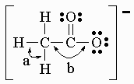
- a is ~90º and b is ~90º
- a is ~109º and b is ~109º
- a is ~120º and b is ~109º
- a is ~90º and b is ~180º
- a is ~109º and b is ~120º
32) When the molecules H₂O, CH₄, and NH₃ are arranged in order of increasing bond angle, the correct sequence is:
- H₂O, CH₄, NH₃
- NH₃, H₂O, CH₄
- CH₄, NH₃, H₂O
- H₂O, NH₃, CH₄
- CH₄, H₂O, NH₃

FREE RESPONSE SECTION
I) THERMOCHEMISTRY (DO ONE(1) OF TWO)
Ia) A 2.20-g sample of Quinone, C₆H₄O₂, is burned in a bomb calorimeter whose total heat capacity is 7.854 kJ/°C. The temperature of the calorimeter increases from 23.44°C to 30.57°C. What is the heat of combustion per mole of quinone? (Molecular weight of quinone is 108.1.)
2750 kJ/mol
OR
Ib) A volume of 50.0 mL of 0.400 M HBr at 24.35°C is added to 50.0 mL of 0.400 M NaOH, also at 24.35°C. The final temperature is 27.06°C. Calculate the enthalpy change, H, in kJ for the following reaction:
HBr(aq) + NaOH(aq) --> NaBr(aq) + H₂O(l)
Assume that the heat capacity of solution is the same as water 4.18J/(g*K)

56.7 kJ/mol

II) ELECTRONIC STRUCTURE (DO ONE(1) OF TWO)
IIa) Place highlighted elements in the periodic table below in order
from the smallest atomic radius to the largest? AND EXPLAIN WHY?
O <P<Ge<In
OR
IIb) Explain why the effective nuclear charge experienced by a 3p electron in sulfur is larger than that experienced by a 3p electron in silicon
S has a larger nuclear charge than Si.

III) HYBRIDIZATION (DO ONE(1) OF TWO)
IIIa) Draw the hybridized orbital structure for H₃C-CH=CH₂ and note the angles between the relevant bonds
OR
IIIb) What is the hybrid orbital diagram for Carbon in C

IV) LEWIS DOT STRUCTURE (DO ONE(1) OF TWO)
IVa) Draw the Lewis Dot Structure for SO₂ and what would be the geometric structure
OR
IVb) Draw the Lewis dot structure for OXeF₄ molecule and DRAW Structure including angles

V) MISCELLANEOUS QUANTUM PRINCIPLES (DO ONE(1) OF THREE)
Va) Draw a ground-state orbital diagram for Oxygen which violates BOTH Hund’s rule and the Pauli-exclusion Principle at the same time and identify
OR
Vb) Using your general knowledge of quantum levels of atoms; explain why some elements have unique flame test colors while others do not.
OR
Vc) The Heisenberg Uncertainty Principle influences all experiments but is more critical at the atomic level, why

