5) Chemical Process (multiple choice and fill-in) (5 pts total)
Which of the following processes represents a decrease in the entropy of a system? (5pts)
a) dissolving a sugar cube in water to give a homogeneous solution
b) the combustion of hydrocarbons into CO₂ and H₂O
c) formation of a snow flake within a cloud
d) water vapor condensing as morning dew
e) the sublimation of water from an ice cube

6 ) Electrochemical Cells
Half-Cell Reduction Potentials | Volts
I₂+ 2e == 2I | 0.53
Br₂ + 2e == 2Br- | 1.07
Using the above data construct a voltaic cell and determine the standard potential and the cell potential at 25ºC if the
concentations of [I-] and [Br-] are 0.2M and 0.02M respectively (3pts)

Br₂ + 2I- =2e = 2Br- + I₂
Standard Cell Potential |  | 0.54
If the concentations of I- and Br- are 0.2M and 0.02M respectively
What would be the voltage of this Voltaic Cell at 298K
E =0.54-( 0.0592/2)*LOG(0.02^2/(0.2)^2) |  |  | 0.599 | volts

7-9) Consider the dissociation reaction of methylamine in water (15pts total)
 | CH₃NH_{2(aq)} | H₂O | CH₃NH₃⁺ | OH⁻
ΔºH_{f} (kJ/K) | -75.29 | -285.8 | -121.5 | -230 | 9.59
Sº (J/K) | 101.3 | 69.91 | 93.4 | -10.7 | -88.51
ΔºG_{f} (kJ/K) | -105.4774 | -306.633 | -149.3332 | -226.811 | 35.96
What is ΔºH_{rxm} (kJ/K) for this reaction? Is this reaction exothermic or endothermic? What happens to the temperature of the system when the reaction takes place? (2pts)
9.59 kJ (ENDOTHERMIC) COOLS
What is ΔºG_{rxm} (kJ/K) for this reaction? (2pts)
35.966
What are the K_{b} (K_{eq}) AND pK_{b} for this reaction at 298K (3pts)
G0/R(298) | 14.51662353
K_{b} | 4.96033E-07
pK_{b}= | 6.30

How does the K_{b} change with DECREASING the temperature to 10ºC (CELSIUS) (3pt)
(Require Value and Trend)
K_{b} = exp(-9.59*1000/(8.314*283))*exp(-88.51/8.314)
K_{b} = 4.04026E-07
pK_{b} = 6.39
Equilibrium constant (Kb) DECREASES

How does this SHIFT the REACTION and WHY?(3pts)
Decreased K means less product and more reactants thus REACTION GOES TO LEFT

Explain answer in terms of the effect of ΔºH_{rxm} and K_{eq} (2pt)

Keq α EXP(-ΔH/RT) if ΔH is positive; then decreasing temperature makes number inside exponential bigger but negative which means the K gets smaller!
FINAL EXAM Chem 102 (August 9, 2007)
NAME: Print _________________________ Sign ____________________________________

1)Balance the following reaction in a BASIC environment(3pts). Show number of electrons transferred(2pts)
Al(s) + NO₂¯ (aq) → AlO₂¯ (aq) + NH₃ (g)
H₂O + 2Al(s) + NO₂¯ (aq) + OH¯ → 2AlO₂¯ (aq) + NH₃ (g)
6ELECTRONS!

2-4) The following initial rate data are for the oxidation of arsenate ion by ferric ion in solution (15pts total): +
AsO₃³⁻ + 2 Fe³⁺ + 2OH⁻ ➔ AsO₄³⁻ + 2 Fe²⁺ + H₂O

Experiment | [AsO₃³⁻]_{o}, M | [Fe⁺³]_{o}, M | Initial Rate, Ms⁻¹
1 | 4.57E-02 | 0.5362 | 5.36E-03
2 | 9.14E-02 | 0.5362 | 1.07E-02
3 | 4.57E-02 | 1.0724 | 2.15E-02
4 | 9.14E-02 | 1.0724 | 4.28E-02

- What is the Rate Order for the reaction AND Rate Law for this reaction (3pts)

R= k[AsO⁻³][Fe⁺³]² Third(3) Order Overall

b) From these data, what is the rate constant ? (4ts)

5.36e-3= k(4.57e-2)(0.536)² k= 0.40

Questions relating to above reaction:

c) Does the Rate for the reaction remain constant as the reaction proceeds while the reactants diminish YES NO (1pt)
Rate diminishes since the reactants diminish

d) Does the Rate Constant (k) remain the same as the reaction proceeds while the reactants diminish? YES NO (1pt)
Rate constant is independent time but is dependent on T

e) Does the Rate for the (forward) reaction approach approach zero YES NO (1pt)
Rate of the forward reaction approaches the Rate of the backward reaction

f).How many electrons are being transferred in the above reaction (2pts)

2 electrons are transferred.

g) If 2 micromoles of arsenate were used up in this reaction over a 2 second period, what current in amperes would be generated by this reaction? (3pts)

Note that 2e are transferred per mole of Arsenate
But 2.0E-6 moles of Arsenate have reacted thus
4.00E-06 | moles of electrons
=0.000004*96500= | 0.386 | Coulombs
0.386C/2sec = | 0.193 | A

10) Match the following aqueous solutions with the appropriate letter from the column on the right.

A___ 0.32 m AgNO₃ = 0.64 a) Lowest freezing point
C___ 0.18 m MnCl₂ = 0.54 b) Second lowest freezing point
D _ 0.17 m NiF₂ = 0.51 c) Third lowest freezing point
B__ 0.62 m Sucrose (nonelectrolyte) = 0.62 d) Highest freezing point

11) Consider the oxidation of Ethanol to Acetaldehyde on a platinum wire. (5pts total)

2CH₃CH₂OH + O₂ == 2CH₃CHO + 2H₂O

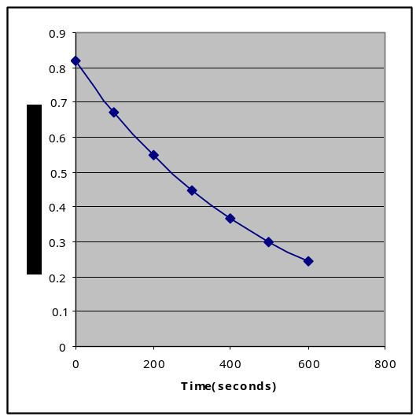
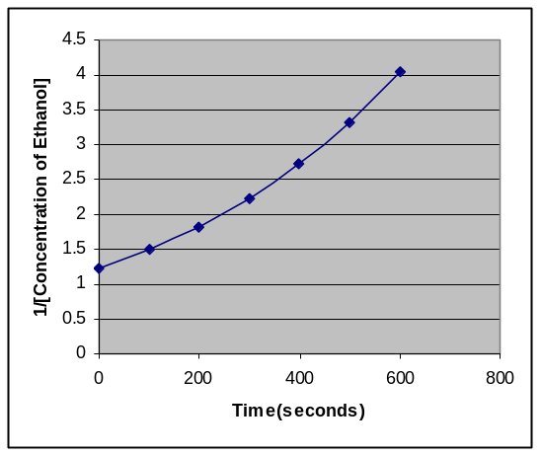
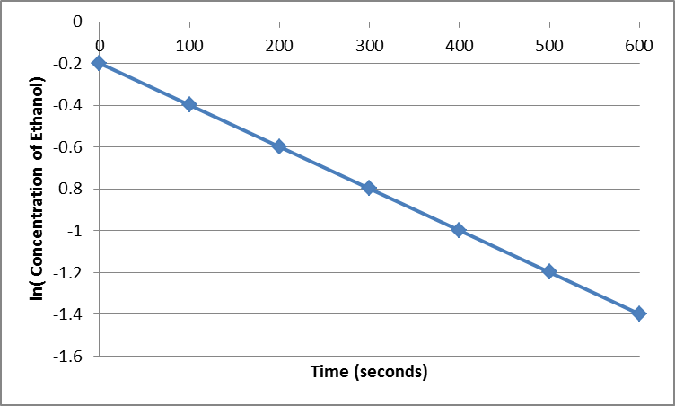

What is the rate order of this reaction and why (1pts)
FIRST ORDER is the LOG plot is linear

Write a time dependent equation that shows the change in methanol with time (4pts)

A = 0.82 exp( -0. 002 t)

12) Using the fact that pK_{a}(HF) = 3.17; show at least TWO ways to construct a BUFFER solution at pH=3.17 using the following:

0.5M solution of NaOH
0.5M solution of NaF
0.5M solution of HCl
0.5M solution of NaCl
0.5M solution of HF

- Equal Volumes both HF and NaF
- One Volume of HF and ½ that volume of NaOH making F-
- One Volume of NaF and ½ that volume of HCl to make HF

Extra Credit(5pt) Choose one of these and define exactly how you might adjust this solution to a pH of 3.25
pH = pKa –log (Acid)/Conjugate Base)
3.25 = 3.17 –log (acid/Conjugate Base)
0.08 | =log(HF/F)
1.1 | = RATIO of HF/F
13) Fill in missing words (5pts)
Endothermic/Exothermic;Free Energy/Entropy/Enthalpy;increase/decrease;release/absorb

- The two main driving forces in nature are __Entropy_ and __Enthalpy__

- The driving force largely responsible for the dissolution of nonvolatile SOLIDS(such as salts) into Solutions is ENTROPY__ since these reactions are often Endothermic.

- The Temperature dependence associated with the solubility of GASES in solvents is largely due to Enthalpy_
- Since the Entropy_ of the gas before and after dissolution are very similar if no negative.
- The dissolving of most gases are Exothermic, thus release heat when dissolved since the gas molecules are now solvated and lower in energy.

Problem 14: Vapor Pressure

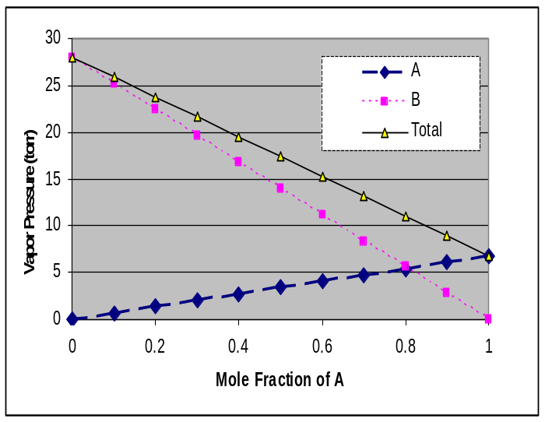

Using the below information(5pts total):
Tolune BP 173.3 ºC
Benzene BP 110.6 ºC

What are the vapor pressures for Toluene at 25ºC (2pts)
7 torr

and Vapor Pressure for Benzene at 25ºC? (2pts)
28 torr

At what temperature will the vapor pressure of Benzene equal 760 torr (1pt)
110.6 C

15) If one were to mix two solutions together in equal volume, one containing the two soluble salt solutions: 1uM PbF₂ and the other containing 2.5uM K₂CrO_{4 .} What would be the Q for this reaction and would anything precipitate?
K_{sp} (PbCrO₄ ) =2.8 x 10⁻¹³; Molar Mass=323.2). (3pts) Hint: Use any Volume

(1.0e-6/2)(2.5e-6/2) = 6.25e-13 Q> Ksp Precipitation would occur!

SETUP only the equation to determine how much PbCrO4 would then dissolve OR precipitate (2pts)

(2.5e-6/2-x)(1.0e-6/2-x) = 2.8e-13
Since it is supersaturated, x will be positive
Correct x =2.23E-07

18) Draw a reasonable titration curve for the reaction of 100 ml 0.02M Benzoic Acid(pK_{a}=4.2) with 0.01M Calcium hydroxide (assume totally soluble). Contrast this with the titration curve for a 0.02M Hydrochloric acid. (5 points)

Note the three(3) important pH’s that help define the shape of this graph (need numeric values!)

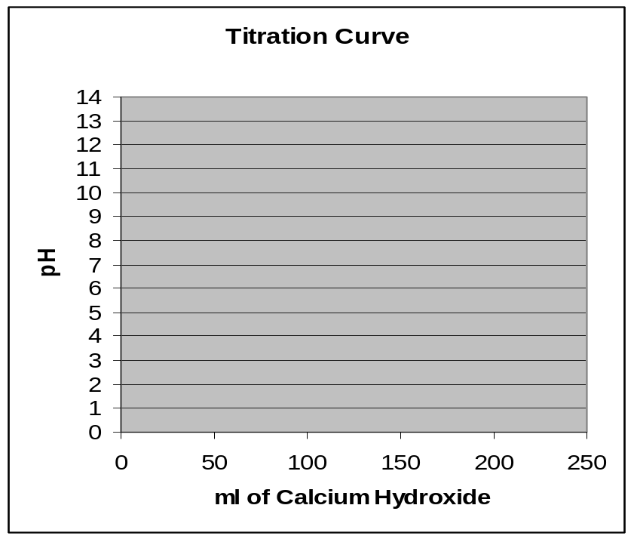

19) The activation energy for the gas phase decomposition of dinitrogen pentoxide is 60.5 kJ.
N₂O₅ 2 NO₂ + 1/2 O₂
The rate constant at 300 K is 7.5e-4 /s. What is the Rate Constant at315 K.
k₂= k₁/exp(E_{act}/R*(1/T₂-1/T₁)) k2 must be GREATER than k1 !
-1.155060693
2.66E-03 | =k2

20) Nuclear Chemistry (5pts total):

a) The alpha decay of -²⁴⁰ Np results in what isotope/element? Show the products. (2pts)

²⁴⁰₉₃ Np ➔ ²³⁶₉₁ Pa + ⁴ ₂α

b) This product THEN decays by beta (e-) radiation to produce what isotope/element (2pts)

²³⁶₉₁ Pa ➔ ²³⁶ ₉₂ U + ⁰ ₋₁ β⁻

c) Does the sum of the masses of nucleons (protons/neutrons) equal the mass of the final nucleus. Why? (1pt)

No, The mass is LESS than the SUM of the PARTS.
The MASS of the nucleons is converted into BINDING ENERGY that
Holds the nucleus together. (E=mc²)

Extra Credit: What is needed to support that M-theory is science and not philosophy? (5 pts)
16-17) Consider the following Titration Conditions: (20 pts total)
0.25 M ACID | 0.25 M BASE | Equation/work | pH
50 ml HNO₃ | 100 ml KOH
  0.0125 | moles OH
  0.083 | Molar
  1.08 | pOH
  12.92 | pH
50 ml Chloroacetic  Acid (pKa=2.85) | 25 ml Ca(OH)₂
   |  | 0.166667 | Molar Anion
  =0.25*0.05-2*0.25*0.025= | 0 | moles of Acid/Base
   | Salt of weak Acid
  =7+0.5*(2.85+LOG(0.166)) | pH= | 8.04
50 ml HCl | 50 ml NH₃  (pK_{b} = 4.75)
  [NH4+] = | 0.125
  Salt of weak Base
  pH=7-0.5*(4.75+LOG(0.125))= | 5.08
80 ml Nitrous Acid  (pK_{a})=3.35 | 40 ml NaOH | At Half Equivalence Point  pH= pKa-log([HA]/[A-]) but log(1)=0  thus pH= 3.35
75 ml of H₂SO₄ | 75 ml of Ca(OH)₂ | pH=7
15ml of Sulfuric Acid | 40 ml of NaOH
  Winner Strong Base
  =0.01*0.25/0.055 | 0.0455 | M OH
   | 1.34 | pOH
   | 12.66 | pH
30 ml Formic Acid  (pKa)=3.17 | 10 ml of Ca(OH)₂
  Winner Weak Acid
  =0.01*0.25 | 0.0025 | moles
   | 0.0625 | Molar | Acid | pH= pka -log(Acid/Conjugate Base)
   | 0.125 | Molar | Formate | pH= | 3.47
20 ml of Cyanic Acid (HCNO)  pKa = 3.46 | No Base
  =0.5*(3.46-LOG(0.25)) | pH=2.03
No Acid | 25 ml of Methylamine pK_{b}=3.34
  pOH= 0.5*(3.34-log(0.25)) | 1.97103
  pH= | 12.02897
25 ml of HCl | 25 ml of Methylamine pK_{b}=3.34
  Salt of Weak Base
  pH=7-0.5*(3.34+LOG(0.125)) | 5.78

