Chemistry 102 SOLUTION to Discussion 1

- For the reaction 2 A + B → Product , the following data is acquired:

[A] M (mol/L) | [B] M | Initial rate, mol/Ls
0.023 | 1.74 × 10 ⁻² | 2.40 × 10 ⁻³
0.023 | 5.8 × 10 ⁻³ | 2.67 × 10 ⁻⁴
0.046 | 5.8 × 10 ⁻³ | 2.67 × 10 ⁻⁴
0.046 | 2.9 × 10 ⁻³ | 6.68 × 10 ⁻⁵

- What is the order with respect to reagent A? Use data points 2 and 3, since [B] is constant:
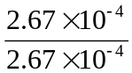 = 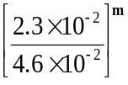 implies, taking ln of each side, ln (1) = (m) × ln (0.5); m = 0

(b) What is the order with respect to reagent B? What is the over-all order? Use data pts. 1, 2; or one
could have used pts 3,4 since, in each pair, [A] is constant:
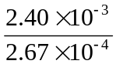 ⁼ 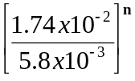implies, taking ln of each side, ln (9) = n ln (3), n = 2 = over-all order
(c) Determine the rate constant k. Use data point (1): k = 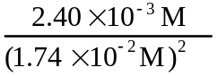 = 7.93 L/mol-s
(d) Write the rate expression: Rate = 7.93 [B]²

- If [A] = [B] = 0.50 M, determine the rate of the reaction. Rate 7.93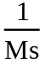× (0.5)² = 1.98 mol/L-s

(2) In the first order decomposition of acetone at 500ºC, the concentration decreases by 25% to 0.030 M after the first 200 minutes of reaction.

- Determine the rate constant for this reaction.
Use ln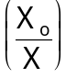 = kt; Both X_{o} and k unknown, but concentration decreases by 25 %, which allows one to find k.

First find the initial concentration .25x = x – 0.030
-0.75 x = - 0.030
0.75x = 0.030
x = 0.04

Thus ln(0.04/0.03) = k × 200 min; Solving, k = 1.44 × 10⁻³min⁻¹.
- Determine the half life of the reaction. τ_{½} = 0.693/k = 481 min

(3) The zeroth order reaction of hydrogen iodide on gold proceeds as
HI(g)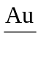 H₂(g) + I₂(g) with rate constant 0.050 M/s at a certain temperature.
- How long will it take for the concentration of HI to drop from 1.00 M to 0.200 M?
t = 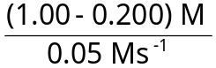 = 16 s.

- If the initial concentration of HI (g) is 1.00 M, how long will it take to deplete 75% of the hydrogen iodide gas? If 75% has been consumed, 25% remains, thus the time that lapsed is:
t = 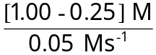 = 0.75/.05 = 15 s.

all of the hydrogen iodide gas? We can solve as above, or whimsically note that this time is
just twice the half life, 2⋅τ = 2⋅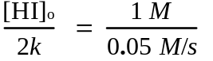= 20 s.

- The data below corresponds to a 1st order reaction. By appropriately transforming the concentration data, graphically determine the rate constant and fill in the missing entries in the table below. Also determine the unit of the rate constant.

Data [A] (M) | 0.16 | 0.08 | 0.04 | 0.0282 | 0.02 | 0.01
-Ln[A] | 1.8 | 2.5 | 3.2 | 3.6 | 3.9 | 4.62
Time (s) | 0 | 3.0 | 6.0 | 7.5 | 9.0 | 12.0

- The data below corresponds to a 2nd order reaction. By appropriately transforming the concentration data, graphically determine the rate constant and fill in the missing entries in the table below. Also determine the unit of the rate constant. Time is plotted (s) along x-axis, 1/[Conc’n] (M⁻¹) along y-axis.

Data [A] (M) | 0.16 | 0.08 | 0.04 | 0.0337 | 0.02 | 0.01
1/[A] | 6.25 | 12.5 | 25. | 28.2 | 50 | 100
Time (s) | 0 | 4.0 | 12.0 | 15.0 | 28.0 | 60.0

1st order: k = (2.5 – 1.8) / (3.0 – 0) s⁻¹ = 0.7 / 3.0 = 0.2333 s⁻¹ 2nd order: k = (12.5 –6.25) M⁻¹ / (4.0-0.0) s = 1.5625 (Ms)⁻¹
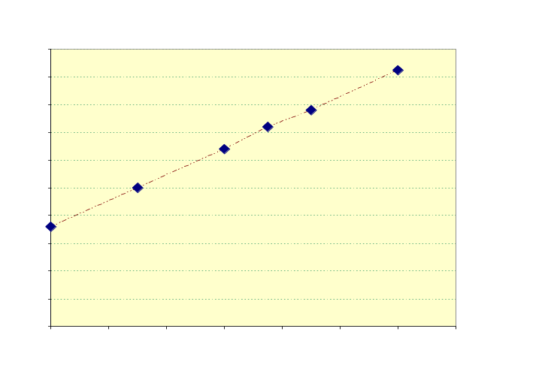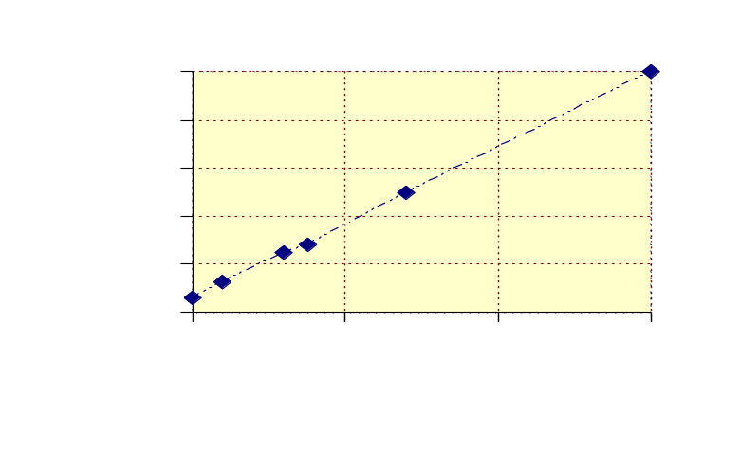

1st order graph 2nd order graph

